**People's Democratic Republic of Algeria MinistryofHigherEducationandscientificResearch**

**UniversityofGhardaia**



**FacultyofLettersandLanguages**

**Difficulties Facing Fourth Year Primary School Pupils in the English Language Reading**

**The case of Fourth-year primary school pupils at Omar Al-Sassi in Guerrara**

**Department of English**

*DissertationsubmittedtoUniversityofGhardaiaforobtainingthe master's degree in Didactics*

**Submittedby:Supervisor:**

*- Thouria HEBAL Dr. Sheikh SERIOU*

*- Fatiha BOUMIDOUNA*

***Boardofexaminers****:*

***Chairperson:Dr.*** *Slimane ABD EL HAKEM*

***Examiner:Dr.*** *Hanan EL ALMI*

***Supervisor:Dr.****Sheikh SERIOU*

***Academicyear:2023/2024***

**Dedication**

Praise be to God, that is enough, and prayers be upon the beloved chosen one, my family, and those who are loyal. As far what follow:

Praise be to God, who helped me to consolidate this step in my academically career, which I have always dreamed of reaching

Special dedication to my parents who accompanied me throughout my academic career with support and encouragement, Allah keep them safe.

To all my brothers and sisters, Abed Al Aziz, Hayat, Her husband and children, Suiha, Bilal, Mouhamed, Amani, Abed Al Djalil, Abed Al Ali, Adam and my brother's wife Anfal. And dont’forget my partner Fatiha.

I thank very much Dr, Cheikh Seriou, who extended a helping hand to us and did not skimp on us with advice even guidance, and don’t forget the good man Dr, Khaled Saadaoui

In the end, we can only pray to God almighty to grant us righteousness, guidance, chastity, wealth, and to make us guided.

**Dedication**

In the name of God, the most gracious, the most merciful,

I dedicate this work to my beloved parents, for their sacrifices, support and constant encouragement. To my sisters, brothers.

To my dear partner, Thouria.

To my beautiful friends: Anfal, Salma, Fatima, Fatima, Zenna, Souad.

All my teachers or anyone who helped me and wished me luck.

**AKNOWLEDGMENT**

Above all, we thank God for reaching this step

All thanks to our fathers and mothers and everyone who provided us with psychological support to accomplish this work

Special thanks to our supervisor, Dr. Sheikh SERIOU

We would like to thank all the English department and everyone who studied us from the beginning of 2019 to 2024

**Abstract**

This research seeks to study the difficulties facing Fourth-year primary school pupils in classroom reading. From here, some strategies will be presented to motivate the pupils and help them participate and develop the reading skill. This research can shed light on the problems that hinder pupils in reading a text or even a word or sentence, such as fear, among other problems. Hence, the case study in this research is Fourth-year pupils at Omar Al-Sassi Primary School in Al-Guerrara. Data and information are collected from two main sources: a questionnaire for pupils and an interview with the English language teacher for the fourth year of primary school. The data is analyzed based on quantitative and qualitative methods. After obtaining the results, we can suggest solutions, such as providing some strategies and techniques to motivate pupils and encourage them to read normally, away from all fears.

**Keywords**: Fourth-year Pupils, Primary School, Reading Difficulties, Techniques and Strategies.

**Table of contents**

**List of Tables**

**Chapter three**

Table N°01: Pupils’ Age 24

Table N°02: Pupils’ gender 25

Table N°03: Pupils’ attitude toward English language 26

Table Nº4: Pupils’ prior knowledge of the English language 27

Table N°05: Pupils’ results in asking their parents to read short stories in English 28

Table N°06: Role of parents in encouraging their children to learn English language 29

Table N°07: Pupils’ interest in improving reading in return 30

Table N°08: Frequency of pupils for watching cartoons or playing games in English 31

Table N°09: Pupils’ feelings about reading in English 32

Table Nº10: Reasons for pupils’ fear when asked to read a text in English 33

Table N°11: Pupils’ reaction when they feel difficulty in reading 34

Table N°12: Motivation for improving Pupils’ reading level 35

Table Nº13: Pupils’ reading abilities 36

**List of Figures**

**Chapter three**

FigureNº1.Pupils’age 24

Figure Nº2.Pupils’ gender 25

Figure Nº3.Pupils’ attitude toward English language 26

Figure Nº4.Pupils’ prior knowledge of the English language 27

Figure Nº5.Pupils results in asking their parents to read short stories 28

Figure Nº6.Role of parents in encouraging their children to learn English language 29

Figure Nº7.Pupils’ interest in improving reading in return 30

Figure Nº8.Frequency of pupils for watching cartoons or playing games in English 31

Figure Nº9.Pupils’ feelings about reading in English 32

Figure Nº10.Reasons for pupils ‘fear when asked to read a text in English 33

Figure Nº11.Pupils’ reaction when they feel difficulty in reading 34

Figure Nº12.Motivation for improving pupils’ reading level 35

Figure Nº13.Pupils’ reading abilities 36

**TABLE OF CONTENT**

**Dedication**

**Acknowledgements**

**Abstract**

**TABLE OF CONTENT**

**List of Tables**

**List of Figures**

**List of Pie Charts**

**List of Acronyms**

**GENERAL INTRODUCTION 2**

Research Questions 2

Hypotheses 2

Methodology 2

Data Collection Instruments 3

Research Objectives 3

Rational 3

Abstract 3

**CHAPTER ONE**

Introduction 6

Review of Literature 7

1.1Definition of reading comprehension 8

1.2Importance of reading comprehension 9

1.3 Factors affecting reading comprehension 9

1.3.1 Text Complexity 9

1.3.2 Environment 10

1.3.3 Anxiety 10

1.3.4 Motivation 10

1.3.5 Health 10

1.4. Strategies to Improve Reading Comprehension 10

1. class discussion 11

2. Visualization 11

3. Reading Aloud 11

4. Providing opportunities to read, write and talk 11

5. Using educational applications 11

6. Making reading enjoyable 11

7. Practicing phonics 11

1.5. Matters of pronunciation 12

1.5.1 Definition of Pronunciation 12

1.5.2 The Nature of Pronunciation 12

1.5.3 Concept of Pronunciation 12

1.5.4 Factors Affecting Pronunciation Difficulties 12

1. Native language 13

2. Age 13

3. Exposure and place 13

4. Innate phonetic ability 13

1.5.5 The importance of pronunciation 13

Conclusion 14

**CHAPTER TWO: DIFFICULTIES IN READING**

Introduction 16

1. Common Techniques in Teaching Reading 17

1.1 Pre-reading activities 17

1.2 During Reading Activities 17

1.3 Post-reading Activities 18

2. Teacher-student Relationship and Students’ Motivation to Learn 18

3. Challenges Faced by Teachers in Teaching Reading 19

Conclusion 21

**CHAPTER THREE: RESULTS AND ANALYSIS**

Introduction 23

3.1 Pupils’ Questionnaire 24

3.1.1 Questionnaire Description 24

3.1.2 Questionnaire Analysis 24

3.2 Interview with an English language teacher 37

3.3 Discussion of the Results 38

Conclusion 40

**GENERAL CONCLUSION 42**

**Bibliography 45**

**Appendices 47**

**GENERAL INTRODUCTION**

Reading is an active cognitive process. It helps the Reader gain new knowledge and renew Prior gains. For example, when the reader forgets information, and when he reads it, he

recalls that information; thus, he enriches his linguistic stock. The first word that was revealed in the Holy Quran to our master Mohammed, peace be upon him, is "Read”. And in

the response of the messenger may God bless him, "I am not a reader". It becomes clear that every person is forced to read in order to seek knowledge.

**Research Questions:**

This work attempts to unveil the difficulties faced by fourth year primary school pupils in the English language reading because it is not an approved language inside and outside the institution.

RQ1: What is the importance of reading?

RQ2: What are the difficulties faced by fourth year primary school pupils?

**Hypotheses**:

This research attempts to investigate a problem that hinders Fourth-year primary school pupils.

H1: The importance of reading:

Reading improves academic abilities. It helps pupils to develop language skills and builds independent self-confidence.

H2: The difficulties faced by Fourth-year primary school pupils in reading are: slow and labored reading, mispronunciation when reading, inability to remember vocabulary, limited experience, lack of training and knowledge, and poor comprehension skills.

**Methodology:**

We have conducted a descriptive method to identify the gaps and fill them. It is also important in motivating students to improve their reading level because English is a foreign language (FL) for them. For the success of this research, a qualitative and quantitative method was used to achieve impressive positive results.

**Data Collection Instruments:**

Through this research work, we will try to find the main reasons for the reading problems among Fourth-year primary school pupils in the English language.

Teacher: in our research we conduct interview with the Fourth-year English teacher at Omar Sassi primary school in Guerrara.

Pupils: the motives for our research, Fourth-year primary school pupils, are the case study for our research, and we gave them a questionnaire about the barriers and gaps specific to their situations.

**Research Objectives**:

The study aims to examine:

- The status of reading skill among learners of English as a foreign language the Fourth-year primary school.

- Improve the reading skill of primary pupils.

- Study the challenges and obstacles facing fourth- year primary pupils.

**Rational:**

The important reasons that force us to examine this topic:

- Facing difficulties and obstacles in the four skills, especially reading because it is a new language for the Fourth-year primary school pupils.

- Through reading, the pupils can learn to write, punctuate, and capitalize.

**Abstract:**

This research seeks to explore the difficulties faced by Fourth-year primary school pupils in reading English as a foreign language (EFL). It provides some solutions to these difficulties to enhance their abilities and skills. It is an attempt to research the problems facing this category, such as the difficulty in pronunciation. As a case study, we chose the Fourth-year primary school pupils at the Omar Al Sassi-Guerrara School. For this reason, we collect information by asking them some questions and interviewing their teacher. Data is collected based on a quantitative and qualitative approach. The results obtained indicate that there are some problems that hinder their reading. Therefore, we present strategies and techniques to enhance their reading.

**Key words**: Difficulties in Reading, English as a Foreign Language (EFL), Fourth Year Primary School Pupils.

**CHAPTER ONE**

**Introduction**

Language is a means of communication between different races, and to acquire the language there are four skills, the most important of which the reading skills, through which a personcan learn several things, including how to pronounce letters and words. It is the foundation of the learner for learning new language. Reading is the most effective way and the bestsource to gain knowledge, it helps learner to relax, reduce stress, and to develop positive thinking. on the other hand, reading helping pupil to build the character, because it plays a major role in developing the pupils’ psychological aspects.

According to Ulmer (2000), reading is a complex process through the dynamic interaction of the reader, and the context of reading is the construction of meaning without understanding and reading, and this will be of no benefit and will not serve any purpose. Therefore, understanding the text is the most important aspect, not for understanding, but for students to understand the text that He reads. It means that understand text is the most important aspect in reading. The students should understand and comprehend the text they read.

This research is guided by three major objectives: firstly, factors affecting reading comprehension, secondly, strategies for improving reading comprehension, and thirdly, matters of pronunciation.

**Review of Literature**

Some researchers (Ovando & Combs (2018); Cortiella& Horowitz (2014)) have explored the difficulties of reading texts in different stages and they found different results. Reading is among the most important linguistic skills, as it is essential, especially for primary school students, because it helps them master the target language (TR). This study aims to identify problems related to the skill of reading in English among primary school students. This research is survey research used for a questionnaire that includes some important and basic personal information that primary school students face in their reading skills in the English language.

Researchers have different opinion about the difficulties faced by pupils when they read text in the English language. According to Sugiarto and Sumarsono (2014), the students’ weakness in acquiring the reading skill, which makes them uninterested in the English language, is due to their lack of mastery of the subject, the confusion between uppercase and lowercase letters, and the deletion of difficult words, which led to their inability to understand the text that is being read. This researcher mentioned an important point that a pupil is exposed to, which is their inability to master the subject and the confusion between letters which makes the reading process difficult for them, especially the English, as it is a second language.

There are other factors capable of disrupting the acquisition of reading skill. They are as follows. In the researcher’s opinion, according to Suggate (2016), the effects of some factors on others are problems in acquiring reading skills for students, and poor reading among students may contribute to the problem of self-confidence and other disciplinary problems. The researcher believes that poor reading can cause psychological problems and spoke about an important point, which is a lack of self-confidence, but in this research and through the case study it became clear that weak reading skill is due to the psychological aspect of the student. Among these psychological aspects that affect the difficulty of reading text are as follows: the style of slander and cursing inside the home, bullying and ridicule among students, and verbal violence. The psychological aspect is not the only factor in the difficulties of students’ reading skills. There are other aspects that negatively affected their reading of the text, and among these factors are the following: Inability to understand letters and differentiate between them, such as the following letters: p, b, and d. The main reason is that the students have never heard English inside or outside the institution and do not have the culture of reading stories in different languages at their homes.

According to the Ministry of Education (2003), the difference in reading skill varies from one student to another, depending on experience, talent, behavior, value, and ability. The same source spoke about the fact that reading skill varies from one student to another, according to what was mentioned previously. It is not necessary for the student to have the ability or experience in order to overcome the difficulty of reading, because it is a skill that requires a matter of time and filling the gap. Most of the world’s geniuses are like Thomas Edison, who was expelled from his school due to his poor academic level. Because the owner and inventor of electricity.

In addition to the consonant in the word, for example in the following words Write, Knife, World, it causes an obstacle and forms difficulties in reading the text because the students have not previously dealt with the information about the consonant.

Some difficulties are due to the teacher who must make the student feel comfortable in his subject so that he can feel comfortable and keep away from him all kinds of fear and anxiety. The student must feel completely comfortable within the classroom and the teacher must provide him with the appropriate atmosphere of activities and the use of video and colorful pictures, especially since English is a new second language for them. It requires patience and effort in teaching it.

Furthermore, Describe (2019) believes that reading skill has factors to achieve it, and among these factors are: teaching method, the role of parents in educating the child, early care friend, self-sufficiency and the availability of reading and reading materials. This researcher mentioned important points for gaining reading skill.

Paananeen, et. al. (2009) believes that reading skill is due to the home environment, whether positively or negatively, in developing students’ ability, and thus the student is affected within his home if the conditions for reading or studying are available in general, and if they are not available, his academic level weakens.

* 1. **Definition of reading comprehension**

. Pressley (2000) and Birsch (2011) define reading comprehension as the ability to get meaning from what is read. It is a thinking process that includes decoding various symbols to reach the desired meaning, or it is a cognitive process through which the meaning of words is constructed, and then the written text is understood.

According to Black (2004) and Graves, Juel, and Graves (1998), reading comprehension is complicated process in which readers have an important role in making meaning from the text through word recognition, fluency, and lexical knowledge.

Tompkins (2001) argues that comprehension is a creative process that hinges on four skills called phonology, syntax, semantics, and pragmatic, through it, the learner can understand the text easily. Marilyn McCord (1994) believes that proficient reading depends on ability to recognize words easily. It is identified by individual’s cognitive growth.

According to Demmis (2008), reading comprehension is a complex process between identifying printed symbols. There are several factors that affect reading comprehension; complexity of the reading text, environmental influence, anxiety during reading comprehension interest motivation and medical problem. These factors are elaborated in detail.

* 1. **Importance of reading comprehension**

Reading is of great importance, as it is an essential factor in giving the person who reads it self-confidence, which helps him in his daily and professional life, so the reader becomes able to engage in dialogue and discussion in various fields. Reading is the beginning of knowledge, and the evidence for this is the revelation of the beginning of the surah, which contains the first verse urging reading, and this is God’s command to the Messenger, may the best prayers and peace be upon him. God says

*Read in the name of your Lord who created (1) He created man from a clot (2) Read and your Lord is the Most Generous (3) He who taught by the pen (4) He taught man what he did not know (5)* Surah Al-Alaq (1-5).

Through this noble verse, we find that it explains that thanks to reading we can learn and understand many things.

**1.3 Factors affecting reading comprehension**

**1.3.1 Text Complexity**

One of the factors that impact learners reading comprehension is the complexity of the texts: This factor is influenced by the readers strength and fluency in language. Oral abilities play an important role in identifying how skilled a reader can be because learners hear words and acquire a lot of vocabulary. It helps them in explaining the unknown words. Through applying the opinions of context (Dennis,2008).

**1.3.2 Environment**

The second factor related to the environment conditions that impact the learners who try to read a passage. If learners are in unsafe place, they find it difficult to focus on their reading. On the contrary, when they are in safe environment, their reading comprehension ability will better.

**1.3.3 Anxiety**



**1.3.4 Motivation**

The fourth factors are interest and motivation, according to Dennis (2008) learners’ interest and motivation are very important in developing reading comprehension is skill, if readers find reading material monotonous, they will have a lot of problems in concentrating on their comprehension. but if the reading comprehension materials is interesting for learners, they can easily understand it and remember it.

**1.3.5 Health**

The last factor is concerned with the medical problems. According to Hollowell (2013), poor reading comprehension may be related to the medical difficulty that does not get addressed until the child is older which leads to speech problems and hearing impairments. She emphasized that learners with hearing difficulties are less likely to take part in the class.

**1.4. Strategies to Improve Reading Comprehension**

If readers want to read various kinds of text, they should use different reading strategies because good readers interact with texts to expand an understanding of the information before them. The application of effective comprehension strategies is important when learners want to improve their reading comprehension skill. (Cain &Oakhil, 2009).

There are some useful strategies for improving reading comprehension skill which are:

**1.class discussion**

According to Goldenberg (1991), class discussion helps learners produce opinions and new questions, because all of our knowledge results from questions which are another way of learn.

**2. Visualization**

Visualization is a mental image created in a reader mind while reading text. It brings words to life and helps them improve their comprehension skill. Visualization is as reading strategy that helps readers connect to the text. resulting in a better understanding of the text.

**3. Reading Aloud**

Learners read aloud to one another and also ask some questions about the text they read. This strategy can provide a model fluent reading and helps learners decoding skills by presenting positive feedback and direct chance for teachers to circulate in the class, watch their learners, and present individual connections (Bell, 2009).

**4. Providing opportunities to read, write and talk**

set aside time to read each day, the most effective ways to build skills is to practice, because when the students have a role in the class and opportunities to read the text and summarize what they read, He will be motivated to improve his reading level.

**5. Using educational applications**

Using apps is an effective way to provide students with the help they need to develop crucial reading skills and stay on track academically. These apps can help students’ skills deficits before they negatively impact their academic career.

**6. Making reading enjoyable**

Try reading together as a family, and let students read to their colleagues also the student chooses another one to complete.

**7. Practicing phonics**

The teacher gives the students practice of how to pronounce the sounds using their phonics. And listen to them every day.

**1.5. Matters of pronunciation**

**1.5.1 Definition of Pronunciation**

According to Stevick (1978) pronunciation is the primary medium which we bring our use of language to the attention of other people.

Pronunciation is the production of sound of a particular language. According to Polland (2008: 65) "pronunciation is an essential aspect of learning to speak a foreign language." When communicating with other people, the students should not only have much vocabulary but also have good pronunciation. Therefore, it is necessity to master pronunciation.

**1.5.2 The Nature of Pronunciation**

Pronunciation is an important and essential aspect of learning the English language. And it has be mastered by the students so they will be familiar to pronounce words, phrases and sentences. Furthermore, pronunciation is the manner to pronounce words in the correct way.

Pronunciation has two main features namely phonemes and supra-segmental features: phonemes are the different sounds within language vowels, while supra-segmental is the features of speech which apply to phonemes stress.

According to Polland (2008: 65), "pronunciation is an essential aspect of learning to speak a foreign language." When communicating with other people, the students should not only have much vocabulary but also have good pronunciation. Therefore, it is necessity to master pronunciation.

**1.5.3 Concept of Pronunciation**

There are two concepts of pronunciation: The first concept is how to pronounce a sound correctly. Besides that, pronunciation refers to the production of sounds that we use for correct meaning. The second concept in pronunciation is important to pay attention to the indicators of pronunciation. According to Djiwandono (2008: 124-125), there are four indicators of pronunciation: intelligibility, fluency, accuracy and native-like.

**1.5.4 Factors Affecting Pronunciation Difficulties**

There are some factors that occur in a process of term pronunciation. Dalton and Seidlhofer (1994: 125) point out that students pronounce another sound which is new with the close sound they have already known. Second, students used to pronounce the words in the way it is written. The third problem is that students do not check the correct pronunciation of words.

There are five factors affecting pronunciation:

**1. Native language**

Native language refers to the language that a person acquires in early childhood and this factor will influence the students if they learn new language.

**2. Age**

The beginners will speak like a native speaker. While for students who already learn a new language, they will be facing difficulties in pronunciation.

**3. Exposure and place**

Students who speak much in class get more chance to occur their pronunciation and speaking well. And to get more exposure depends on how long the time takes in learning.

**4. Innate phonetic ability**

Students can find themselves easily learning a pronunciation because they used to hear the language when the teacher speak and read text.

**5. Motivation and concern for good pronunciation**

Some learners are not particularly concern about their pronunciation while others are. If motivation and concern are high, then the necessary effort will expand in pursuit of gaols.

**1.5.5 The importance of pronunciation**

Pronunciation plays an important role in English speaking to express ideas. Many people learning and speaking English language don't pay attention to their pronunciation, some of them focus on the meaning, underestimate it and ignore it. Because they think pronunciation is not important as speaking and is less important than grammar and vocabulary. Misunderstanding in communication was caused by the mispronouncing of words of the improper intonation. In addition, good pronunciation also gives much value to those who master it.

Good pronunciation gives you more self-confidence, when you speak in front of people, and it is necessity to learn correct pronunciation because it is the communication by wish we form our society and get near to the people.

**Conclusion**

This study dealt with identifying the reasons of Fourth-year primary school pupils in the English language face difficulty in reading skills. Through this study, it was found that most students face many difficulties represented in confusing the letters p, b, and d facing some psychological and even medical problems such as speech problems and weakness. This is the result of several factors, including lack of interest in reading, the influence of parents, and the environment.

**CHAPTER TWO**

**Chapter Two: Difficulties in Reading**

**Introduction**

The teacher is the active element within the classroom. He is responsible for building pupils' abilities, ideas, and skills. The teacher bears a great responsibility towards his students, especially primary school pupils, because they are the foundation and representatives of the future. The teacher must be patient and strive to provide valuable and positive results for each learner. Teachers are both guides and counsellors.

This research addressed aspects related to the teacher and his students, that is, the relationship between them within the classroom and some strategies and techniques to enhance their reading of text in the English language.

It affects the relationship, either negatively or positively. If there is a close relationship between the pupil and his teacher, this is a factor and a catalyst for the success of the academic level. Among the factors that contribute to the pupil making great efforts is the good relationship and the correct treatment of the teacher with his pupil, being fair among the pupil, and enhancing the pupils’ sense of the extent of their importance, so who must instill the spirit of passion and love,because people who are full of feeling and feelings are often confident, active, and enthusiastic in interacting within classroom.

1. **Common Techniques in Teaching Reading**

Psycholinguistic ally, reading is viewed as an interactive process between language and thought. Coody (1979) points out that this interactive process involves three factors: conceptual abilities, background knowledge, and process strategies. Furthermore, a typical reading class involves the reading of text followed by questions, vocabulary exercises and, at the same time, grammatical exercises are also developed.

There are three kinds of activities: pre reading activities, during /whilst activities, and post reading activities.

**1.1 Pre-reading activities**

Most activities are directed at reader’s prior knowledge, especially of building and activating reader's schemata before reading. Tierney and Cunningham (1984) admit that in building reader's schemata prior to reading, Pre-teaching vocabulary are required.

Pre reading activities are instructional activities carried out before student conduct the real reading activities. In Pre-reading activities, activation is concerned with student's background knowledge, objectives of reading class, and motivating the students (Mason and Au, 1990). In this stage, teachers presenting key words, asking questions related to the topic, or explaining briefly the contents of the text.

Pre-reading is to tell students the purpose of reading and learning. According to Finn (1985) the purposes of reading include to: get the students thinking along with the lines of the story they are about to read, and identify the important information the students should be alert to or a question. Pre-reading is to motivating. Motivation in reading attracts student's attention to the text. In motivating students, teachers can do some ways like using some attractive colour schema a cartoon, a picture, or some other approaches to gain the attention of the students.

**1.2 During Reading Activities**

During reading activities are the activities that a reader does while reading takes place. In an attempt to influence how a reader, process a text to increase comprehension, a variety of intervention can be applied. Greenwood (1981) mentions that while reading includes: identifying the main idea, finding details in a text, following a sequence, inferring from the text, and recognizing the discourse patterns.

Greenwood (1981) suggests five activities to do in while reading:

* First, readers identify main ideas of the text, through giving a title.
* Second, readers find the details in the text, through scanning the text, and finding specific information.
* Third, readers follow a sequence by relating items in a particular order.
* Fourth, readers infer from the text by trying to understand the text.
* Fifth, readers recognize the discourse patterns by applying all their knowledge.

**1.3 Post-reading Activities**

Post reading activities are the activities conducted by a reader after reading. The activities used to recheck reader's understanding on the text topic being read. In post reading activities, students do post-questions, feedback, and group and whole class discussions (Tierney and Cunningham 1984).

Post-reading activities are instructional activities that the students and teacher do after reading takes place. Tierney and Cunningham (1989) point out that questions, group and whole class discussion are activities that can be done in the phase of post-reading activities. The activities function to check student's comprehension about the text being read.

In addition, Sudiana (1996) suggests that the questions asked in the phase of post-reading activities should be directed to the development of the student's higherskill. The development of this skill can be done by using effective questioning strategies.

Beside asking questions, the activity of summarizing the contents of the text is also applicable to the students, encouraging students to involve more actively with the text.

1. **Teacher-student Relationship and Students’ Motivation to Learn**

When children enter school, they face a set of challenges and obstacle, such as creating a new relationship with peer groups, as well the teacher himself, and learning to meet the demands of wide range of cognitive, social, and academic tasks (Baker, 2006; Birch & Ladd, 1997; Pianta et al., 1995).Teacher-child relationship plays a prominent role because teachers can affect students’ intellectual and socio-emotional experiences by motivating them. Moreover, the teacher-students relationships serve a regulatory function for the development of social, emotional and academic skill (Davis, 2006).

The degree to which children develop social and academic competencies in their school lives is a good indicator of successful school adaption and positive teacher and peer relationship (Birch & Ladd, 1997; Piantan et al, 1995).

In addition, it is widely recognized that the students tended to work hard and smart if they liked their teachers and had respect relationships with them. Additionally, a teachers sense of well-being and success within the classroom climate influence the quality of the teacher student’s relationships. Also, this relationship has positive effects on student outcomes. And these strategies, contributing to improved effective outcomes and goals.

Hadré and Sullivan (2008) noted that difference within teachers influence how they motivated their students.

In sum, positive teacher-student relationships can contribute to a warm classroom environment that facilitates successful adaptation in school. On the other hand, conflictual teacher-students’ relationships are associated with lower achievement and lower self-esteem (Buyse et al., 2008; Hamre & Pianta, 2005) Therefore, teacher-student relationships play a key role children's motivation to learn and school adjustment.

**3-Challenges Faced by Teachers in Teaching Reading**

In every class there are some students who could have some reading difficulties. Because of this obstacle, teachers meet many learners for whom reading is difficult. Teaching these learners is a challenge for the teachers. (Paananen et al., 2009). Of course, teachers in this case are trying to help readers in their classroom. Even in cases where reading materials are sufficient, poor readers reading skill cannot be improved, and the teacher in this case does not know how to help the poor readers (Kalindi, 2000)

It is also important to bear in mind that teachers have been working under difficult circumstances such as, the number of students in class, irregular attendance of students and others. It is known that when there are too many pupils in the class it because difficult for the teacher to give individual attention to those who are lagging behind in reading. A teacher may have the required skill in teaching reading, but it is different for him teach effectively and motivating if the necessity and sufficient teaching material are not available.

The challenges of behavior management are one of the most important challenges that a teacher face. He hates to know all the complexities of each student and recognizes his most prominent and bringing out their best.

Another challenge faced by teachers is that differentiation, as classes are made up of students with different interests and abilities. For this reason, is difficult to apply a single standard method to all.

Overcrowded classrooms are yet another challenge where a large number of students in the class make it difficult for the teachers to assign their attention to each student individually. Also, overcrowded classrooms make it difficult for teachers to ensure quality education for their students. The number of students in some classes has exceeded 45, even though the typical class should not have more than 25 students. Moreover, the teachers find it really difficult to introduce language games, classroom activities, reading story, etc.

The challenges of time management require the teachers has to accomplish a variety of tasks within the stipulated time span of a class, where he teaching the class as a whole, works with weak individual students, and maintains discipline. Therefore, the teachers must complete all these things in addition to completing the curriculum on time.

**Conclusion**

It is obvious from the research that the teacher has an important and effective role in the classroom, because he challenges many problems, including the lack of time, the large number of students within the classroom, and other obstacles that disturb the safe conduct of the class. All of these conflicts are the responsibility of the teacher, and all this concern is in order to build the pupils’ abilities and skills and achieve their goals.

**CHAPTER THREE**

**Chapter Three: Results and Analysis**

**Introduction**

When visiting Omar Al-Sassi Primary School in Guerrara Foundation and making an appointment with the English teacher, some questions were asked through which this research was able to reveal difficulties, problems and find solutions for them. Special questions were also asked to Fourth-year primary school pupils to find out the reasons, and the answers differ from one pupil to another.

The answers have been taken into account.

**3.1 Pupils’ Questionnaire**

**3.1.1 Questionnaire Description**

Questions were asked about the difficulty of reading in the English language to fourth year primary school pupils at Omar Al-Sasi School in Al-Guerarra during the academic year 2023-2024. The questions varied from personal to general to identify the problem and fill the gaps. 63 pupils answered all the questions asked, including 36 females and 27 males.

It consisted of 13 questions, where the researchers explained each question to the sample and took it into consideration.

**3.1.2 Questionnaire Analysis**

**1. Age**

**Table N°01: Pupils’ Age**

|  |  |  |
| --- | --- | --- |
| **Age** | **Number** | **Parentages** |
| **9** | 61 | 97% |
| **10-11** | 02 | 03% |
| **Total** | 63 | 100% |

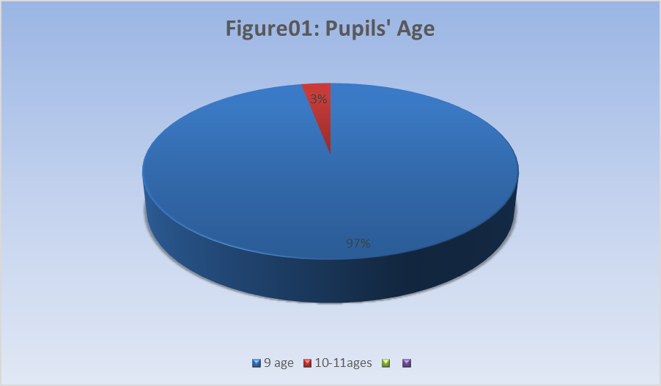

The first question concerned the pupils’ age. It was found that most of them were 9 years old, while the rest of the pupils constituted a percentage of 3% of their ages between (10-11), who repeated the fourth year.

**2. Gender**

**Table N°02: Pupils’ gender**

|  |  |  |
| --- | --- | --- |
| **Gender** | **Numbers** | **Parentages** |
| **Female** | 36 | 57% |
| **Male** | 27 | 43% |
| **Total** | 63 | 100% |

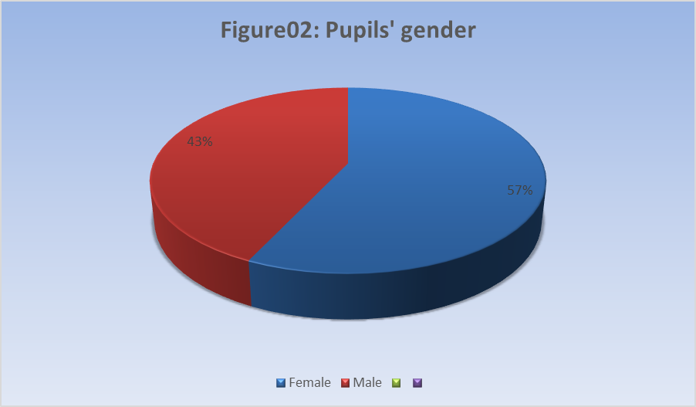

The largest percentage was for females, reaching (57%), while the remaining percentage was (43%) for males.

**3- Do you like the English language?**

**Table N°03: Pupils’ attitude toward English language**

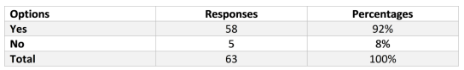

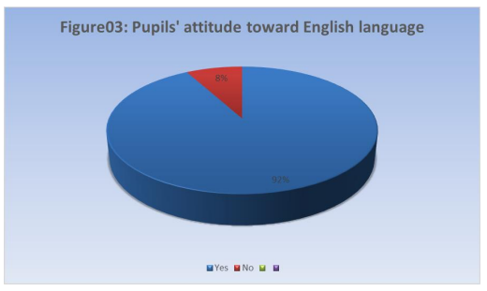

58 pupils (92%) respondedthatthey love the English languagedespitefacingsomedifficulties.

**4- Have you ever heard of the English language before?**

**Table Nº4: Pupils’ prior knowledge of the English language**

|  |  |  |
| --- | --- | --- |
| **Options** | **Responses** | **Percentages** |
| **Yes** | 10 | 16% |
| **No** | 53 | 84% |
| **Total** | 63 | 100% |

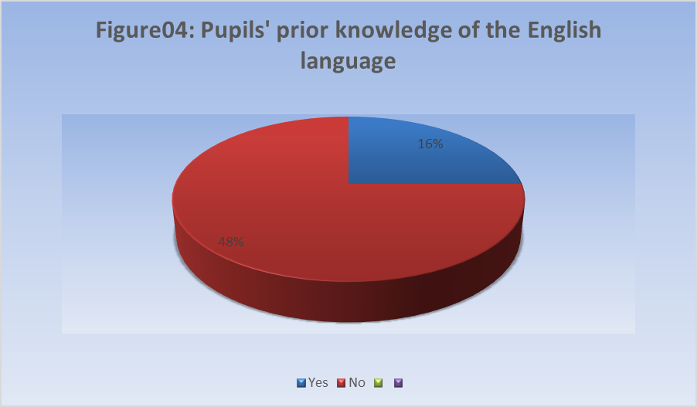

English isconsidered a new languagethatis not heard by fourth- year primaryschoolpupils, as the percentage of answerssaying “no, we have neverheard of itbefore” reached 84%.

**5- Have your parents asked you to read a short story in English?**

**Table N°05: Pupils’ results in asking their parents to read short stories in English**

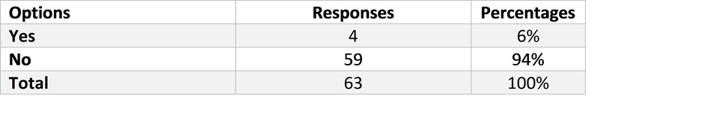

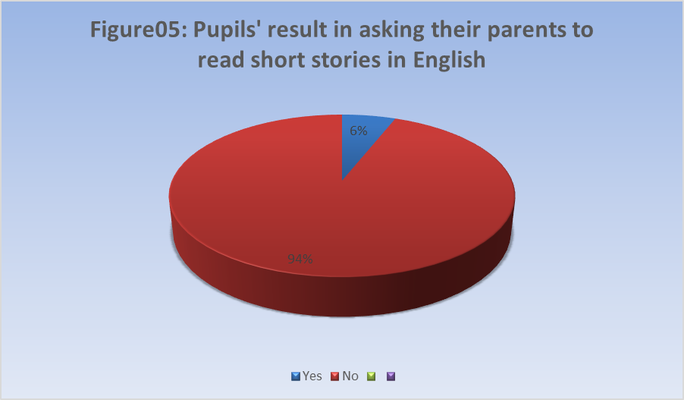

There is no culture of reading short stories among many parents, as it constituted a very large percentage when pupils answered (94%) that their parents do not ask them to read stories in English.

**6- Do you have encouragements from your parents to learn English?**

**Table N°06: Role of parents in encouraging their children to learn English language**

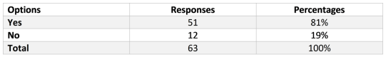

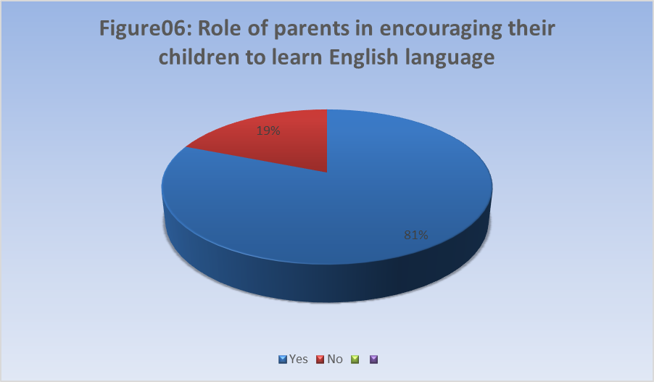

Most of the pupils 51 (81%) answered that their parents encourage them to learn English, and this is a positive thing that can confront the difficulty of reading for most pupils.

**7- If the teacher asked you to improve your reading level in return, would you care and take the initiative to do so?**

**Table N°07: Pupils’ interest in improving reading in return**

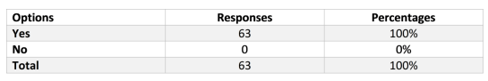

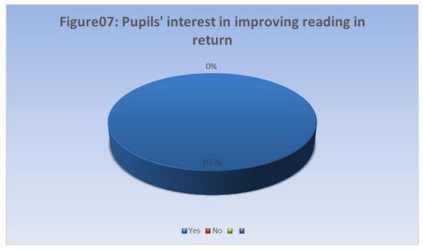

The largest percentage (100%) was when analyzing samples, and the largest percentage was when improving reading. Whereas, everyone said yes that they would be interested.

**8-How often do you watch cartoons or play games in English?**

**Table N°08: Frequency of pupils for watching cartoons or playing games in English**

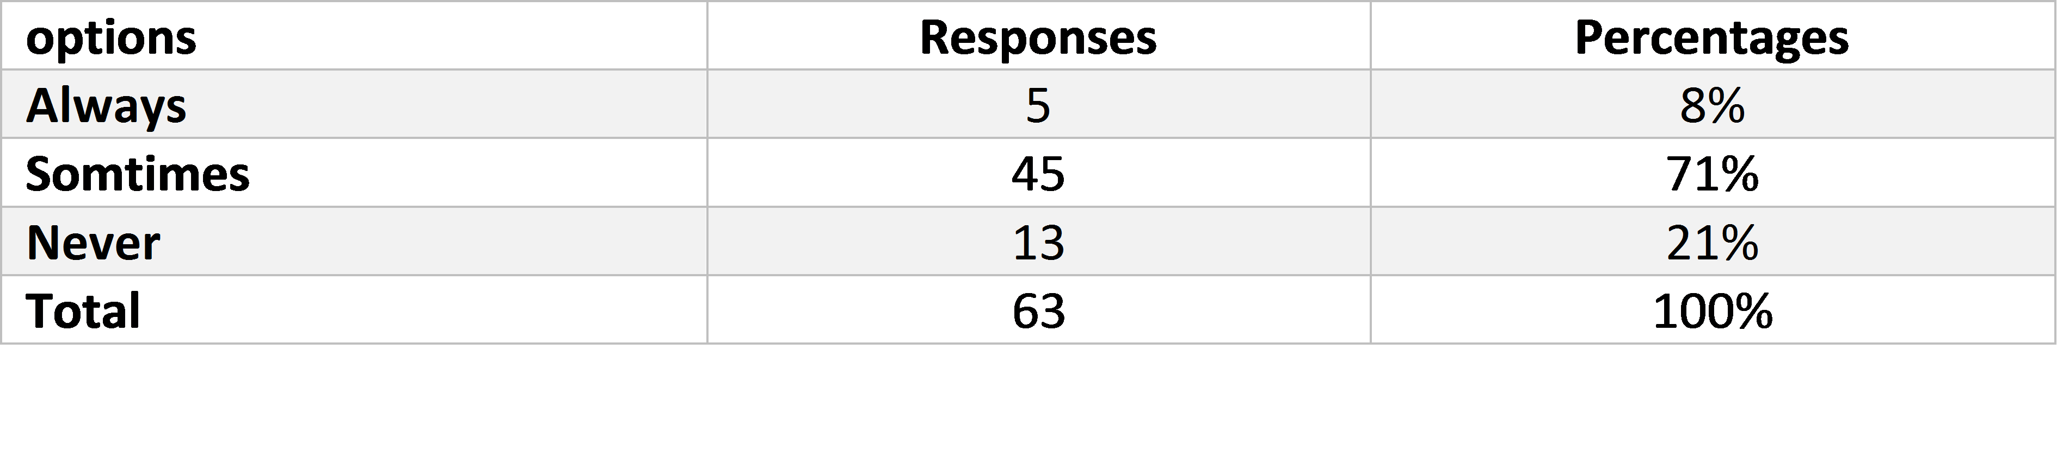

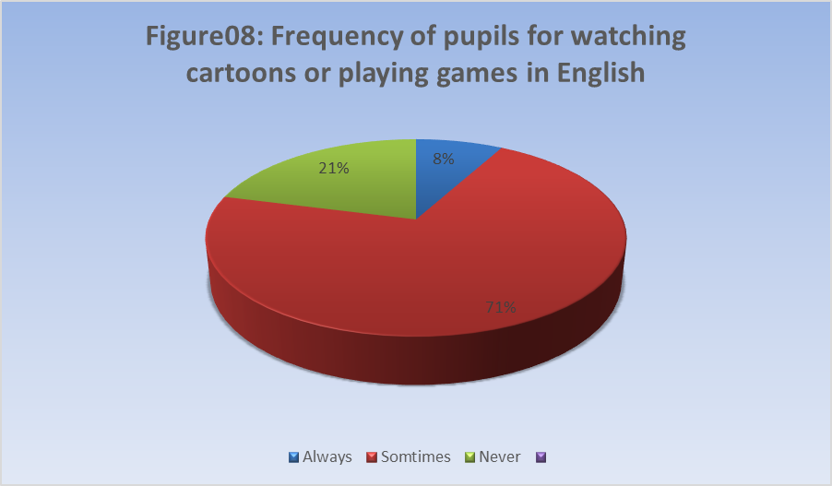

It is known that children love to watch cartoons, playing games, and despite this, significant percentages when they answered about playing games and watching cartoons in English were (8%), always, sometimes, (71%), never (21%).

**9- What do you feel when your teacher asks you to read words or sentences in English?**

**Table N°09: Pupils’ feelings about reading in English**

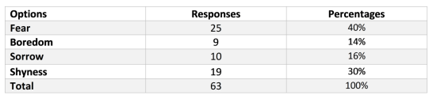

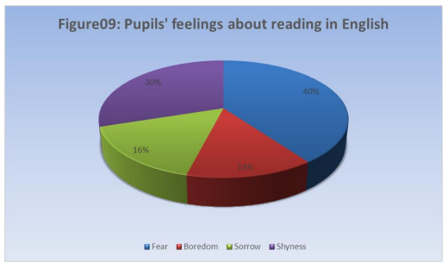

When this question was asked, it became clear that most of the pupils have a psychological problem. When the teacher is asked to read words or sentences, he feels fear (40%) and even shy, as it reached (30%).

**10- What is the first thing you think of when you are asked to read a text? Is your fear of reading text in English caused by?**

**Table Nº10: Reasons for pupils’ fear when asked to read a text in English**

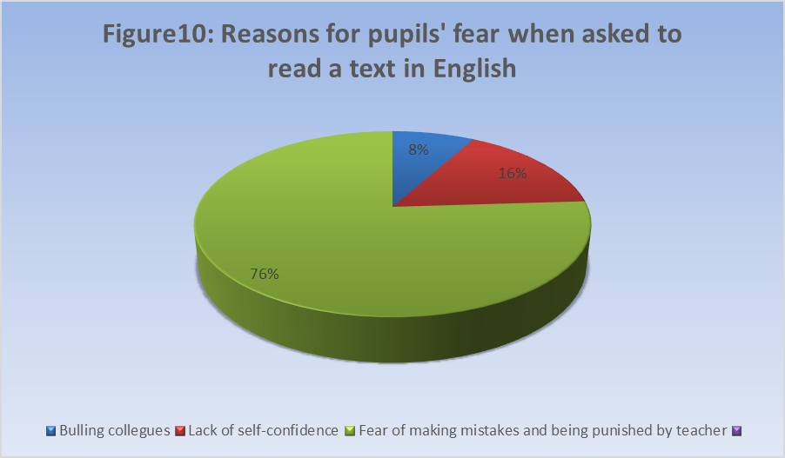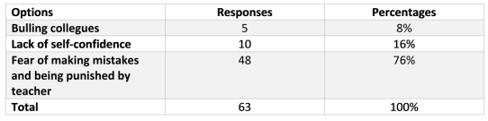

As usual, and with the mention of fear, the students are still suffering from the problem of fear, as (76%) of the pupils reported that they are afraid of making a mistake and of being punished by the teacher. This became clear when they answered the question of fear of reading an English text resulting from options being given, and percentages weakened when there was a lack of self-confidence (16%) and bullying by friends (8%).

**11- What do you turn to when you feel reading difficulty?**

**Table N°11: Pupils’ reaction when they feel difficulty in reading**

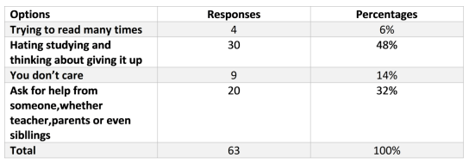

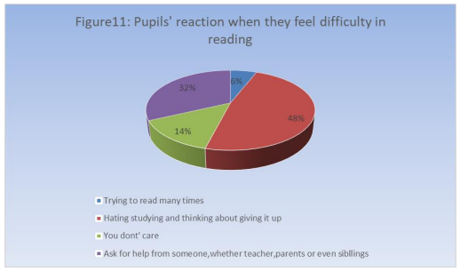

The percentages differed regarding when pupils feel difficulty in reading, what should they do? 30 pupils (48%) answered that they hate studying and are thinking about abandoning it, and the smallest percentage was at only four pupils (6%) in reading many times, 9 pupils (14%) did not care about that, 20 students, (32%) answered, that they ask for help from others, whether a teacher or Parents.

**12- What is the thing that can motivate you to improve your reading level?**

**Table N°12: Motivation for improving Pupils’ reading level**

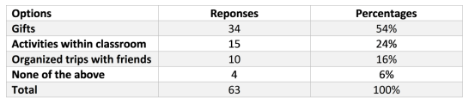

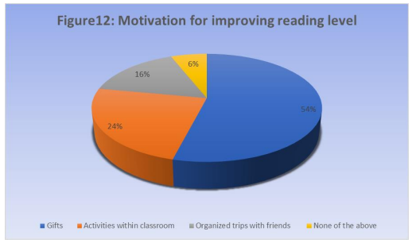

Encouragement has an important role in building the pupils’ abilities and skills, as 34 pupils’ (54%) responded that the gifts encourage them to improve their reading skills, 15 pupils (24%) included activities in the department, 10 students (16%) organized trips with friends, while four pupils (6%) responded none of the above.

**13- Reading English is:**

**Table Nº13: Pupils’ reading abilities**

|  |  |  |
| --- | --- | --- |
| **Options** | **Responses** | **Percentages** |
| **Easy** | 7 | 11,11% |
| **Difficult** | 29 | 46,03% |
| **Very difficult** | 27 | 42,86% |
| **Total** | 63 | 100% |

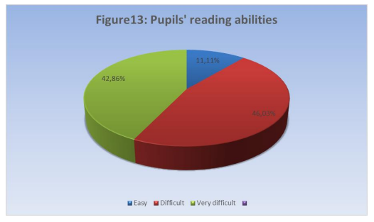

Reading in English is difficult for (46,03%) of the pupils, (42,86%) of them find it very difficult and (11,11%) of them find it easy.

**3.2 Interview with an English language teacher**

A questionnaire has been submitted to the English language teacher on Sunday, April 22, 2024. We also conducted an interview with her at Omar Al-Sasi School in Al-Guerarra after obtaining permission from the administration and the teacher.

The purpose of this interview is for the teacher to answer questionnaire questions about the students and obtain her opinions about what this research seeks to achieve, and to raise awareness of the difficulties facing fourth- year primary school pupils in the English language and in the reading skill. Before all of this, special questions were asked to the teacher about her academic degree, and even her university major, and she answered. To all questions, she said that she obtained a master’s degree as a graduate of linguistics from Ammar Al-Thaliji University in the state of Laghouat in 2015, but it was her first experience in education.

**Teachers’ Profile**

When conducting the interview with the English language teacher, he was asked some special questions.

* **How do you comment on your Pupils’ reading?**

The teacher answered that most of the students have difficulty reading, as their reading level is weak, and they need care and support to confront this problem.

* **Could you give the major reasons for the difficulty of reading for your pupils?**

Among the main reasons that cause the problem of difficulty reading among pupils are the problems, and these vary to the last, such as medical, environmental, etc., but she answered that the psychological problem has a major impact on his studies and reading level.

**- What do you think about pupils reading level is related to their family and surroundings?**

When the question was asked about the family and the environment, can it have an effect? She answered, “Yes, it does have an effect,” and I noticed that among my pupils. It cannot be said because the cause and effect are fundamental, but to a moderate extent because there is no encouragement from the parents for this language and there is no culture of the English language at home and in the environment.

* **Which category makes reading smoother for males or females?**

The teacher answered that we often find females who love languages from a young age, and I noticed that the female group has a greater motivation and keenness to learn the English language than the males, despite the presence of some obstacles.

**- Do you think that encouragement from parents can improve Pupils’ reading?**

The teacher said that encouragement from parents can improve reading skills, as children at this age need support and attention to see better results for their children.

* **Is it possible to say that the responsibility of the teacher alone sufficient to alleviate the difficulty of reading?**

She said that not all responsibilities fall on the teacher, because not all problems are solved by him, but rather require support from parents.

The teacher's responsibility is insufficient to improve reading and study skills in general

**-Do you have a special method you use it when you teaching?**

The teacher answered yes, that she uses the motivational approach despite the differences and multiplicity of problems among the pupils.

**3.3 Discussion of the Results**

The questionnaire is an important tool for collecting and analyzing information about the difficulties pupils face in reading skills in the English language at Omar Al-Sasi School in Al-Guerarra during the 2023-2024 academic year.

The total number of students is 63, including 27 males, representing (43%), and 36 females, who constitute the largest percentage of students, accounting for (57%). Most pupils are aged 9, and (03%) of those aged (10-11) are repeating the year.

58 pupils (92%) responded that they love the English language despite having difficulties in reading it. A large percentage of students (84%) said that they had not heard this language because it was not used inside or outside school, especially when they answered that their parents were not interested and did not ask them to read short stories in English. The percentage was also representative and was a very large percentage. (94%) Also, 51 pupils (81%) responded that their parents did not encourage them to read this language, even a little.

They made up the largest proportion of the study, and 100% of the 63 pupils were selected for their answers on reading development. On the other hand, everyone answered that they would be interested in it, and the children who are known for their love of cartoons and games, where the percentage of watching and playing in English reached (71%), said sometimes, never (8%). Most students feel afraid when the teacher asks them to read English words or phrases, 25 pupils (40%) answered that they are afraid. After this percentage, 19 students (30%) responded that they felt ashamed. Other percentages are divided between feeling bored and sad.

The reasons for fear of reading text in English are due to pupils’ fear of making a mistake and being punished by the teacher because it occupies a large percentage of (76%), while the percentages are limited to (16%), which is lack of self-confidence, and (8%) bullying among pupils.

Also, most of the large percentages are among the interests of pupils, as we find 30 pupils (48%) who answered that they hate studying and are thinking of leaving it because they feel difficulty in reading. Only four pupils (6%) responded that they read several times, and the majority of percentages were divided into lack of interest and asking for help from others.

The results are even more impressive when it comes to things that encourage pupils to improve their reading: gifts (54%), in-class activities (24%), and organized trips with friends (16%).

Reading in English was considered very difficult by 27 pupils (42,86%), 29 pupils (46,03%) considered it difficult, and the remaining percentage (11,11%) said it was easy.

**Conclusion**

This chapter consists of quantitative and qualitative analysis of data and analysis of results about the most important reading difficulties among Fourth-year primary school pupils in the English language, where the problems were summarized that most students suffer from psychological problems and even lack of language at home and in the environment, which has led to difficulty in reading and even learning it.

**GENERAL CONCLUSION**

Since ancient times, that is, about 14 centuries ago, reading has had great status and importance, and with it, God sent King Gabriel to the Messenger, may the best prayers and peace be upon him, and commanded him to read, and from here he urged Islam to learn the first thing in life, which is the request to read, and the evidence for this is the revelation of the first Surah. In the Holy Qur’an, it is the word “read”.

Reading is necessary, especially in the age of development in which we live, because it is the gateway to science and knowledge. Anyone can open the doors of science and technology.

However, this skill is hampered by many factors.

This research seeks to talk about the reading skill and its difficulties among Fourth-year primary school pupils.

A questionnaire was also conducted for the pupils and an interview with the English teacher

The hypotheses confirmed that the difficulty of reading is many and varied, but one of the most important reasons that constituted an obstacle for students, most of which are psychological problems such as fear and shyness. Also, the language is English, which is a new language for the pupils, which led to their lack of words and the ignorance of some of the letters.

This research also has a fundamental role, which is to try to find out the reasons and problems that students face in the English language, specifically in the reading skill, by looking at the main factors that led to their exposure to these difficulties.

The strategies also had an effective role in confronting reading difficulties and improving them to answer all research questions.

It can also be said that the fourth- year pupils at Omar Al-Sassi School in Guerrara faced many of these problems

The most important of which are the fear of making mistakes and anxiety. To avoid this problem, the teacher must give sufficient time and attention to each pupil and instill a spirit of self-confidence in him, and provide hours dedicated only to reading and speaking, especially providing activities within the classroom such as listening to video and imitating letters and words.

As for their guardians, they must support them inside the home and give them complete love to avoid any psychological problem

Finally, reading is considered one of the most important skills because it can have an impact, whether negatively or positively. The teacher and parents must cooperate and support the future pupil to master reading and overcome all his fears.

**Bibliography**

**References**

1. Abbas, Pourhosien, G. & Narjes Banou, S. (2016). A study of factors Affecting EFL Learners’ Reading comprehension skill and the strategies for Improvement. *International Journal of English Linguistics. pp.181-183.*
2. Azlina. A. (2019). The problems in reading skills of English among rural primary school pupils. *RELIGACIÓN Revista de Ciencias Sociales y Humanidades*. *pp.150-151.*
3. Estika, S. (2018). Reading Comprehension Difficulties Encountered by English students of Universitas Islam Riau. *Journal of English Academic*. *p.16*
4. Fatih Koca, Ph.D. (2016). Motivation to Learn and Teacher-student Relationship. *Journal of International Education and Leadership. pp.7-9.*
5. Fikriani, I. A. &Aminun, O. (2019). Factors Affecting Pronunciation Difficulties of 8th Grade Students of MTSN palu Barat. *Journal of Foreign Language and Educational Research. pp.11-13.*
6. Nhi Huynh, N. (2021). A Study on Native-like Pronunciation Matters Encountered by Third-year English Majors at the University of Food Industry in Ho Chi Minh City. pp. 2-11
7. Pandya, D. P. (2018). Importance of Pronunciation in English Language Communication. 7 (2). pp.16-17
8. Shafaque, Z. & Md, M. (2016). Reading Difficulties of post-primary Learners and challenges faced by teachers in teaching reading: A study of Dhanbad District. *English for Specific Purposes World. pp.8-11.*
9. Teguh, B. (2014). Reading Strategies in EFL Classroom: A Theoretical Review. *Web: cendekia.pusatbahasa.or.id. pp.198-200.*
10. Tekle, M. &Geberew, T. M. (2022). Early Reading Difficulties among Quilliso Primary School Children in Ethiopia: Reflections from teachers’ children and parents. *Modern Applied Science. p.42.*
11. The Holy Quran. Surah Al-Alaq (1-5).

**Appendices**



**University of Ghardaia**

**Faculty of letters and languages**

**Department of English language**

**Pupils’ questionnaire:**

Dear Pupils’:

-you are invited to answer the following questions that will be asked to you about the difficulty of reading in English. Put mark(x) ​​in the appropriate box.

1-Age…

2-Gender

-Male

-Female

3- Do you like the English language?

Yes

No

4- Have you ever heard of the English language before?

Yes

No

5-your parents ask you to read a short story in the English language?

Yes

No

6-Do you have encouragement from your parents to learn the English language?

Yes

No

7-If the teacher asked you to improve your reading level in return, would you care and take initiative to do so?

Yes

No

8-How often do you watch cartoons or play games in English?

Always

Sometime

Never

9-What do you feel when your teacher asks you to read words or sentences in English language?

a-the fear

b-Boredom

c-Anger

d-Sorrow

e- Shyness

10-What is the first thing you think of when you are asked to read a text?

Is your fear of reading text in English caused by?

a- Bullying colleagues

b- Lack of self-confidence

C- Fear of making a mistake and being punished by the teacher

11-When you feel difficulty reading, what do you turn to?

a-Trying to read many times

b-Hating studying and is thinking about giving it up

c-You don't care

d- Ask for help from someone, whether a teacher, parents, or even siblings

12-What is the thing that can motivate you to improve your reading level?

a-Gifts

b-Activities within the classroom

c- organized trips with friends

d-None of the above

13-Reading English is:

a-easy

b-difficult

c-very Difficult

- How do you comment on your students’ reading?

- Could you give the major reasons for the difficulty of reading for your students?

- What do you think about students reading level is related to their family and surroundings?

-Which category makes reading smoother for males or females?

- Do you think that encouragement from parents can improve students’ reading?

-Is it possible to say that the responsibility of the teacher alone sufficient to alleviate the difficulty of reading?

-Do you have a special method you use it when you teaching?

**الملخص**

تناولنا في دراستنا هذه بعض الصعوبات التي يوجهها تلاميذ الرابعة ابتدائي في مهارة القراءة في اللغة لإنجليزيه واجرينا بعض الفرضيات ان التلاميذ يواجهون مشاكل نفسية طبية عائلية وحتى محيطية بيئية ولتأكيد هذه المعلومات قمنا بإجراء استبيان للتلاميذ وشرح كل أسئلة لاستبيان لهم ومقابلة مع معلمة اللغة لإنجليزيه بمدرسة عمر الساسي بالقرارة

قمنا بطرح بعض من الأسئلة على تلاميذ الرابعة ابتدائي واستجوبنا معلمة اللغة لإنجليزيه حول ما يسعى اليه مبحثنا هذا وهو الصعوبات التي يواجهها التلاميذ في القراءة وينقسم هذا العمل إلى جزء نظري ويتضمن فصلين. الفصل الأول تناولنا فيه القراءة وأهميتها وحتى استراتيجيات لتحسينها. أما الفصل الثاني فقد تناول علاقة المعلم بالطلاب والتحديات التي يواجهها المعلم. أما الفصل الثالث والأخير فقد احتوى على الدراسة التطبيقية التي قمنا فيها بتحليل الاستبيان الذي قدمناه للتلاميذ كما كان الهدف من مقابلة معلمة المادة هو اخذ رأيها حول المشاكل والصعوبات التي يواجهها التلاميذ في مهارة القراءة في اللغة لإنجليزيه ومن خلال النتائج التي خرجنا بها اتضح أن هناك بعض العوامل المؤثرة على مهارة القراءة لدى التلاميذ وتختلف من تلميذ لآخر كما قمنا باقتراح بعض لإستراتيجيات والتقنيات لتحسين القراءة عند التلاميذ

**الكلمات المفتاحية**:

مهارة القراءة‚ تلاميذ الرابعة ابتدائي‚ مشاكل نفسية‚ لاستراتيجيات والتقنيات