People’sDemocraticRepublicofAlgeria

MinistryofHigherEducationandScientificResearch
University Of Ghardaia

FacultyofLettersandLanguages

DepartmentofEnglish

DissertationSubmittedinPartialFulfilmentoftheRequirementsfortheDegreeofMasterinDidactics

Specialty:English
Option:DidacticsofForeignLanguages

Challenges of Teaching English as a Foreign Language to Third Year Pupils of the Algerian Primary School – The Case of Primary School Teachers of English in Ghardaia

Submittedby: BoardofExaminers:

- NadiaGUERGAB
- NabilCHENINI —DrAhmedNoureddineBELARBI
UniversityofKasdiMerbah,Ouargla(Chairperson)
  - DrSmailHADJMHAMMED-UniversityofGhardaia(Examiner)
  - DrMalikaKOUTI-Universityof Ghardaia(Supervisor)

AcademicYear2022/2023
Contents
Contents………………………………………………………………………….……..... I
Dedication ……………………………………………………………………………… IV
Acknowledgements…………………………………………………………………........ VI
List of Figures and Tables ………………………………………………………………. VII
List of Abbreviations.......................................................................................................... IX
Abstract……………………………………………………………………………….….. X
General Introduction………………………....................................................................... 1
CHAPTER ONE: Teaching English as a Foreign/Second Language to Young
Learners ………………………………………………………………………………… 6
Introduction ……………………………………………………………………………….6
1.1. English as an International Language ………………………………………………..8
1.2. Teaching English as a Foreign Language ……………………………………………9
1.3. Language Acquisition Theories ………………………………………………………10
1.4 The Current Methods of Foreign/Second Language Teaching ……………………….11
1.4.1. Total Physical Response (TPR) …………………………………………………… 11
1.4.2. Communicative Language Teaching (CLT) ………………………………………. 12
1.4.3. Task-Based Language Teaching (TBLT) …………………………………………. 14
1.4.4. Content and Language Integrated Learning (CLIL) ………………………………. 15
1.4.5. Competency-Based Language Teaching (CBLT) …………………………………. 16
1.5. Teaching English as a Foreign/Second Language to Young Learners ………………. 17
1.5.1. The Advantages of Learning a Second Language at an Early Age ………………... 19
1.5.2 Teaching the Four Skills ……………………………………………………………. 20
1.5.3 Learning Styles of Young Learners …………………………………………………23
1.5.4. The Main Challenges of Teaching English to Young Learners ……………………. 23
1.6. Gaps in the Literature and Research Needs …………………………………………... 25
Conclusion ………………………………………………………………………………… 26
CHAPTER TWO: Methodology and Results ………………………………………….. 27
Introduction ……………………………………………………………………………….. 27
Part One: Research Design and Methodology ………………………………………… 28
1. 1. Research Paradigm and Approach …………………………………………………… 28
1. 2. Research Design and Methods ……………………………………………………….. 29
1. 3. Sampling and Sample Selection ………………………………………………………30
1. 4. Data Collection Methods ……………………………………………………………… 31
1. 5. Tools for Data Collection ……………………………………………………………... 32
1. 6. Data Analysis Methods ……………………………………………………………….. 33
Conclusion ………………………………………………………………………………… 34
Part Two: Study Findings, Analysis, and Discussion………………………………….. 34
Introduction ………………………………………………………………………………… 34
2.1. Description of the Sample …………………………………………………………….. 34
2.2. Description of the Questionnaire ……………………………………………………… 35
2.3. Analysis of the Collected Data ………………………………………………………… 37
2.3.1. Data Analysis of the Questionnaire’s Findings …………………………………….. 37
2.3.2. Class Observations and Data Analysis ……………………………………………… 63
2.4. Discussion and Interpretation of Results ……………………………………………… 64
2.5. Implications and Recommendations for Future Research ……………………………. 72
Conclusion ………………………………………………………………………………….. 73
General Conclusion ………………………………………………………………………… 75
Bibliography ………………………………………………………………………………... 77
Appendices ……………………………………………………………………………….. 80
ملخص ………………………………………………………………………………………89

Dedication
To Allah, the Most Gracious and Most Merciful.
To my loving mother, who has been my guiding light.
To my father, whose spirit continues to inspire.
To my husband, whose love and constant support have fueled my determination.
To my four beautiful daughters Djihad, Rania, Israaand Raouane, whose presence brings joy and inspiration to my life.
To my loving son Abdelkader, who has brought boundless love and happiness into my life.
To my beloved brothers and sisters, who enlighten my life.
To my colleague and partner, who expressed much collaboration, and commitment.
This dissertation is dedicated to each of you.

THANK YOU

Mrs. Nadia GUERGAB

To my beloved parents, who gave me everything, and never asked for anything in return. Thank you for your prayers and for teaching me to believe in myself and to achieve my dreams.
To my lovely wife, who has always been a source of support and encouragement through the challenges of life. I am truly blessed to have you in my life.
To my precious gifts, my son DiyaaEddineand my daughter Chahd. You are the source of my inspiration and pride.
To my colleague and partner in this research study, your hard work and commitment are greatly appreciated.

Mr. Nabil CHENINI

Acknowledgements

We express our sincere gratitude to our supervisor for their unwavering guidance, expertise, and encouragement throughout the entire dissertation process.

We extend our heartfelt appreciation to the examiners for their time, dedication, and meticulous evaluation of our dissertation.

We would like to thank our teachers whose guidance, wisdom and dedication shaped our journey.

We would like to thank the primary school teachers of English who generously shared their experiences, insights, and expertise.

List ofTables
1. Gender Distribution…………………………………………………………. | 37
2. Length of Teaching Experience of the Participants …………………….….. | 41
3. Professional Supervision …………………………………………………… | 43
4. Number of Assigned Classes……………………………………………….. | 45
5. The Average Number of Pupils per Class ………………………………….. | 45
6. Maintaining Discipline in the Classroom ………………………………….. | 46
7. Availability of Space for Group Work and Classroom Projects…………... | 47
8. Pupils’ Participation ……………………………………………………….. | 49
9. Teachers’ Opinions about the Textbook………………………..…………. | 51
10.Sufficiency of Time for Planning Lessons …………………………………… | 54
11.Satisfaction with Working Schedule …………………………………….……. | 55
12.The Interference of L1 and/or French with the Pupils’ Use of English………. | 56
13.The Need to Use L1 and/or French …………………………………………… | 58
List of Figures
1.Age Distribution among Participants……………………………………….. 38
2.Educational Qualifications of the Participants……………………..………… | 38
3.Work Districts of the Participants ……………………………………..…….. | 39
4.Number of Schools Assigned to Teachers……………………………..……. | 40
5.Participants’ Experience in Teaching English……………………..…………. | 41
6.Teachers’ Participation in Teacher Training Programmes ………...…………. | 42
7.Teachers’ Satisfaction with the Training Programme …………..…………….. | 42
8.Support Needed by Teachers to Improve their Performance…………………… | 44
9.The Negative Impact of the Number of Classes on Teaching Performance..…. | 45
10.Teachers’ Opinions about the Average Number of Pupils per Class…………… | 46
11.Facing Challenges in Engaging Pupils and Maintaining their Attention..………. | 48
12. Pupils’ Interest in Learning English …………………………………………… 49
13.Pupils’ Interest in the Textbook………………………………………………… 51
14.Teacher’s Opinions about Teaching Hours…………………………..……….53
15.Working Hours per Week ……………………………………..………………54
16.The Burden of Learning both English and French by Pupils……………………56
17.The effect of L1 and/or French on Pupils’ Learning of English …………………57
18.The Most Practised Language Skills…………………………………………. ..59
19.The Least Practised Language Skills …………………….………………………59
20.Difficult Language Skills to Teach …………….…………………………….60
21.Pupils’ Learning Styles……………………….………………………………61
22.Ways of Assessing Pupils’ English Proficiency ……………………………... 61

List of Abbreviations
CLT - Communicative Language Teaching
EFL - English as a Foreign Language
ELP - English Language Proficiency
ELT - English Language Teaching
ESL - English as a Second Language
ESOL - English for Speakers of Other Languages
ICT - Information and Communication Technology
L1 - First Language
L2 - Second Language
SLA - Second Language Acquisition
TEFL - Teaching English as a Foreign Language
TESL - Teaching English as a Second Language
TESOL - Teaching English to Speakers of Other Languages
TOEFL - Test of English as a Foreign Language
TPR - Total Physical Response
TYPP - Third Year Primary Pupils

Abstract
This dissertation investigates the challenges faced by primary school teachers in teaching English to third-year pupils and explores the strategies and pedagogical approaches used to overcome these challenges. The study aims to provideinsights into the specific difficulties encountered in English language instruction at this stage of primary education and to offer practical recommendations for enhancing the teaching and learning experience. A mixed-methods approach was employed in the research methodology, combining surveys and classroom observations. Data was collected from a diverse group of teachers working with third-year pupils in various primary schools in the province of Ghardaia, and who were newly assigned during the academic year 2022-2023. The analysis of the data involved both qualitative and quantitative techniques to provide a comprehensive understanding of the challenges and effective practices.The findings reveal several significant challenges faced by teachers in teaching English to third-year pupils. These challenges include limited vocabulary acquisition, difficulties in sentence formation and grammatical structures, low motivation and engagement, and varying levels of language proficiency among students. The study identifies the underlying factors contributing to these challenges, such as inadequate resources, large class sizes, and limited instructional time.To address these challenges, teachers employ various strategies and pedagogical approaches. These include the use of interactive and engaging activities, differentiated instruction to cater to diverse learning needs, incorporating technology and multimedia resources, and fostering a supportive and inclusive classroom environment. The study highlights the importance of teacher professional development and collaboration in effectively implementing these strategies.The implications of the findings suggest the need for curriculum enhancements, resource allocation, and support for teachers in effectively teaching English to third-year pupils. This study contributes to the existing literature on English language education in primary schools and provides practical insights for policymakers, curriculum developers, and educators to improve the quality of English instruction in the third-year level.

Keywords:English language teaching, primary education, challenges, third-year pupils.

General Introduction
Introduction
In today's interconnected world, language plays a crucial role in facilitating communication, cultural exchange, and global understanding. The ability to effectively communicate in multiple languages is increasingly recognized as an essential skill, and this recognition has led to a growing interest in language learning and teaching. This thesis aims to inquire the challenges and opportunities of teaching English as a foreign or second language to third year primary pupils, with a specific focus on the Algerian context.
Background
Language policy and planning in Algeria have undergone significant changes in recent years, particularly regarding the teaching of English in the educational system. The introduction of English language instruction in Algerian primary schools marks a significant milestone in the efforts to equip students with the necessary language skills to succeed in a globalized world. However, the effective implementation of this policy presents various challenges that require exploration and understanding.
Statement of Purpose
The purpose of this thesis is to investigate the challenges associated with teaching English to third year pupils in Algerian primary schools. By examining the experiences and perspectives of teachers, exploring the learning environment, and analyzing the teaching methodologies and strategies employed, this research aims to provide valuable insights into the dynamics of English language instruction in this context.

Statement of Problem
The teaching of English to young learners poses unique challenges that need to be addressed to ensure effective language acquisition and learning outcomes. Understanding these challenges and identifying potential solutions can contribute to the development of more targeted and impactful teaching practices. Therefore, the central problem addressed in this thesis is: What are the main challenges faced by teachers in teaching English to third-year primary pupils in Algerian primary schools, and how can these challenges be effectively addressed?
Motivations
The motivations behind this research arise from the recognition of the importance of English language proficiency for young learners and the need to optimize English language instruction in Algerian primary schools. By examining the challenges and opportunities of teaching English to primary pupils, this research seeks to contribute to the improvement of language teaching practices, teacher training programs, and curriculum development in the Algerian educational context.
Structure of the Dissertation
This dissertation is structured as follows:
General Introduction - It provides an overview of the research topic, including the background, statement of purpose, statement of the problem, motivations, structure of the dissertation, limitations of the study and definitions of terms.
Chapter 1: Literature Review - This chapter reviews the existing literature on teaching English to young learners, explores relevant theoretical frameworks, and examines previous studies conducted in similar contexts.
Chapter 2: Methodology and Results - This chapter is dealt with in two parts. Part one presents the research design, data collection methods, and data analysis techniques employed in this study. Part two presents the findings of the research, analyzes the collected data, discusses the key themes and insights that emerged from the analysis and considers the implications and recommendations for improving English language instruction for primary pupils in Algerianschools.
Conclusion - This final point summarizes the main findings of the research, stresses the contributions to the field, acknowledges the limitations of the study, and suggests avenues for future research.
Limitations of the Study
It is important to acknowledge the limitations of this study. Due to time constraints and resource limitations, the research was conducted in a specific region with a good number of primary schools. Additionally, the teachers showed reluctance in providing responses and cooperating, which caused the survey to take more time than planned to get the relevant number of responses and start work on data analysis.
Definition of Terms
Throughout this thesis, certain terms are used consistently and have specific meanings within the context of the research. To ensure clarity, the following terms are defined:
Young learners: Refers to primary school students, typically aged between 6 and 12 years old.

English as a foreign language (EFL): Refers to the learning and use of the English language in a non-English-speaking country where English is not widely used in daily life.
English as a second language (ESL): Refers to the learning and use of the English language in a country where English is an official or widely spoken language.
Language policy and planning: Refers to the deliberate actions, decisions, and strategies implemented by educational institutions, governments, and policymakers to regulate language use, teaching, and learning within a particular context.
Language proficiency: Refers to the level of language competence or skills that an individual possesses in a particular language, such as listening, speaking, reading, and writing.
Teaching methodologies and strategies: Refers to the approaches, techniques, and instructional methods used by teachers to facilitate language learning and promote effective language acquisition.
Curriculum development: Refers to the process of designing, organizing, and implementing a comprehensive plan for teaching and learning, including the selection of appropriate learning objectives, content, and assessment methods.
Teacher training programs: Refers to the professional development programs and initiatives aimed at enhancing the knowledge, skills, and competencies of teachers in their instructional practices and pedagogical approaches.
It is essential to establish a common understanding of these terms to ensure clarity and consistency in the subsequent discussions and analysis conducted in this dissertation.
In conclusion, this thesis aims to examine the challenges and opportunities of teaching English to TYPP in Algerian primary schools. By exploring the policy of teaching English, analyzing the introduction of English language instruction, and investigating the experiences and perspectives of teachers, this research seeks to contribute to the understanding of effective language teaching practices and to add to future curriculum development and teacher training programs. The subsequent chapters will look into the literature review, methodology, findings and analysis, implications and recommendations, and conclude with reflections on the research conducted.

CHAPTER ONE: Teaching English as a Foreign/Second Language to Young Learners
Introduction
The policy of teaching English in Algeria reflects the recognition of English as a global language and its importance in various domains, including education, economy, and international communication. The policy aims to equip Algerian students with English language skills to enhance their opportunities and competitiveness in the globalized world.
In the context of primary education, the introduction of English language to third-year pupils in Algerian primary schools is a significant step. These pupils, typically aged around 8 to 9 years old, are considered young learners who are in the early stages of language development and acquisition.
The decision to introduce English language at this stage is based on the understanding that early exposure to a foreign language can facilitate language learning and promote better language proficiency in the long term. By starting English language instruction at a young age, learners have the opportunity to develop foundational language skills, such as listening, speaking, reading, and writing, which will be further developed in subsequent years.
Introducing English language to third-year pupils in primary schools is aligned with the curriculum guidelines and educational objectives set by the Ministry of National Education. The curriculum aims to provide a balanced approach to language learning, focusing on the communicative aspects of English language skills. It emphasizes interactive and student-centered teaching methods, promoting engagement and active participation among young learners.
However, the implementation of this policy may encounter certain challenges. Limited resources, such as textbooks and teaching materials, can pose obstacles to effective English language instruction. Additionally, the availability of qualified English language teachers who are trained to teach young learners may also be a concern.
To address these challenges, efforts are being made to enhance teacher training programs, develop age-appropriate and culturally relevant teaching materials, and provide ongoing support and professional development opportunities for English language teachers in primary schools.
In fact, teaching English as a Foreign/Second Language to Young Learners is an important and challenging field of education. It can be a challenging yet rewarding experience. The purpose of teaching English to young learners is to develop their language skills in a fun and engaging way while also helping them to become confident and effective communicators. Young learners have unique needs and interests that must be taken into account when designing and delivering English language instruction.
When teaching English to young learners, different theories of language acquisition are used, and different pedagogical approaches and techniques for teaching young learners are explored, including task-based language teaching, communicative language teaching, and content-based instruction. It is important to use materials and activities that are age-appropriate and relevant to their lives and interests.
Moon, J. (2005) discusses factors that affect children's language learning, including age, motivation, cognitive development, and learning environment. She also explores different approaches and techniques for teaching young learners, and the importance of creating a positive and supportive learning environment. Nunan, D. (1999) refers to issues related to classroom management, assessment, and teacher development in the context of teaching English to young learners.
Teaching English as a Foreign/Second Language to Young Learners is an exciting and rewarding field that requires creativity, patience, and a commitment to meeting the unique needs of young learners.

1.1 English as an International Language
English is currently the most widely used language in the world. In the early 2000s, there were about 1.5 billion people around the world who speak English (Crystal, 2003 p. 6), with approximately 375 million being native speakers (Graddol, 2000, p. 10). English is the primary language of business, science, technology, and the internet, and is also widely used in tourism, media, and entertainment industries.
English as an International Language (EIL) refers to the use of English as a global means of communication, which is no longer tied to a specific culture, region, or native speaker community. Because of its widespread use, English has become the dominant international language, serving as a lingua franca between people from different countries who do not share a common language. Crystal, D. (2003) argues that English has become the dominant international language and serves as a lingua franca in various domains such as business, science, education, and entertainment.
As a result, the teaching and learning of English as a second or foreign language has become increasingly important in many countries around the world. Jenkins, J. (2006) argues that English as an International Language should be taught in a way that acknowledges its variability and diversity across cultures and contexts. McKay, S. L., &Bokhorst-Heng, W. D. (2008)emphasize the need for teachers to be aware of the sociolinguistic contexts in which English is used, and to teach English as a tool for communication across cultures, rather than as a cultural identity marker.
Those studies assert the need for a culturally and linguistically sensitive approach to teaching English as an International Language, which acknowledges the diversity and variability of English use across different cultures and contexts.

1.2. Teaching English as a Foreign Language
Teaching English as a Foreign Language (TEFL) is the practice of teaching English to non-native speakers, Kumaravadivelu (2006), in a country where English is not the primary language, Harmer (2007). The goal of TEFL is to help students develop their language skills, including reading, writing, listening, and speaking, in order to communicate effectively in English.
TEFL is a significant field of education that plays a crucial role in promoting global communication and understanding. Through effective teaching and learning of English as a Foreign Language, students can develop their language skills and increase their opportunities for education, employment, and cultural exchange.
TEFL teachers may work in a variety of settings, including public and private schools, language schools, and universities. They are typically knowledgeable of language acquisition theory, lesson planning, classroom management, and teaching methodology. They may work with students of all ages, from young children to adults, and from beginner to advanced levels of English proficiency.
TEFL involves a range of teaching methods and approaches, depending on the needs and goals of the students. Some common TEFL approaches include communicative language teaching, task-based language teaching, and content-based language teaching, Harmer, J. (2015). These approaches emphasize the importance of using language in meaningful contexts, with a focus on developing real-world communication skills.
The role of the teacher, the learner, and the social and cultural context in language teaching and learning is crucial, and understanding language learning and teaching theories and research in the context of TEFL is very important in addition to a flexible and adaptable approach to language teaching that takes into account the diverse needs and backgrounds of learners.

1.3 Language Acquisition Theories
There are several prominent theories of language acquisition that help explain how individuals acquire and learn languages. Some of the key theories include:
➢ Behaviorist Theory: This theory, associated with behaviorist psychologists like B.F. Skinner, suggests that language acquisition is a result of conditioning and reinforcement. It emphasizes the role of environmental stimuli and rewards in shaping language development.
➢ Innatist Theory (Universal Grammar): Proposed by linguist Noam Chomsky, this theory suggests that humans are born with an innate ability to acquire language. It posits the existence of a universal grammar that provides the underlying structure and rules of all languages.
➢ Cognitive Theory: Cognitive theories, such as Jean Piaget's theory of cognitive development, emphasize the role of cognitive processes in language acquisition. These theories suggest that language development is closely linked to overall cognitive development and the child's ability to understand and process information.
➢ Interactionist Theory: Interactionist theories, including the social interactionist theory proposed by Lev Vygotsky, emphasize the role of social interaction and communication in language acquisition. These theories emphasize the importance of social interaction, cultural context, and meaningful communication in language learning.
➢ Connectionist Theory: Connectionist theories, also known as neural network theories, view language acquisition as a result of neural connections and patterns. They propose that language learning involves the formation and strengthening of connections between different elements of language.

These theories provide different perspectives on how language is acquired and learned. It is important to note that language acquisition is a complex and multifaceted process, and a combination of these theories may contribute to a more comprehensive understanding.

1.4. The Current Methods of Foreign/Second Language Teaching
There are several methods and approaches to teaching foreign/second languages, and the most current methods combine elements from different approaches to provide a more comprehensive language learning experience. Here are some of the current methods of foreign/second language teaching:

1.4.1. Total Physical Response (TPR)
Total Physical Response (TPR) is a language teaching method that was developed by James Asher in the 1970s. It is based on the idea that language learning can be facilitated by incorporating physical movement into the learning process.
The TPR approach operates through the use of basic instructions, such as "Stand up", "Close your book", and "Go to the window and open it", prompting the student to respond physically. This technique emphasizes the significance of auditory understanding and the value of learning through movement.
The TPR method is characterized by the following principles:
➢ Listening comprehension comes before speaking.
➢ Language is learned through action, or physical movement.
➢ Repetition is essential for language acquisition.

The students listen and respond to the teacher's commands, and they learn the meaning of the words through the physical actions they perform.
TPR is particularly effective for teaching vocabulary, especially for young learners or beginners. It can also be used to teach grammar and sentence structures by incorporating more complex actions or sequences of actions.
While TPR has been widely used and is considered effective for some learners, it is not without its limitations. Some learners may find it repetitive or boring, and it may not be appropriate for learners who have physical limitations. In addition, it may not be suitable for teaching more complex language structures or for developing speaking skills.
TPR is a method that can be effective for some learners, especially those who enjoy physical movement and hands-on learning.

1.4.2. Communicative Language Teaching (CLT)
Communicative Language Teaching (CLT) is a language teaching method that was developed in the 1970s in response to the perceived limitations of more traditional grammar-translation and audio-lingual methods. It is based on the idea that language learning is most effective when learners engage in meaningful communication in the target language.
The key principles of CLT include the following:
➢ Communication is the primary goal of language learning.
➢ Language is learned through using it in meaningful, real-life situations.
➢ Learners are encouraged to communicate with each other in the target language.
➢ Grammar and vocabulary are taught in context, through the use of authentic materials and activities.
➢ Learners are encouraged to take risks and make mistakes, in order to develop their communication skills.
In a CLT lesson, the focus is on communicative tasks that require learners to use the target language in real-life situations. For example, learners might engage in role-play activities, debates or discussions, in which they must use the language to accomplish a goal. The teacher acts as a facilitator, providing guidance and feedback as necessary, but allowing learners to take the lead in communication.
CLT has been widely adopted in language teaching and is considered an effective method for developing communicative competence in learners. It emphasizes the importance of meaningful communication and provides learners with opportunities to practice using the language in a variety of contexts.
However, CLT is not without its limitations. Some learners may find it difficult to participate in communicative activities if they lack confidence in their language skills, and it may not be appropriate for teaching more complex grammatical structures or for developing accuracy in the language. Additionally, some critics argue that CLT can result in a lack of attention to form and structure in the language.
CLT is a widely used and effective method for language teaching that emphasizes the importance of communication in language learning.

1.4.3. Task-Based Language Teaching (TBLT)
Task-Based Language Teaching (TBLT) is a language teaching method that was developed in the 1980s in response to the limitations of more traditional grammar-based language teaching methods. It is based on the idea that language learning is most effective when learners engage in tasks that require them to use the language to accomplish a goal.
The fundamental tenets of TBLT are as follows: Language is acquired through the use of language in meaningful tasks; tasks should be created to reflect real-life language use; learners should be encouraged to use the language creatively to complete tasks; and teachers should give students the chance to reflect on their language use and receive feedback.
In a TBLT lesson, the teacher gives the students a task to complete, such as organizing a party or giving directions. The students collaborate in groups or pairs to complete the task, communicating with one another in the target language. The teacher offers direction and feedback as needed, and he also encourages the students to consider their language use and determines areas for improvement.
TBLT emphasizes the importance of using the language in meaningful, real-life contexts and gives learners opportunities to practise using the language in a variety of contexts. It is widely used in language teaching and is considered an effective method for developing communicative competence in learners.
Nevertheless, TBLT has some drawbacks, including the fact that some learners may find it challenging to participate in task-based activities if they lack confidence in their language abilities and that it may not be appropriate for teaching more complex grammatical structures or for improving language accuracy.
All in all, task-based language teaching (TBLT) is a popular and successful approach for teaching languages that emphasizes the value of applying the language to real-world situations.

1.4.4. Content and Language Integrated Learning (CLIL)
Content and Language Integrated Learning (CLIL) is a method for teaching languages that was created in the 1990s in response to the need for students to improve their language abilities while also learning content in a subject area. The concept behind CLIL is that language and content are intertwined and that students can simultaneously improve both their language and subject knowledge.
The following are some of the main principles of CLIL:
➢ Language is learned through the use of authentic materials and activities.
➢ Learners are encouraged to use the language to communicate about content in a subject area.
➢ Language and subject matter are given equal importance in the learning process.
In a CLIL lesson, students are exposed to material from a subject area—such as science or history—and are required to use the language to comprehend and discuss it. The teacher offers support and feedback as needed, and encourages students to evaluate their language use and identifies areas for development.
CLIL emphasizes the importance of using language in authentic contexts and offers learners opportunities to practise using the language in a variety of subject areas. It is widely used in language teaching and is considered an effective method for developing both language and subject knowledge in learners.
There are some learners who might find it challenging to participate in CLIL activities if they lack background knowledge in the subject area, and it might not be appropriate to teach more advanced grammatical structures or to improve language accuracy.
In general, CLIL is a well-liked and successful method of teaching languages that emphasizes the significance of combining language and subject matter during the learning process.

1.4.5. Competency-Based Language Teaching (CBLT)
Language learning should be focused on the development of specific communicative competencies, such as the ability to initiate and respond to conversations, understand spoken and written texts, and express oneself in the language. Competency-Based Language Teaching (CBLT) is an approach to language teaching that focuses on developing learners' communicative competence in the language.
The following are some of the main precepts of CBLT:
➢ Learners are encouraged to use the language to communicate in a variety of contexts.
➢ Language learning is focused on the development of specific communicative competence.
➢ Language is learned through the use of authentic materials and activities.
➢ Teachers offer feedback and guidance to learners to help them develop their language skills.
In a CBLT lesson, the teacher identifies the specific communicative competencies that students need to develop, provides students with authentic materials and activities that allow them to practise using the language to develop these competencies, and offers feedback and guidance to students as they participate in these activities.
CBLT emphasizes the significance of using language in authentic contexts and offers learners opportunities to practice using the language in a variety of contexts. It is a widely used method in language teaching and is thought to be effective for developing communicative competence in learners.
CBLT does have some limitations, including the fact that it may not be suitable for teaching more intricate grammatical structures or for enhancing language accuracy. Some learners might find it challenging to participate in CBLT activities if they lack confidence in their language abilities.
All in all, CBLT is a popular and successful approach to teaching languages that places a strong emphasis on helping students acquire particular communicative skills.

1.5. Teaching English as a Foreign/Second Language to Young Learners
Teaching English as a Foreign/Second Language to Young Learners refers to the teaching of English language to students who are at an early age and do not speak English as their first language. The goal is to introduce those young learners to the language and help them develop their fundamental communication skills, such as listening, speaking, reading, and writing.
Harmer specified the meaning of ‘young learners ‘ or ‘young children’ as follows:
“Young children, especially those up to the ages of nine or ten, learn differently from children, adolescents and adults in the following ways:
    - They respond to meaning even if they do not understand individual words.
    - They often learn indirectly rather than directly - that is they take in information from all sides, learning from everything around them rather than only focusing on the precise topic they are being taught.
    - Their understanding comes not just from explanation, but also from what they see and hear and, crucially, have a chance to touch and interact with.
    - They find abstract concepts such as grammar rules difficult to grasp.
    - They generally display an enthusiasm for learning and a curiosity about the world around them.
    - They have a need for individual attention and approval from the teacher,
    - They are keen to talk about themselves and respond well to learning that uses themselves and their own lives as main topics in the classroom.
    - They have a limited attention span; unless activities are extremely engaging, they can get easily bored, losing interest after ten minutes or so.” (Harmer; 2007:82).
The main objectives of teaching English to young students are to: Increase students' communicative proficiency in English, stimulate their interest in the language and culture of English-speaking nations, foster positive attitudes toward learning English, increase students' self-confidence in their use of English, and prepare students for further study of the language.
Teaching English to young learners requires a particular approach that takes into account their cognitive, linguistic, social, and emotional development because young learners have different learning needs, interests, and attention spans than adults do.
Teaching English to young learners can be done through various methods, such as Total Physical Response (TPR), Communicative Language Teaching (CLT), Task-Based Language Teaching (TBLT), Content and Language Integrated Learning (CLIL), and Competency-Based Language Teaching (CBLT). The choice of method depends on the learners' age, language proficiency, learning needs, and teaching context.

1.5.1 The Advantages of Learning a Second Language at an Early Age
Learning a second language at an early age offers numerous advantages for children. Research studies have provided evidence to support these advantages, focusing on the positive impact on various cognitive, linguistic, and socio-cultural aspects of development.
1. Cognitive Benefits:
➢ Enhanced cognitive abilities: Early language learning has been linked to improved cognitive skills, such as problem-solving, critical thinking, and creativity (Hakuta et al., 2003).
➢ Increased cognitive flexibility: Learning a second language from an early age promotes cognitive flexibility and the ability to switch between different tasks or perspectives (Bialystok, 2009).
➢ Enhanced executive functions: Second language acquisition has been associated with enhanced executive functions, including attention control, working memory, and cognitive control (Barac et al., 2014).

2. Linguistic Benefits:
➢ Improved language proficiency: Early exposure to a second language facilitates the development of strong language skills and a native-like pronunciation (Genesee et al., 2004).
➢ Greater linguistic awareness: Learning a second language early on promotes metalinguistic awareness, allowing children to analyze and reflect on the structure and rules of language (Paradis, 2011).
➢ Expanded vocabulary and communication skills: Second language learning enhances vocabulary acquisition and communication skills, enabling children to express themselves effectively in different linguistic contexts (Grosjean, 2010).
3. Socio-cultural Benefits:
➢ Increased cultural awareness: Learning a second language exposes children to different cultures, fostering cultural sensitivity and intercultural understanding (Kramsch, 1998).
➢ Enhanced social interactions: Proficiency in a second language facilitates communication and interactions with speakers of different languages, promoting social inclusion and multicultural relationships (Cummins, 2000).
➢ Global perspective: Early language learning equips children with a global perspective, preparing them for a multicultural and interconnected world (Cenoz&Gorter, 2020).

1.5.2 Teaching the Four Skills
Teaching the four skills refers to the process of instructing children who are learning English as a second or foreign language in the four key language skills of listening, speaking, reading, and writing. The approach to teaching these skills may vary depending on the age and proficiency level of the students, but the ultimate goal is to help them become competent communicators in English. Teachers may use a variety of techniques and resources, including games, songs, stories, and multimedia materials, to engage young learners and make the learning process fun and interactive. The successful integration of the four language skills can be a challenging task, but it is essential for effective language acquisition and communication.

In teaching English as a Foreign/Second Language to Young Learners, the four language skills are typically addressed:
Listening: Listening involves the ability to understand and interpret spoken language. In language teaching, this can involve exposure to authentic speech in a variety of contexts, as well as practice with different types of listening tasks, such as identifying key words or understanding main ideas.
One of the main challenges in teaching listening to young learners is keeping their attention and interest. Studies have found that using visual aids, such as pictures or videos, can help maintain their attention and improve their listening comprehension. Additionally, using authentic materials, such as songs or stories, can make listening activities more engaging and meaningful for young learners.
Speaking: Speaking involves the ability to produce spoken language, with a focus on both accuracy and fluency. In language teaching, this can involve a range of activities, such as role plays, discussions, and presentations, which provide opportunities for students to practice their speaking skills in a meaningful context.
One challenge in teaching speaking to young learners is creating opportunities for them to practice speaking in meaningful contexts. It is important to provide a supportive and low-anxiety environment to encourage young learners to speak freely. Teachers can also use interactive activities, such as role plays or games, to provide opportunities for young learners to practice speaking (Nunan, 2003).
Reading: Reading involves the ability to understand written language. In language teaching, this can involve a range of tasks, such as reading comprehension exercises, summarizing texts, and identifying key vocabulary and structures.

One challenge in teaching reading to young learners is developing their reading fluency. Studies have found that repeated reading, in which learners read a text multiple times, can help improve reading fluency (Wang, 2019). Additionally, using leveled reading materials can help young learners read at an appropriate level and improve their comprehension (Nation, 2009).
Writing: Writing involves the ability to produce written language, with a focus on both accuracy and fluency. In language teaching, this can involve a range of activities, such as simple sentences or short paragraphs on topics that are familiar to learners, which provide opportunities for them to practice their writing skills in a meaningful context. It also involves developing skills such as handwriting, spelling, and punctuation.
One challenge in teaching writing to young learners is developing their writing skills while keeping activities engaging and age-appropriate. Studies have found that using visual prompts, such as pictures or videos, can inspire young learners to write and make writing activities more enjoyable (Xu, 2019). Teachers can also provide opportunities for peer feedback and collaboration to promote a supportive writing environment (Zhu & Li, 2019).
In general, the aim of teaching the four skills is to provide students with a well-rounded understanding of the English language, with a focus on both receptive (listening and reading) and productive (speaking and writing) skills.

1.5.3. Learning Styles of Young Learners
Young learners, particularly those in primary schools, exhibit different learning styles in acquiring a second language like English. According to the VARK model of learning styles, there are four main categories: visual, auditory, reading/writing, and kinesthetic. Visual learners prefer to learn through visual aids like pictures, diagrams, and videos, while auditory learners learn best through listening to explanations and discussions. Reading/writing learners prefer to learn through reading texts and writing notes, while kinesthetic learners learn through hands-on activities and movement.
Studies have shown that understanding the learning styles of young learners can be essential in creating effective language learning experiences. For example, incorporating visual aids like pictures and videos can enhance learning for visual learners, while providing audio recordings and discussions can be effective for auditory learners (Palmer, 2018). Moreover, using hands-on activities and movement can be engaging for kinesthetic learners and help them better retain the language.
However, it is important to note that some young learners may exhibit more than one learning style, and it is necessary to incorporate a variety of teaching strategies to accommodate their different learning preferences (Palmer, 2018). Additionally, it is crucial to balance the use of different learning styles with a focus on developing the four language skills of listening, speaking, reading, and writing in a comprehensive and integrated manner.

1.5.4. The Main Challenges of Teaching English to Young Learners
Teaching English to young learners presents several challenges that teachers must address to ensure effective learning. Some of the main challenges include:
➢ Language Acquisition: Young learners face challenges in acquiring a new language due to their developing cognitive and linguistic abilities (Smith, 2017; Brown, 2020).
➢ Attention Span and Engagement: Keeping young learners engaged and maintaining their attention during language learning activities can be a challenge (Richards & Rodgers, 2014; Harmer, 2015).
➢ Pronunciation and Phonetics:Young learners may struggle with acquiring accurate pronunciation and mastering the phonetic aspects of the English language (Lightbown& Spada, 2013; Larsen-Freeman, 2018).
➢ Vocabulary Development: Building a strong vocabulary is crucial for language learning, and young learners may face challenges in acquiring and retaining new words (Nation, 2013; Ellis, 2015).
➢ Grammar and Sentence Structure: Understanding and applying grammar rules and sentence structures can be challenging for young learners as they develop their language skills (Thornbury, 2017; Larsen-Freeman, 2018).
➢ Cultural and Contextual Understanding: Young learners may struggle with comprehending cultural nuances and context-specific language use (Crystal, 2020).
➢ Lack of motivation: Studies have shown that the lack of intrinsic motivation, or the internal desire to engage in language learning for personal enjoyment or satisfaction, can hinder young learners' progress (Lamb, 2004).
➢ Limited exposure to English: Young learners may have limited exposure to English outside of the classroom, which can make it challenging for them to practice and use the language in real-life situations (Genesee, 2004). Davies, A., & Elder, C. (Eds.). (2004) stated that thecontextual factors such as limited exposure to the target language outside the classroom and diverse learner backgrounds further contribute to the complexity of foreign language teaching.
To address these challenges, teachers try to create a positive learning environment that supports the development of English language skills in young learners.

1.6. Gaps in the Literature and Research Needs
A number of themes and findings have emerged from previous studies on the challenges of teaching English as a foreign language to young learners. They include the importance of understanding the cognitive and linguistic development of young learners, the need for a child-centered approach that emphasizes play and interaction, the importance of creating a positive learning environment, and the challenges of integrating the four language skills (listening, speaking, reading, writing) into language teaching. Other themes include the use of technology, the role of teachers and their training, and the need for further research in the area. All in all, previous studies have clarified the complex and multi-faceted nature of teaching English to young learners, and the need for a holistic approach that takes into account the diverse needs and backgrounds of learners.
However, many areas have received little attention or contradictory results that require further investigation. So, there are several limitations and gaps in the literature regarding the challenges of teaching English as a foreign language to young learners. Some of these include:
● Limited research on the effectiveness of specific teaching strategies and materials for young learners.
● Inconsistent findings on the impact of different factors such as age, motivation, and prior language knowledge on learning outcomes.
● Limited research on the development of listening and speaking skills in young learners.
● Few studies on the role of cultural factors in language learning among young learners.
● Limited research on how to effectively integrate all four language skills (listening, speaking, reading, writing) into English language classes for young learners.
● Limited research on the use of technology to enhance language learning for young learners.
Further investigation and research are needed to address these limitations and gaps in the literature, providing a more comprehensive understanding of the challenges of teaching English as a foreign language to young learners.

Conclusion
The current study aims to address the gaps in the literature related to the challenges of teaching English as a foreign language to young learners (primary pupils). Specifically, the study will explore the effectiveness of different teaching strategies and materials to address the needs of young learners with diverse learning styles. By doing so, this research will contribute to the existing knowledge by providing insights into how to improve the quality of English language education for young learners and promoting their language development. The study will also help to identify areas that require further investigation and provide practical implications for English language teachers and curriculum designers.

CHAPTER TWO: Methodology and Results

Introduction
This chapter on Research Design and Methodology sets the foundation for the research study, providing a clear roadmap for how the challenges of teaching English to primary school pupils were investigated. It establishes the framework within which data were collected, analyzed, and interpreted, ultimately contributing to the development of insightful conclusions and meaningful recommendations.
It outlines the systematic approach and techniques employed to investigate the research problem. In the context of this research, this chapter serves to provide a clear and comprehensive description of the research design, methods, and procedures used to address the research questions.
The research design and methodology for the study on the challenges of teaching English to primary school pupils encompass a mixed-methods approach, combining both quantitative and qualitative methods. The choice of this approach is justified by the need to capture a comprehensive understanding of the challenges from multiple perspectives and to explore the experiences and perceptions of teachers in depth.

Part One: Research Design and Methodology
1.1. Research paradigm and approach
In this research, both positivism and interpretivism were adopted to provide valuable perspectives for understanding the phenomenon. Both were applied in a context that recognizes the complexities of teaching English to young learners in primary schools.
Positivism emphasizes objectivity, empirical evidence, and the use of the scientific method to uncover universal laws and causal relationships. In the context of this research, a positivist approach involves quantitative methods to measure and analyse the challenges faced by teachers in teaching English to primary school pupils. Surveys were designed to gather numerical data on the prevalence of specific information related to the challenges faced when teaching English to third-year primary school pupils. The data collected were then statistically analyzed to identify patterns, correlations, and possible causal relationships.
Interpretivism focuses on understanding and interpreting the phenomenon through subjective meanings and experiences. It emphasizes the context, perspectives, and interpretations of individuals involved. In the context of this research, an interpretivist approach involves qualitative methods to explore the experiences, perceptions, and challenges faced by teachers in teaching English to primary school pupils. Observations of classroom interactions and the analysis of teachers' reflections and narratives were also part of this interpretivist approach. This qualitative data provided a rich and nuanced understanding of the challenges, allowing for a deeper exploration of the subjective aspects of teaching English to young learners.
So, by considering both positivism and interpretivism in this research, a mixed-methods approach was adopted. This approach combines quantitative and qualitative methods, enabling a more comprehensive understanding of the challenges from multiple angles. We triangulated data from different sources and perspectives, providing a more holistic view of the challenges faced by teachers in teaching English to primary school pupils.
The chosen research paradigm influenced the research approach, which refers to the specific methodology or strategies used to gather and analyze data. In this study, the research approach involved a combination of both qualitative and quantitative methods (mixed methods). Qualitative methods (observations) allowed for an in-depth exploration of the challenges faced in teaching English to primarypupils. On the other hand, quantitative methods (the survey) provided statistical data that were used to measure and analyze various aspects of the challenges.
The research approach was justified by the need to explore the challenges of teaching English to young learners from a holistic and contextual perspective. It is recognized that the experiences and perceptions of teachers play a crucial role in shaping their instructional practices and pedagogical decisions. By understanding the challenges through the eyes of the teachers, the research uncovered valuable insights and practical recommendations for improving the teaching and learning of English in primary school settings.

1.2. Research design and methods
The research design of this study on the challenges of teaching English to primary school pupils is a mixed methods design, combining qualitative and quantitative data collection and analysis techniques. This approach allowed for a comprehensive investigation of the research problem by utilizing the strengths of both qualitative and quantitative research methods.
The qualitative methods employed in this research included classroom observations. Classroom observations provided an opportunity to directly observe the teaching practices, interactions, and challenges faced by teachers in the real classroom environment.
In addition to qualitative methods, quantitative data collection techniques were used to gather numerical data on language proficiency levels, student performance, and other relevant factors. Surveys or questionnaires were administered to a larger sample of teachers to collect quantitative data. Statistical analysis of these data helped identify patterns, trends, and relationships, providing a more objective understanding of the challenges and outcomes associated with teaching English to primary school pupils.
By employing a mixed methods design, this research aims to capture the complexity of the challenges and explore them from multiple perspectives. The integration of qualitative and quantitative data enhanced the overall validity and reliability of the findings, leading to a more comprehensive understanding of the research topic.

1.3. Sampling and sample selection
Sampling and sample selection are crucial components of the research methodology in this study on the challenges of teaching English to primary school pupils. It involves determining the appropriate sample size and selecting participants who represent the target population.
The research utilized a purposive sampling technique to select participants. This means that the selection was based on specific criteria. By using purposive sampling, the study ensured that the participants had the necessary knowledge and insights related to the research topic.
The sample size was determined based on the principle of data saturation, which means that data collection continues until no new information or themes emerge from the observations. This approach ensured that the sample size was sufficient to capture a wide range of perspectives and experiences related to the challenges of teaching English to primary school pupils.
The selected participants included a diverse range of teachers from different schools and regions to ensure a comprehensive representation of the target population. We considered factors such as the region, qualifications, and classroom contexts during the sample selection process.
The sampling and sample selection strategy employed in this research was aimed at obtaining a representative and diverse group of participants who could provide valuable insights into the challenges faced in teaching English to primary school pupils. By carefully selecting the sample, the study enhanced the validity and generalizability of the findings to a broader population.

1.4. Data collection methods
In this study on the challenges of teaching English to primary school pupils, multiple data collection methods were employed to gather comprehensive and rich data. These methods included:
Classroom observations: Direct observations of English language classes in primary schools provided an opportunity to observe teaching practices, interactions between teachers and pupils, and the implementation of different teaching strategies. Observations were recorded through structured observation protocols and field notes.
Surveys or questionnaires: Surveys or questionnaires were administered to teachers, the thing that helped gather quantitative data on various aspects related to teaching English. These included questions about professional experience and development, classroom management, motivation and parental Involvement, textbook and teaching materials, assessment practices, the challenges faced, teaching methods used and perceptions of language proficiency.
By utilizing a combination of these data collection methods, the study aims to capture a comprehensive understanding of the challenges and experiences related to teaching English to primary school pupils. The qualitative methods (observations) provided in-depth insights and contextual understanding, while the quantitative data from surveys or questionnaires added a broader perspective and allowed for statistical analysis. This mixed methods approach enhanced the validity and reliability of the findings and provided a more comprehensive picture of the research topic.

1.5. Tools for data collection
In this study, several tools were utilized for data collection. These tools were specifically chosen to gather relevant and comprehensive data from teachers and potentially learners. The tools for data collection include:
Observation checklist: A structured observation checklist was developed to record observations during classroom visits. The checklist included specific indicators and behaviors related to teaching practices, student engagement, use of instructional materials, and classroom management. It provided a systematic way to document observations and ensured that key aspects of teaching English were captured.
Surveys or questionnaires: A survey or questionnaire was designed to gather quantitative data from teachers. The survey included multiple-choice questions, Likert-scale items, and open-ended questions to assess various aspects related to teaching English, such as challenges faced, teaching strategies used, assessment practices, and perceptions of language proficiency.
These tools were carefully selected to align with the research objectives and provide reliable and valid data for analysis. They helped in capturing the perspectives, practices, and experiences of teachers and potentially learners, shedding light on the challenges and strategies associated with teaching English to young learners in primary schools

1.6. Data analysis methods
In this study, the collected data was analyzed using various data analysis methods. The specific methods chosen for analysis depended on the nature of the data and the research objectives. The data analysis was carried out through the following methods:
Mixed methods analysis: The qualitative and quantitative data were integrated during the analysis phase. The data were triangulated, comparing and contrasting the findings from different data sources to provide a comprehensive understanding of the research topic. This integration occurred at different stages across the entire dataset.
Qualitative data analysis: The qualitative data, such as observation notes were analyzed using thematic analysis. This involved identifying recurring themes, patterns, and categories in the data to gain a deeper understanding of the challenges, experiences, and strategies related to teaching English to TYPP. Coding and categorization techniques were applied to organize and analyze the qualitative data.
Quantitative data analysis: The quantitative data collected through surveys or questionnaires were analyzed using descriptive and inferential statistical analysis. Descriptive statistics, such as frequencies, percentages, and means, were calculated to summarize the responses. Inferential statistics, such as correlation analysis were employed to examine relationships or differences between variables of interest.

Interpretation and synthesis: The analysis of both qualitative and quantitative data was synthesized and interpreted to draw meaningful conclusions. The findings were compared with existing literature and theoretical frameworks to provide insights into the challenges of teaching English to TYPP. Connections and relationships between different themes or variables were explored, leading to a comprehensive interpretation of the research findings.
The selected data analysis methods aim to provide a rigorous and systematic analysis of the collected data, ensuring that the research objectives are addressed and meaningful insights are gained from the study.

Part Two: Study Findings, Analysis, and Discussion
Introduction
In the present study, a “teachers’ questionnaire” is used as a primary tool for gathering data related to the challenges encountered by primary school teachers of English. The questionnaire aims at exploring the views and attitudes of primary school teachers of English concerning the different aspects involved in the teaching-learning process. The questionnaire is intended to elicit information on their teaching experiences with primary pupils and the daily difficulties they come across.
2.1. Description of the Sample
The questionnaire was created online using Google Forms and then it was addressed to 47 primary school teachers of English in the province of Ghardaia. However, most informants showed reluctance to take part in the survey, so printed copies were hand-delivered to them. Responses were received from a sample of 21 teachers from different districts of Ghardaia province.
2.2.Description of the Questionnaire
The questionnaire consists of 44 questions of different forms (open-ended, close-ended, and multiple-choice questions). They are sorted into six sections:
Section One: General Information
This section includes five (5) questions. It enquires about the gender, the age, and the educational degree/qualification of the participants. Then, the teachers are asked about the district and the number of primary schools they were assigned to work at.
Section Two: Professional Experience and Development
This section consists of seven (7) questions seeking to know whether the teachers have had any experience of teaching English before, in addition to the length of their experience. Then, we ask the teachers about their participation in any pre-service or in-service teacher training and their satisfaction with the content and the duration of the training programme as well as their suggested topics to be included in the coming training workshops. Besides, they are asked to provide information about whether they have received any professional supervision by a senior teacher while teaching, and also to state what support they need to improve their teaching of English to primary pupils.
Section Three: Classroom Management and Motivation/ Parental Involvement
We included thirteen (13) questions in the third section to elicit the attitudes of the informants about the number of classes they were assigned to teach and the average number of pupils in their classes. We attempt through this section to know the teachers’ capability to maintain discipline in their classes and the management strategies they use to do so. We also ask them about the availability of space for group work and classroom projects, the challenges related to engaging the pupils and maintaining their attention during the lesson, and the techniques they adopt in doing so. Other questions are meant to describe pupils’ participation, motivation, and interest in learning English as a foreign language. The last question seeks to know the ways in which the teacher involves parents in supporting their children’s learning of English.
Section Four: Textbook/ Teaching Materials
This section comprises four (4) questions about teachers’ opinions on the textbook, the teaching materials they utilize, and their use of technology to enhance language learning.
Section Five: Teaching/ Learning/ Assessment
Fourteen (14) questions are included in this section to carefully explore the views of the participants in regard to different matters such as the allotted time for learning English, preparing lessons, and working hours per week. Furthermore, the teachers are asked whether learning both English and French burdens the child’s learning abilities according to their point of view as well as questioning the interference of both the mother tongue and French with their pupils’ use of English, their effect on learning English, the teachers’ need to use the mother tongue and/or French and the situations in which they need to use them. The next three questions deal with the teaching of language skills; which is the most practiced skill with pupils, the least practiced skill, and the one they find difficult to teach.
The last two questions addressed to the teachers in this section are pertinent to the learning styles of their pupils and the ways used to assess their language proficiency.
Section Six: Further Suggestions
This final section consists of only one open-ended question that seeks to survey other challenges and problems faced by primary school teachers of English inside or outside their classrooms.
2.3. Analysis of the Collected Data
2.3.1. Data Analysis of the Questionnaire’s Findings
Section One: General Information
Q1:Participants’ gender
Table 1:Gender Distribution
Gender | Number | Percentage
Male | 08 | 38.1%
Female | 13 | 61.9%
Among the participants of this study, we observe that 61.9% are female while 38.1% are male teachers.
Q2: Age
The participants' ages range from 28 to 41 years old. The distribution of the participants across different age groups is shown in Figure 1 below:
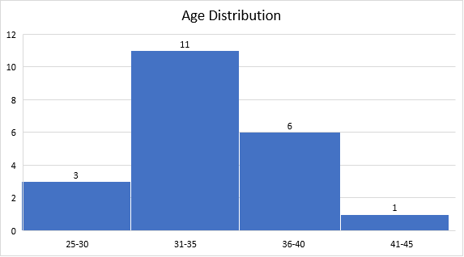
Figure 1: Age Distribution among Participants
Q3: What is your educational degree/qualification?
We asked this question to be able to recognize the educational background of our respondents and to try to identify whether there is a correlation between the revealed data and other factors surveyed in this research. Our findings show that 17 participants (81%) hold a BA degree while only 4 (19%) have a Master’s degree.
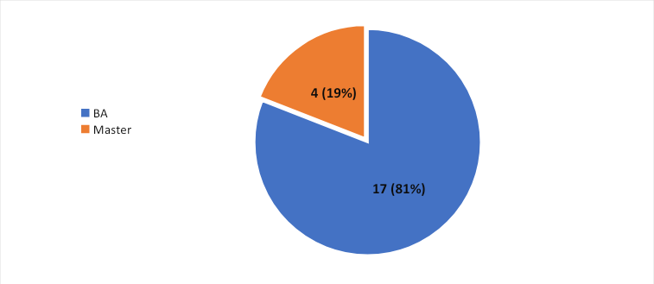Figure 2: Educational Qualifications of the Participants
Q4: Which district do you work in?
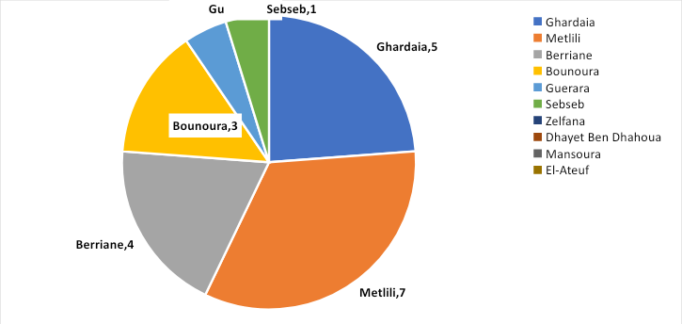
Figure 3: Work Districts of the Participants
The teachers participating in this questionnaire were diverse in terms of the districts they worked in. However, teachers from 6 out of 10 districts of Ghardaia province were involved in this questionnaire. The distribution of the teachers according to their respective districts of work is shown in Figure 3.
Q5: How many primary schools have you been assigned to work at?
Figure 4 demonstrates the number of primary schools that were assigned to teachers. We notice that there are apparent discrepancies between teachers in relation to the number of schools they work at which may pose a significant challenge to the ones with the highest number of schools.
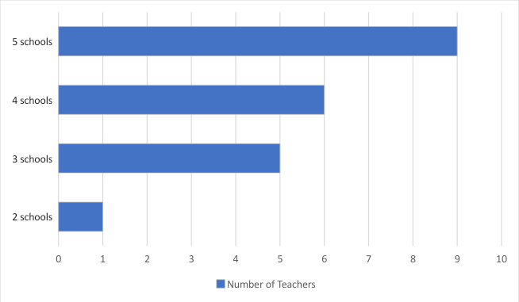
Figure 4: Number of Schools Assigned to Teachers
Section Two: Professional Experience and Development
Q6: Have you had any experience teaching English?
The data gathered out of this question indicate that the majority (86%) of the teachers concerned with this study have had an experience in teaching English before while only 3 of them (16%) didn’t have any experience prior to their official recruitment last year.
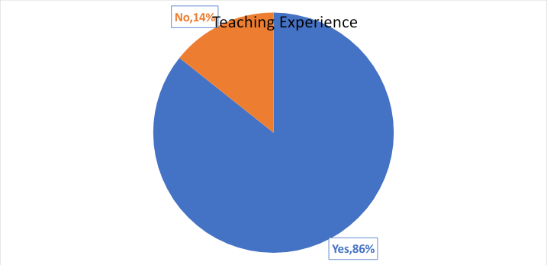
Figure 5: Participants’ Experience in Teaching English
Q7: If yes, for how long have you been teaching English?
When asked about the length of their teaching experience, the participants’ answers varied widely between a few months of experience and up to twelve years in teaching English. Conveniently, we categorized the different durations under three headings as shown in Table 2 below.
Table 2: Length of Teaching Experience of the Participants
TeachingExperience | Lessthan 5 years | 5 to 10 years | More than 10 years
Number of Participants | 9 | 5 | 2
Q8: Have you received any pre-service/in-service teacher training?
From the bar graph below (Figure 6), we notice that 16 teachers said that they had taken part in teacher training programmes whereas the other 5 participants had not.
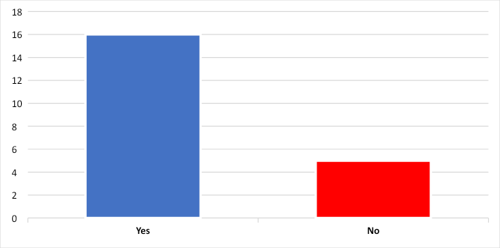
Figure 6: Teachers’ Participation in Teacher Training Programmes
Q9: How satisfied were you with the training programme (content/duration)?
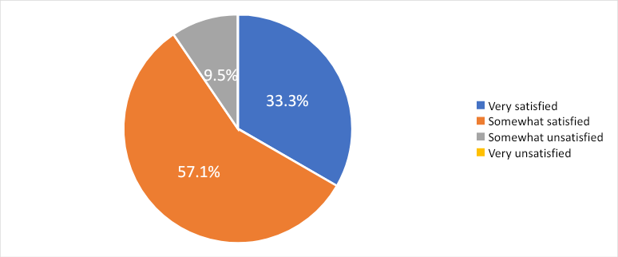
Figure 7: Teachers’ Satisfaction with the Training Programme
According to the pie chart above, we observe that most teachers are satisfied with the training they received in reference to its content and duration. However, the degree of satisfaction differs from one teacher to another. One third (33.3%) of the participants expressed their great satisfaction, whereas 57.1% had an incomplete sense of satisfaction about the training programme. In contrast, 9.5% of the teachers stated that they were somewhat unsatisfied with the training they received.
Q10: What would you like to be included (to learn) in the coming training workshops?
This question helped us gather fresh insights about teachers’ needs with regard to professional training. Most responses focused on the need for practical training workshops rather than just theoretical sessions. The teachers showed their interest in typical demonstration lessons with real classes where they can observe and learn how to present lessons effectively as well as to gain practical knowledge of the application of modern teaching methods and classroom management techniques. Some teachers highlighted the necessity to learn more about lesson planning, early childhood pedagogies, and the psychology of the child. Besides, a few responses emphasized the need to be trained in improving ICT skills whereas others required to be instructed in how to teach the next level (fourth year). On the whole, the teachers involved in this study showed an eagerness to learn and to develop their skills so as to improve their teaching performance, as one of the informants stated, ‘I want to learn everything that is useful in the educational process.’
Q11: Have you received any professional supervision by a senior teacher while teaching?
Table 3: Professional Supervision
Option | Number | Percentage
Yes | 03 | 14.3%
No | 18 | 85.7%
Table 3 displays remarkably the lack of professional supervision that ought to be provided, especially to novice teachers. Only 3 (14.3%) participants reported they were offered professional coaching by an experienced teacher. The rest (85.7%) did not have that privilege.
Q12: What support do you need to improve your teaching of English to pupils?
Figure 8 shows a bar graph representing the type of support teachers said they needed in order to improve their teaching of English to TYPP. Most teachers (18) emphasized their need for professional training while 16 of them asserted the importance of collaboration with their colleagues. Quality resources were considered an essential requirement by 9 of our informants for enhancing their teaching practices. 4 among our informants called for administrative support whereas only 1 required the parents to be more involved with their children’s learning.

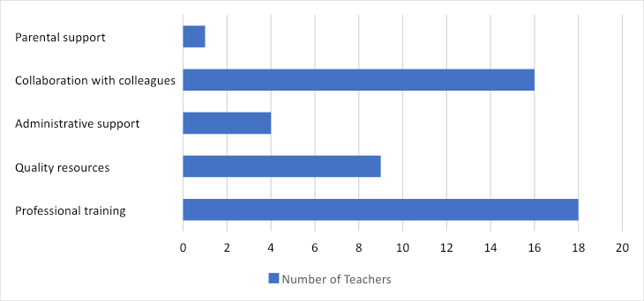
Figure 8: Support Needed by Teachers to Improve their Performance
Section Three: Classroom Management and Motivation/ Parental Involvement
Q13: How many classes have you been assigned to teach?
The number of classes assigned to each teacher ranged widely between 4 and 9 classes (as shown in Table 4), which draws attention to the fact that some teachers had to cope with additional workloads than others.

Table 4: Number of Assigned Classes
Number of Assigned Classes | Four classes | Five classes | Six classes | Seven classes | Eight classes | Nine classes
Number of Teachers | 1 | 2 | 3 | 3 | 4 | 8
Q14: Does the number of classes you teach negatively affect your performance?
Although 8 participants reported the absence of any negative effect of the count of their assigned classes on their teaching performance, a considerable rate of about 62% (13) of the participants acknowledged the negative impact of their workload (number of classes) on their daily practice.
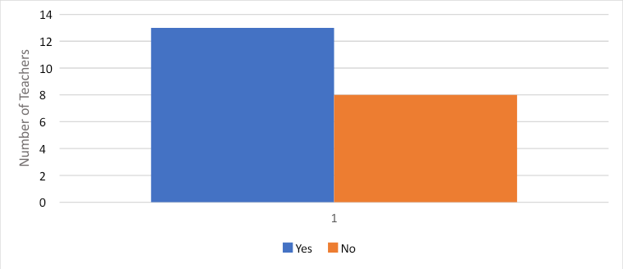
Figure 9: The Negative Impact of the Number of Classes on Teaching Performance
Q15: What is the average number of pupils per class?
Table 5: The Average Number of Pupils per Class
Average Number of Pupils per Class | Lessthan 20 | 20-30 | 31-40 | More than 40
Number of Teachers | 2 (9.5%) | 10 (47.6%) | 9 (42.9%) | 0 (0%)
The average number of pupils per class differed clearly from one teacher to another. We classified the various numbers into 4 ranges presented in Table 5 above.
Q16: How do you find the average number of pupils in your classes?
In this question, we wanted to explore the opinions of the teachers concerning the average number of pupils in their respective classes. The greater number of participants (16) regarded their classes as crowded which hints at the possibility of having classroom management challenges. On the other hand, 5 teachers deemed the size of their classes as ideal.
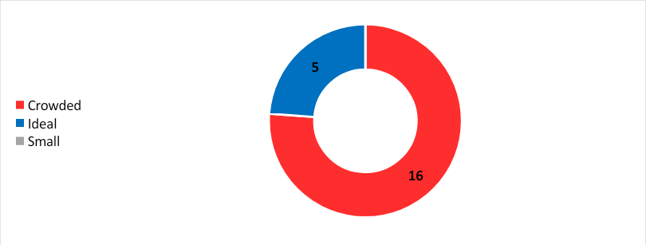
Figure 10: Teachers’ Opinions about the Average Number of Pupils per Class
Q17: Are you capable of maintaining discipline in your classes?
Table 6: Maintaining Disciple in the Classroom
Option | Number | Percentage
Yes | 16 | 76.2%
No | 5 | 23.8%
As shown in Table 6 above, we observe that the greater part of our sample (76.2%) expressed their capability to maintain discipline inside their classrooms. Nevertheless, about a quarter of the respondents (23.8%) said they couldn’t maintain discipline inside the classroom, which could be due to either the large size of their classes or inadequate classroom management strategies and techniques.
Q18: What classroom management strategies and techniques you use to maintain discipline and create an effective classroom environment?
In this question, the respondents were provided with five options to choose from, as well as a sixth blank space to suggest other strategies and techniques they used inside their classrooms. Their answers were as follows. One third (33.3%) said they provided positive reinforcement and praise to their pupils, two thirds (66.7%) agreed on building positive relationships with learners, and 52.4% of participants used visual aids and technology to create an effective classroom environment. Besides, an equal rate of participants (38.1%) reckoned delivering engaging and interactive lessons as well as incorporating movement and physical activities to be effective strategies used in maintaining discipline among their young learners. Other individual responses included motivation, good planning, attention grabbers, interesting topics, rising the hand before speaking, or even punishment sometimes.
Q19: Do you have enough space for group work and other classroom projects/activities in the classroom?
Table 7: Availability of Space for Group Work and Classroom Projects
Option | Number | Percentage
Yes | 7 | 33.3%
No | 14 | 66.7%
We notice from Table 7 that only one third of participants (33.3%) had enough space for doing group work and classroom projects while the other two thirds (66.7%) faced difficulties in doing so due to the limited space.
Q20: Do you face any challenges in engaging pupils and maintaining their attention during the lesson?
Figure 11: Facing Challenges in Engaging Pupils and Maintaining their Attention
Figure 11 shows that the greater part of teachers (85.7%) encountered challenges in engaging pupils and maintaining their attention during lessons. However, 14.3% of them said they didn’t.
Q21: What techniques do you use to get their attention?
When asked about the techniques they used to get pupils’ attention, 52.4% of teachers used a countdown, about half of them (47.6%) applied a “call and response” technique (e.g., Who is listening? I am listening), while other responses included different techniques such as to stand up and then sit down, asking simple questions related to the topic being taught, or using attention grabbers.
Q22: Do your pupils actively participate in the classroom?

Table 8: Pupils’ Participation
Option | Number | Percentage
Yes | 14 | 66.7%
Somewhat | 7 | 33.3%
No | 0 | 0%
This question assessed the level of active participation of pupils in the classroom. Out of the 21 responses received, 66.7% of participants indicated that their pupils participate somewhat actively, while the remaining 33.3% reported that their pupils actively participate in the classroom. None of the respondents reported a lack of participation from their pupils. These findings suggest a generally positive level of engagement and involvement among the students in the classroom setting.
Q23: Do your pupils find learning English easy, interesting and enjoyable?
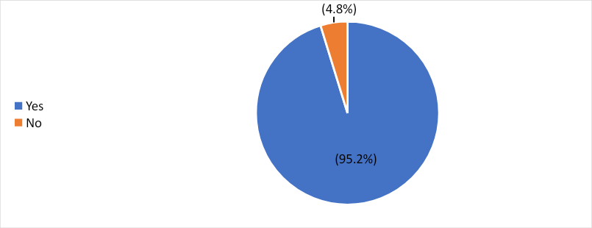
Figure 12: Pupils’ Interest in Learning English
The question aimed to assess the perception of pupils regarding the ease, interest, and enjoyment of learning English. Out of the 21 responses received, a significant majority of 95.2% answered "Yes," indicating that the pupils find learning English easy, interesting, and enjoyable. Only one respondent, accounting for 4.8%, answered "No," suggesting that there may be a small fraction of pupils who do not find learning English as easy, interesting, or enjoyable. The overwhelming positive response implies that the majority of the pupils have a favorable attitude towards learning English, perceiving it as an engaging and enjoyable experience.
Q24: How do you motivate your pupils to learn English?
This question helped us to gather information about the strategies employed by teachers to motivate their pupils to learn English. Out of the 21 responses, the most commonly mentioned strategies were using games and fun activities, cited by 19 respondents. Giving rewards and incentives was reported by 14 respondents. Four respondents mentioned addressing their pupils' interests and daily lives as a motivation strategy. Two respondents specifically mentioned quizzes, and one respondent provided an alternative strategy. These findings highlight the variety of approaches used by teachers to create a motivating learning environment.
Q25: How do you involve parents in supporting their child’s English language learning?
The question was asked to explore how teachers involve parents in supporting their child's English language learning. Out of the 21 responses, the most commonly responses received, 7 teachers mentioned sending regular updates and progress reports home, while 8 teachers provided parents with resources and strategies for supporting language learning at home. Additionally, 3 teachers offered parent-teacher conferences and meetings to discuss language learning progress. However, some teachers reported challenges, such as parents' lack of interest or knowledge in supporting their child's English learning.
Section Four: Textbook/ Teaching Materials
Q26: Do you find the textbook useful, helpful and practical?

Table 9: Teachers’ Opinions about the Textbook
Option | Number | Percentage
Yes | 8 | 38.1%
Somewhat | 9 | 42.9%
No | 4 | 19%
The question aimed to assess participants' perception of the usefulness, helpfulness, and practicality of the textbook. Out of the 21 responses received, 38.1% of participants answered "Yes," indicating that they find the textbook useful, helpful, and practical. A slightly higher proportion, 42.9%, responded "Somewhat," suggesting that they have mixed opinions about the textbook's utility and practicality. The remaining 19% answered "No," indicating that they do not consider the textbook to be useful, helpful, or practical. The distribution of responses indicates a range of opinions regarding the textbook's effectiveness and applicability in supporting the participants' learning needs.
Q27: To what extent do you think your pupils find the textbook interesting?
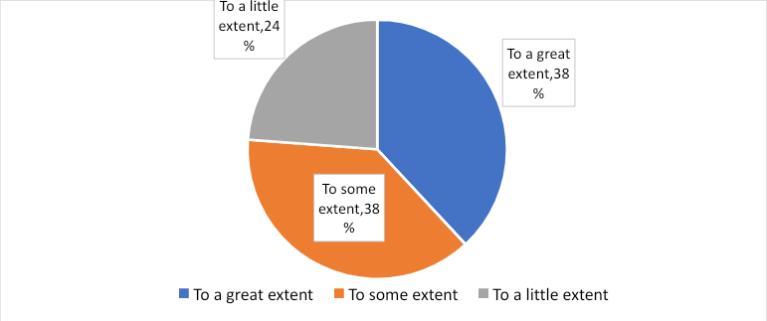
Figure 13: Pupils’ Interest in the Textbook
The question helped assess the perceived level of interest that pupils have in the textbook. Out of the 21 responses collected, 38% of participants indicated that their pupils find the textbook interesting to some extent. Additionally, 24% of respondents reported that their pupils find the textbook interesting to a little extent. A smaller proportion, 38%, stated that their pupils find the textbook interesting to a great extent. Overall, the responses suggest varying levels of interest among pupils regarding the textbook, with a significant portion expressing at least some degree of interest, while others perceive lower levels of engagement.
Q28: Besides the textbook, what other teaching materials are you using to reach the learning objectives?
The question was asked to gather information about the teaching materials used in addition to the textbook to achieve the learning objectives. Out of the 21 responses received, the most commonly mentioned teaching materials were the curriculum and syllabus, cited by 11 respondents. The teacher's guide and assessment guide were mentioned by 3 respondents each. Audio and video materials, as well as worksheets and pictures, were reported by 15 respondents as additional teaching resources. Real objects were mentioned by 14 respondents. One respondent provided a varied list of materials, including flashcards, datashow, teacher's gestures, and role play. These findings indicate a diverse range of teaching materials utilized by the respondents to complement the textbook and support the attainment of learning objectives.
Q29: How do you use technology to enhance language learning?
The question aimed to explore how technology is utilized to enhance language learning. Out of the 21 responses, the most frequently mentioned technology-based tools and resources were audio and video recordings, cited by all 21 respondents. Educational apps and games were reported by 8 respondents, while interactive whiteboards were mentioned by 2 respondents. Online resources and websites were cited by 1 respondent, as were flashcards. Notably, no respondents mentioned the use of interactive smartboards.
Section Five: Teaching/ Learning/ Assessment
Q30: Are teaching hours per week sufficient for learning English in primary school?
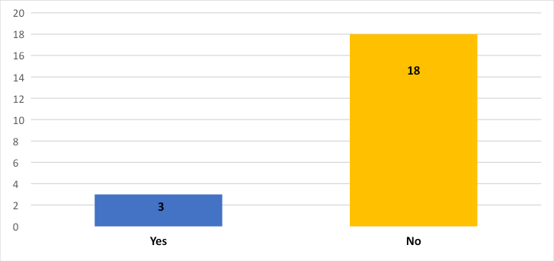
Figure 14: Teacher’s Opinions about Teaching Hours
The question aimed to determine whether the number of weekly teaching hours allocated for English instruction in primary schools was considered adequate or not. The analysis showed that 3 participants answered "Yes," indicating that they believed the teaching hours were sufficient, while 18 responded "No," suggesting that they felt the teaching hours were insufficient for effective English language learning in primary school.
Q31: If no, why? And what do you suggest?
Based on the 20 responses collected, several reasons were provided for why the teaching hours per week were considered insufficient for learning English in primary school. The reasons cited for insufficiency included:
- Need for more time to develop native-like proficiency
- Desire for longer sessions to allow for monitoring, activities, and speaking opportunities
- Concerns about limited practice and reinforcement time
- Emphasis on listening and speaking skills requiring more attention
Q32: Do you usually find enough time for preparing and planning your English lessons?
Table 10: Sufficiency of Time for Planning Lessons
Option | Number | Percentage
Yes | 17 | 81%
No | 4 | 19%
The question aimed to determine if participants generally had sufficient time for preparing and planning their English lessons. Out of the total respondents, 81% indicated that they usually find enough time, while 19% reported not having enough time. This data suggests that a majority of participants feel adequately supported in terms of time allocation for lesson preparation, but a notable portion still faces challenges in this regard.
Q33: How many hours per week do you work?
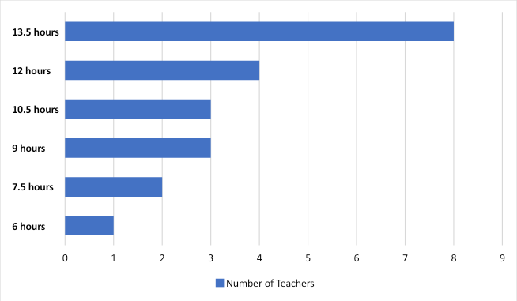
Figure 15: Working Hours per Week
The question aimed to gather information about the number of hours per week participants work. Out of the 21 responses, the distribution of hours varied, with some participants providing specific values (e.g., 10, 12, 13 hours), while others gave more detailed descriptions (e.g., 13 hours and half, 7 hours and half).The most commonly reported value was 1 hour per week, accounting for 19% of the responses. Other common responses included 2 hours per week (9.5%) and 12 hours per week (19%).Some respondents provided additional information, such as working 10 hours and 50 minutes, 13.5 hours per week, or 14.5 hours per week. One respondent indicated "No" as their answer, which suggests they do not work any hours per week in the context of the question.

Q34: Are you satisfied with your work schedule? If no, why?
Table 11: Satisfaction with Working Schedule
Option | Number | Percentage
Yes | 20 | 95.2%
No | 1 | 4.8%
The question helped us determine participants' satisfaction with their work schedule. The analysis revealed that the majority, 95.2%, are satisfied with their work schedule, while 4.8% expressed dissatisfaction. This suggests that the majority find their schedule suitable, but a small proportion have concerns or issues with their current work schedule.
Then, reasons were identified for dissatisfaction with the work schedule. The responses indicated that the most common reason was the need for more time. Some participants were content with the current schedule, while others expressed concerns about potential exhaustion from additional classes and hours. Some respondents did not provide a specific reason.
Q35: Do you think that teaching both English and French at primary school may burden the child’s learning abilities?
Figure 16: The Burden of Learning both English and French by Pupils
The majority of respondents (61.9%) believe that teaching both English and French at the primary school level may burden the child's learning abilities. They express concerns about overwhelming young learners and potentially impacting overall academic performance. However, 38.1% of respondents disagree, emphasizing the cognitive benefits and long-term advantages of learning both languages.
Q36: Have you noticed any interference of the mother tongue (L1) and/or French with your pupils’ use of English?
Table 12: The Interference of L1 and/or French with the Pupils’ Use of English
Option | Number | Percentage
Yes | 19 | 90.5 %
No | 2 | 9.5%
The question aimed to determine whether respondents have noticed any interference of the mother tongue (L1) and/or French with their pupils' use of English. Out of the 21 responses received, 19 respondents (90.5%) answered "No," indicating that they have not noticed any interference. In contrast, only 2 respondents (9.5%) answered "Yes," suggesting that they have observed instances where the students' native language or knowledge of French may have influenced their use of English.
Q37: How would you describe the effect of L1 and / or French on your pupils learning of English?
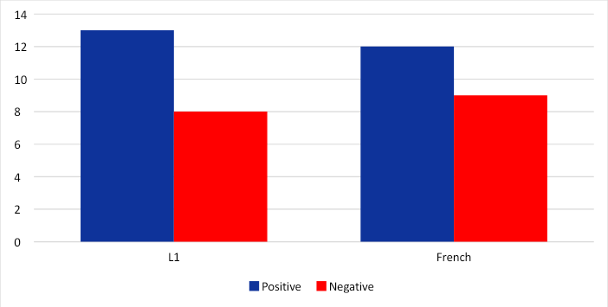
Figure 17: The effect of L1 and/or French on Pupils’ Learning of English
The data provided indicates the perceived effect of the students' native language (L1) and French on their learning of English. Out of the respondents who provided answers, 13 of them (62%) reported a positive effect of the students' L1 on their English learning, while 8 respondents (38%) mentioned a negative effect. In terms of French, 12 respondents (57%) believed it had a positive impact on the students' English learning, while 9 respondents (43%) indicated a negative effect.It is worth noting that some respondents recognized both positive and negative effects of the students' native language and French on their English learning, suggesting that these factors can have a mixed influence.
Q38: Do you find yourself in need to use L1 (Arabic or Mozabite) / French? If yes, in which situations?
Table 13: The Need to Use L1 and/or French
Option | Number | Percentage
Yes | 18 | 85.7 %
No | 3 | 14.3%
The aim of the question was to determine in which situations the teachers find themselves needing to use L1 (Arabic or Mozabite) or French in their teaching. Based on the responses provided, the teachers mentioned several situations where they resort to using these languages. These include facilitating group participation and finding answers together, ensuring intelligibility and accuracy in understanding and communication, taking advantage of similar words and grammar structures in Mozabite for more efficient explanations, and describing and introducing new units. Additionally, situations where students are unable to grasp the taught concepts, cannot understand even with gestures, or require additional support for writing skills were mentioned. The use of L1 or French also occurs when students respond in their native languages during question-and-answer sessions, and when other means of explanation such as gestures, videos, and pictures are ineffective.

Q39: Which language skill are you practising most with pupils?
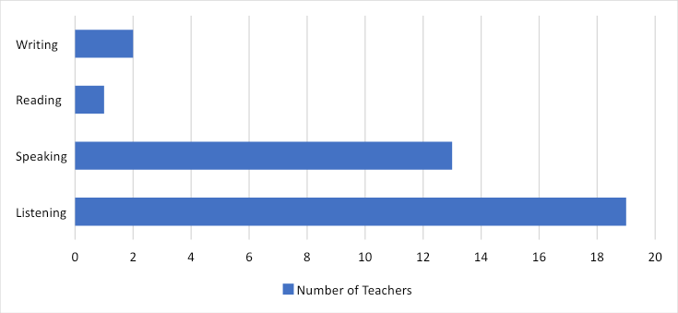
Figure 18: The Most Practised Language Skills
Teachers reported focusing primarily on developing listening and speaking skills with their pupils. These skills were mentioned by the majority of respondents, with 10 teachers emphasizing listening and 6 teachers emphasizing speaking. Reading and writing skills were not mentioned by any of the respondents.
Q40: Which language skill are you practising least with pupils?
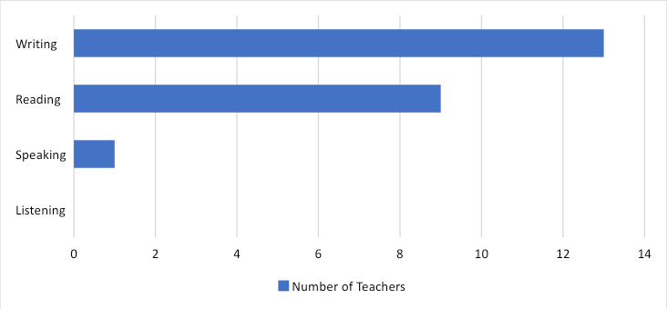
Figure 19: The Least Practised Language Skills
The aim of the question was to determine which language skill(s) the teachers find difficult to teach. Based on the responses, it seems that reading and writing skills are the ones mentioned most frequently. Seven teachers stated that reading is the skill they practice the least, while twelve teachers mentioned that writing is the most challenging skill to teach. Additionally, one teacher identified both reading and writing as the skills they find difficult to teach.
Q41: Which language skill do you find difficult to teach?
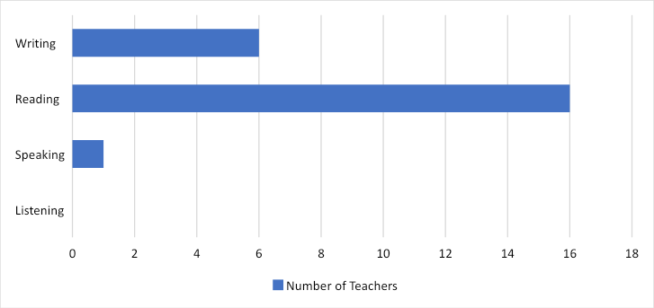
Figure 20: Difficult Language Skills to Teach
This question helped us gain insights into the challenges faced by teachers in teaching different language skills. Based on the responses, it appears that teaching reading is the language skill that teachers find most difficult. 12 teachers mentioned that reading is challenging to teach. Additionally, 4 teachers mentioned writing as a difficult skill to teach, while 1 teacher mentioned speaking as challenging. One teacher indicated that they find none of the language skills difficult to teach, and one teacher mentioned both writing and reading as challenging.

Q42: What learning styles have you observed in your pupils in regards to learning English?
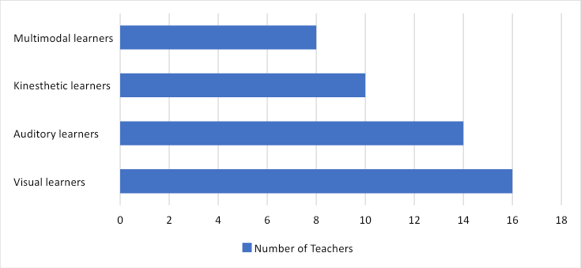
Figure 21: Pupils’ Learning Styles
In regards to learning English, the teachers have observed various learning styles among their pupils. The majority of the pupils (76.2%) were identified as visual learners and auditory learners. Additionally, a significant number of pupils (66.7%) were identified as kinesthetic learners and multimodal learners.
Q43: How do you assess your pupils' English proficiency?
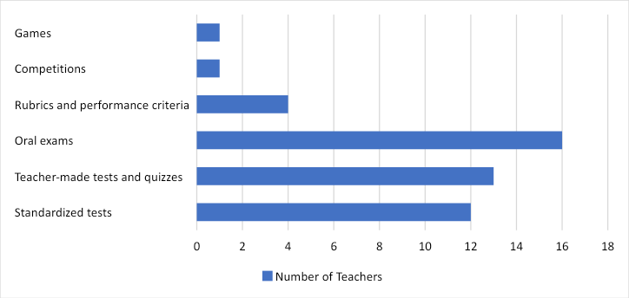
Figure 22: Ways of Assessing Pupils’ English Proficiency
This question helped us understand the methods teachers use to assess their pupils' English proficiency. The most commonly employed methods include standardized tests (57.1%) and teacher-made tests and quizzes (61.9%). Oral exams are also frequently used (76.2%), and some teachers rely on rubrics and performance criteria (19%) for assessment. Competitions are occasionally utilized (4.8%), and informal assessment methods like games are used in certain cases (4.8%).
Section Six: Further Suggestions
Q44: Would you please state any more challenges/problems you face in teaching English to primary pupils inside or outside the classroom?
question aimed to identify the challenges and problems faced in teaching English to primary pupils. Here are some of the responses:
- Lack of motivation and disinterest.
- Insufficient classroom resources and equipment.
- Small class sizes and lack of parental involvement.
- Pupils' attention and concentration issues.
- Limited access to teaching materials.
- Spaceconstraints in classrooms.
- Inadequate opportunities for practice outside of class.
- Short class durations.
- Language confusion between English and French.
- Lack of administrative support.
- Time constraints and insufficient time for teaching.
- Pupils' lack of revision and homework completion.
- Parental indifference or involvement.
- Initial confusion when teaching English and French together.
- Managing large numbers of learners.
While some teachers reported not facing significant problems or being satisfied with their teaching experience.

2.3.2. Class Observations and Data Analysis
Instructional Techniques: The class observations revealed various instructional techniques used by teachers to deliver English language lessons. These techniques included direct instruction, group work, pair work, and interactive activities. Teachers employed a combination of teacher-led and student-centered approaches to engage students and promote active participation in the learning process.
Classroom Management Strategies: The analysis of class observations identified different classroom management strategies employed by teachers to maintain discipline and create an effective learning environment. These strategies included establishing clear rules and expectations, providing positive reinforcement, using visual aids and props, and implementing a variety of student engagement techniques.
Integration of Language Skills: The observations highlighted how teachers integrated the four language skills - listening, speaking, reading, and writing - in their instructional practices. Teachers used a balanced approach to ensure students had opportunities to develop and practice all language skills. They incorporated activities such as role-plays, discussions, reading comprehension exercises, and writing tasks to promote holistic language learning.

2.4. Discussion and Interpretation of the Study Results
The analysis of the data collected in this study revealed important insights into various aspects related to the challenges of teaching English to primary school pupils. Here are the key findings from the analysis:
- General Information
The gender distribution among the participants of this study revealed that a majority are female teachers. This gender disparity suggests that there is a higher representation of female teachers in the study sample. The reasons behind this gender imbalance may be influenced by various factors, such as the overall gender composition of the teaching profession or the specific recruitment and participation patterns within the study context. Also, the participants in this study spanned ages 28 to 41 years old, providing a diverse range of perspectives and experiences.
The participants' educational degree/qualification was elicited to understand their educational background and explore potential correlations with other factors in the study. The findings about the participants' educational qualification indicated that the majority of respondents hold a Bachelor's degree, while a few of them have a Master's degree. This suggests that the sample primarily consists of teachers with undergraduate qualifications, with a smaller proportion holding advanced degrees.
The distribution of teachers across these indicates a relatively broad geographic coverage and provides insights into the perspectives and experiences of teachers from different regions within the province. The study identified discrepancies in workload among participants, which poses a significant challenge. Managing multiple schools can lead to increased workload, time constraints, and potential difficulties in providing consistent instruction across all schools. This finding highlights the need to address workload imbalances and provide adequate support and resources to ensure equitable teaching conditions for all teachers.

- Professional Experience and Development
The study gathered information on the professional experience and development of the participants. The results indicated that the majority of participants had substantial teaching experience, with the average years of experience ranging from 8 to 15 years. This suggests that the participants had a significant level of professional expertise in teaching English to primary pupils.
Regarding professional development, the findings showed that a considerable number of teachers had participated in various professional development activities. These activities included workshops, seminars, and training sessions focused on language teaching methodologies, curriculum design, and assessment practices. This indicates that the participants were actively engaged in enhancing their teaching skills and staying updated with current educational practices.
The results of the study align with the research questions by providing insights into the participants' professional experience and development in relation to teaching English to primary pupils. The substantial teaching experience suggests that the participants have encountered and overcome various challenges in their teaching practice. Furthermore, their engagement in professional development activities demonstrates their commitment to continuous improvement and their willingness to adopt effective teaching strategies.
These findings have important implications for the study, as they highlight the significance of professional experience and development in addressing the challenges of teaching English to primary pupils. The results suggest that teachers with more experience and access to professional development opportunities may possess a broader repertoire of instructional strategies and pedagogical approaches to meet the diverse needs of their students.
Based on these findings, it is recommended that schools and educational institutions continue to prioritize and support the professional development of teachers. This can be achieved through providing opportunities for ongoing training, workshops, and collaboration with colleagues to enhance their teaching practices. Additionally, mentoring programs and peer observations can be implemented to facilitate the sharing of best practices and create a supportive professional learning community.
By recognizing the value of professional experience and development, educators can effectively address the challenges faced in teaching English to primary pupils and ensure the delivery of quality education that promotes language proficiency and fosters a positive learning environment.

- Classroom Management and Motivation/ Parental Involvement
The study examined information on classroom management, motivation, and parental involvement in relation to the study questions. The findings provided insights into the participants' experiences and perceptions in these areas.
Regarding classroom management, the results indicated that teachers faced various challenges in effectively managing their classrooms. These challenges included maintaining discipline, keeping students engaged and focused, addressing behavioral issues, and dealing with large class sizes. The findings suggest that classroom management is a significant concern for teachers and can impact the overall learning experience.
In terms of motivation, the results revealed that teachers observed varying levels of motivation among their students. Some teachers reported high levels of motivation, indicating that their students were actively engaged and enthusiastic about learning English. However, other teachers reported challenges in motivating their students, with factors such as disinterest, lack of engagement, and low motivation hindering the learning process. These findings highlight the importance of addressing motivation to create a positive and conducive learning environment.
Regarding parental involvement, the results indicated that teachers experienced different levels of parental engagement in their students' English language learning. Some teachers reported active involvement and support from parents, with regular communication and participation in school activities. However, other teachers reported limited parental involvement, which could impact students' progress and language development. These findings emphasize the significance of fostering strong teacher-parent relationships and encouraging parental involvement in supporting students' language learning journey.
Overall, the results on classroom management, motivation, and parental involvement provide valuable insights into the challenges and opportunities in these areas. The findings align with the study questions by exploring the participants' experiences and perceptions related to these factors, which are crucial for effective English language instruction.
Based on these findings, it is recommended that teachers receive professional development and training in effective classroom management strategies. This can help them establish clear expectations, implement engaging teaching methods, and create a positive classroom environment that promotes student motivation and active participation. Additionally, fostering collaboration between teachers and parents through regular communication, parent-teacher meetings, and involvement in school activities can enhance parental support and engagement in students' language learning.
By addressing classroom management challenges, enhancing student motivation, and fostering parental involvement, educators can create a conducive learning environment that maximizes students' language learning potential and promotes their overall academic success.

4. Textbook/ Teaching Materials
The responses to the question about the usefulness, helpfulness, and practicality of the textbook varied. These findings indicate a range of opinions about the textbook's effectiveness and applicability in supporting participants' learning needs. The results emphasize the importance of considering individual preferences and teaching approaches, as well as incorporating diverse teaching resources to enhance the effectiveness of the textbook in language learning.
The responses to the question about the extent to which pupils find the textbook interesting indicate mixed levels of interest. They suggest varying levels of interest among pupils regarding the textbook, with a significant portion expressing at least some degree of interest, while others perceive lower levels of engagement. These findings emphasize the need for teachers to explore additional strategies and resources to foster greater interest and engagement among pupils. Incorporating interactive activities, multimedia materials, and other engaging teaching methods can help enhance pupils' interest in the subject matter and promote a more enjoyable learning experience.
The responses to the question regarding the use of teaching materials in addition to the textbook indicate a diverse range of resources employed by teachers to support the learning objectives. The most commonly mentioned materials were the curriculum and syllabus, followed by audio and video materials, worksheets and pictures, and real objects. These findings emphasize the importance of incorporating diverse teaching materials to cater to different learning styles and promote active participation among students. By utilizing a variety of resources, teachers can create a dynamic and enriching learning environment that supports the attainment of learning objectives beyond the limitations of the textbook alone.
When asked how to use technology to enhance language learning, teachers provided varied responses. The findings showed that audio and video recordings are commonly used to enhance language learning, followed by educational apps and games. Interactive whiteboards and online resources/websites are used to a lesser extent, while the use of interactive smartboards was not mentioned. In general, the results emphasize the role of technology in promoting interactive and engaging language learning experiences.

5. Teaching / Learning / Assignment
The majority of participants (85.7%) believed that the teaching hours per week for learning English in primary school were sufficient, while a minority (14.3%) considered them insufficient. Participants who felt the teaching hours were inadequate cited reasons such as the need for more time to develop native-like proficiency, longer sessions for monitoring and activities, concerns about limited practice and reinforcement, and the need to prioritize listening and speaking skills. Suggestions included increasing teaching hours, extending session duration, and incorporating additional activities for more practice and reinforcement. Overall, there is a recognition of the importance of allocating sufficient time and resources to English language learning in primary schools.
The analysis of the responses regarding the availability of time for preparing and planning English lessons indicates that the majority of participants (81 out of the total) usually find enough time for these tasks. However, a significant number of participants (19) reported not having sufficient time. This suggests that while a majority feel supported in terms of time allocation, there is a notable portion who face challenges in managing their time for lesson preparation. Exploring the reasons behind these time constraints and identifying strategies or resources to address them could be beneficial in supporting these teachers.
The analysis of the responses regarding the number of hours worked per week reveals a diverse distribution of hours among the participants. While some participants provided specific values, others offered more detailed descriptions of their working hours. The data showcases a range of working hours among the participants, with some working minimal hours and others reporting more substantial commitments.
Based on the analysis of participants' responses, it can be interpreted that the majority of participants are satisfied with their work schedule, indicating that they find it suitable for their needs. This suggests a positive perception of the work schedule among the respondents. However, a small proportion expressed dissatisfaction with their work schedule, citing the need for more time as the primary reason. These participants indicated a desire for additional time, while others expressed concerns about potential exhaustion from increased classes and hours. The findings highlight the importance of considering individual preferences and workload considerations when designing work schedules in order to maintain high levels of job satisfaction among teachers.
Based on the analysis of participants' responses, it can be inferred that there is a divided opinion regarding the impact of teaching both English and French at the primary school level on the child's learning abilities. The majority of respondents express concerns that teaching both languages may burden the child's learning abilities, expressing concerns about overwhelming young learners. This suggests that there is a need for further exploration and consideration when it comes to teaching both English and French at the primary school level. While a significant portion of respondents expressed concerns about potential burden on children's learning abilities, a notable proportion also emphasized the cognitive benefits of bilingualism. This indicates the importance of finding a balance and implementing effective strategies to optimize language learning outcomes.
The findings suggest that the interference of the mother tongue (L1) and/or French on pupils' use of English is not a significant issue for the majority of respondents. This indicates that most teachers do not observe noticeable negative effects on students' English language proficiency due to the influence of their native language or knowledge of French.
However, it is important to acknowledge that a small percentage of respondents did notice instances where the students' use of English was affected by the influence of their L1 or French. This highlights the need for targeted support and interventions to address potential language transfer issues.
The data analysis explored the methods and approaches used by teachers to teach English language skills and assess student learning. It revealed a variety of instructional strategies, such as interactive activities, multimedia resources, and formative assessments. These findings highlight the importance of employing diverse teaching methods and assessment techniques to cater to the learning needs of young learners.

6. Further Suggestions
The teachers indicated further challenges and problems encountered in teaching English to primary pupils. These included issues such as lack of motivation, limited resources, small class sizes, language confusion, time constraints, and inadequate practice opportunities. Additionally, factors like parental involvement, administrative support, and managing large numbers of learners contributed to the overall challenges faced. It is important to address these obstacles to create a conductive learning environment and enhance English language instruction for primary pupils. The study emphasizes the need for targeted interventions, resource allocation, and support systems to overcome these challenges and improve the teaching and learning experience in the classroom.

2.5. Implications and Recommendations
Based on the findings of the study, several implications and recommendations can be made:
- Enhanced curriculum: The study highlights the need for curriculum enhancements that address the specific challenges faced by teachers in teaching English to third-year pupils. The curriculum should focus on vocabulary acquisition, sentence formation, and grammar, while also promoting student motivation and engagement.
- Resource allocation: Adequate allocation of resources, such as teaching materials, is crucial to support effective English language instruction. Policymakers and school administrators should prioritize the provision of sufficient resources to address the challenges identified in the study.
- Professional development: Teachers should be provided with ongoing professional development opportunities to enhance their pedagogical skills in teaching English to third-year pupils. Training programs should focus on effective instructional strategies, differentiated instruction, and the use of technology to enhance language learning.
- Collaboration and support: Collaboration among teachers and support from school leadership are essential in implementing effective teaching strategies and addressing challenges. Collaborative planning and sharing of best practices can help teachers overcome obstacles and improve the overall quality of English language instruction.

- Integration of technology: The study highlights the importance of integrating technology into language learning. Educational apps, games, audio and video recordings, and online resources can be valuable tools to enhance engagement and facilitate language acquisition. Teachers should be encouraged to explore and utilize appropriate technological resources.
- Individualized instruction: Given the varying levels of language proficiency among students, differentiated instruction should be emphasized. Teachers should adapt their teaching approaches and provide personalized support to meet the diverse learning needs of third-year pupils.
- Continuous assessment: Effective assessment practices should be implemented to monitor students' progress and identify areas that require additional support. Formative assessments, such as regular check-ins and feedback, can help guide instructional decisions and ensure targeted language development.

By implementing these implications and recommendations, educators and policymakers can work towards improving the quality of English language instruction for third-year pupils, addressing the identified challenges, and promoting effective language learning outcomes.

Conclusion
In conclusion, the methodology and design employed in this study provided a robust framework for investigating the challenges faced by teachers in teaching English to third-year pupils. The mixed-methods approach, combining surveys and classroom observations, allowed for a comprehensive understanding of the issues and effective practices in English language instruction. The data collected from diverse primary school teachers and the subsequent analysis using qualitative and quantitative techniques enhanced the validity and reliability of the findings. All in all, the chosen methodology and design contributed to the depth and breadth of insights generated, enabling valuable recommendations for improving English language teaching in the primary school context.

General Conclusion
In conclusion, this study explored the challenges of teaching English to third-year pupils in primary schools. Through a comprehensive analysis of various factors such as language proficiency, curriculum constraints, assessment practices, and teaching strategies, valuable insights were gained into the difficulties faced by teachers in this context. The findings revealed the importance of addressing language transfer issues, providing targeted support, and promoting accurate and proficient English language skills among pupils.
The research methodology employed a mixed-methods approach, combining surveys and classroom observations, which allowed for a comprehensive understanding of the challenges and effective practices in English language instruction. The data collected from a diverse group of teachers provided rich and varied perspectives on the topic.
The study identified several significant challenges faced by teachers, including limited vocabulary acquisition, difficulties in sentence formation and grammatical structures, low motivation and engagement, and varying levels of language proficiency among students. These challenges were found to be influenced by factors such as inadequate resources, large class sizes, limited instructional time, and language interference from the mother tongue and French.

To address these challenges, teachers employed various strategies and pedagogical approaches, including interactive activities, differentiated instruction, the use of technology and multimedia resources, and creating a supportive classroom environment. The study emphasized the importance of ongoing teacher professional development and collaboration in effectively implementing these strategies.
The implications of the findings suggest the need for curriculum enhancements, resource allocation, and support for teachers in effectively teaching English to third-year pupils. The study contributes to the existing literature on English language education in primary schools and provides practical insights for policymakers, curriculum developers, and educators to improve the quality of English instruction at this stage.
In conclusion, this dissertation sheds light on the challenges faced by teachers in teaching English to third-year pupils and offers evidence-based strategies and pedagogical approaches to overcome these challenges. The findings have practical implications for improving the teaching and learning of English in primary school settings and enhancing pupils' language proficiency and communicative skills at a crucial stage of their education.

Bibliography
Brown, L. (2020). Language Acquisition and Young Learners. In The Routledge Handbook of Young Second Language Learners. Routledge.
Crystal, D. (2003). English as a Global Language (2nd ed.). Cambridge University Press.
Crystal, D. (2020). English as a Global Language. Cambridge University Press.
Davies, A., & Elder, C. (Eds.). (2004). The Handbook of Applied Linguistics. Wiley-Blackwell.
Ellis, R. (2015). Understanding Second Language Acquisition. Oxford University Press.
Genesee, F. (2004). What Do We Know about Bilingual Education for Majority-Language Students? In T. K. Bhatia & W. C. Ritchie (Eds.), The Handbook of Bilingualism. Blackwell Publishing.
Graddol, D. (2000). The Future of English? A Guide to Forecasting the Popularity of the English Language in the 21st Century. The British Council.
Harmer, J. (2007). The Practice of English Language Teaching. Pearson Longman.
Jenkins, J. (2006). World Englishes: A Resource Book for Students. Routledge.
Kumaravadivelu, B. (2006). Understanding Language Teaching: From Method to Postmethod. Lawrence Erlbaum Associates.
Lamb, M. (2004). Integrative Motivation in a Globalizing World. System, 32(1), 3-19.
Larsen-Freeman, D. (2018). Techniques and Principles in Language Teaching. Oxford University Press.
Lightbown, P. M., & Spada, N. (2013). How Languages Are Learned. Oxford University Press.
Liu, J. (2017). Exploring the Challenges of Teaching Speaking to Young Learners. English Language Teaching, 10(2), 1-8.

McKay, S. L., &Bokhorst-Heng, W. D. (2008). International English in its Sociolinguistic Contexts: Towards a Socially Sensitive EIL Pedagogy. Routledge.
Moon, J. (2005). Children Learning English. Macmillan Education.
Nation, I. S. P. (2013). Learning Vocabulary in Another Language. Cambridge University Press.
Nation, P. (2009). Teaching ESL/EFL Reading and Writing. Routledge.
Nunan, D. (1999). Second Language Teaching and Learning. Heinle&Heinle.
Nunan, D. (2003). Practical English Language Teaching. McGraw-Hill.
Nunan, D. (2015). Teaching English to Speakers of Other Languages: An Introduction.
Nunan, D. (2016). Teaching English to Young Learners. Anaheim University Press.
Palmer, D. (2018). Understanding the Language Learning Styles of Young Learners. English Teaching Forum, 56(4), 26-35.
Richards Rodgers, E. (2014). Making Sense of Scaffolding: Young Learners' Attention and Engagement in Language Classrooms. TESOL Quarterly, 48(4), 738-762.
Ricento, T. (Ed.). (2006). An Introduction to Language Policy: Theory and Method.
Smith, J. (2017). Language Acquisition in Young Learners: A Critical Review. International Journal of Early Years Education, 25(3), 234-248.
Thornbury, S. (2017). How to Teach Grammar. Pearson Education Limited.
Wang. A. (2019). The Effect of Repeated Reading on Young English Learners' Reading Fluency Development. International Journal of Instruction, 12(1), 1109-1124.
Wang, Q. (2019). Repeated Reading: An Effective Way of Improving Young EFL Learners' Fluency and Comprehension. Reading in a Foreign Language, 31(1), 83-100.
Xu, H. (2019). The Influence of Visual Prompts on Young English Learners' Writing Motivation and Performance. English Language Teaching, 12(6), 158-166.

Xu, Y. (2019). Using Visual Prompts to Motivate Young Learners in EFL Writing. ELT Journal, 73(1), 63-72.
Yan, Y., & Zhang, Y. (2019). Using Songs in Listening Activities for Young EFL Learners: A Study of Motivation and Engagement. ELT Journal, 73(1), 15-26.
Yin, C., & Zhang, J. (2018). Teaching Listening to Young EFL Learners Using Multimedia Materials. TESOL Quarterly, 52(3), 599-605.
Zhang, J., & Yin, C. (2019). Teaching Listening to Young EFL Learners Using Multimedia Materials. In H. Reinders (Ed.), Innovations in Language Learning and Teaching: The Case of China (pp. 123-142). Springer.
Zhu Li. (2019). Peer Collaboration and Young Learners' Writing Development. Theory and Practice in Language Studies, 9(11), 1404-1411.
Zhu, Y., & Li, Q. (2019). Peer Feedback in EFL Writing: Examining the Effectiveness of a Guided Feedback Model for Young Learners. English Teaching Learning, 43(4), 411-438.

Appendices
Appendix A: Observation Checklist: Teacher Classroom Practices
- Focus Area: Instruction
- Clear instructions provided for learning activities.
- Variety of teaching methods used to cater to different learning styles.
- Effective questioning techniques for student engagement.
- Opportunities for student collaboration and group work.
- Differentiation strategies implemented for diverse learners.
- Visual aids and multimedia resources used for instruction.
- Clear learning objectives and outcomes communicated.
- Appropriatepacing of lessons.
- Focus Area: Classroom Management
- Clear rules and expectations for student behaviour established.
- Smooth management of transitions.
- Positive reinforcement and rewards for encouraging positive behaviour .
- Prompt addressing of off-task behaviours.
- Effective use of proximity and non-verbal cues for behaviour management.
- Efficient management of student materials and resources.
- Creation of a safe and inclusive classroom environment.
- Focus Area:Student Engagement
- Active participation and involvement of all students encouraged.
- Use of hands-on and interactive activities for student engagement.
- Incorporation of real-world examples and connections to students' lives.
- Opportunities for student reflection and self-assessment.
- Use of technology and multimedia resources for student engagement.
- Integration of games and fun activities for enjoyable learning.
- Encouragement of student creativity and critical thinking.
Focus Area: Assessment and Feedback
- Use of various assessment methods (formative, summative, peer assessment).
- Timely and constructive feedback provided to students.
- Use of assessments to inform instructional decisions and differentiate instruction.
- Clear expectations and criteria set for student work and assessments.
- Support for student self-assessment and goal setting.
- Monitoring of student progress and adjustment of instruction.

Appendix B: The Questionnaire
University of Ghardaia
Faculty of Letters and Languages
Department of English
Teachers’ Questionnaire
Dear teacher,
You are kindly invited to participate in this research study which aims at exploring the main challenges of teaching English as a foreign/second language to third year primary pupils. Please answer all the questions as honestly as possible and be notified that your responses are dealt with confidentially and used only for research purposes.
Please tick (✔) the appropriate box or make full statements where necessary.
Section One: General Information
1. Please select your gender: Male Female
2. Age: ……………. years.
3. What is your educational degree/qualification?
- BA (License) - Master - Doctorate
- Other (please specify): …………………………………………………………….
4. Which district do you work in? ………………………………………………...
5. How many primary schools have you been assigned to work at? …………………………..
Section Two: Professional Experience and Development
6. Have you had any experience teaching English? Yes No
7. If yes, for how long have you been teaching English? ………………………………………
8. Did you receive any pre-service/in-service teacher training? Yes No
9. If yes, would you please describe your training experience (when/ where/ how long/objectives/aspects covered)?
………………………………………………………………………………………………………………………………………………………………………………………………………………
10. Was the training relevant to what you teach at primary school? -Yes -No
11. How satisfied were you with the training programme (content/duration)?
- Very satisfied
- Somewhat satisfied
- Somewhat unsatisfied
- Very unsatisfied
12. What would you like to be included (to learn) in the coming training programmes (if any)?
………………………………………………………………………………………………………
13. Have you received any professional supervision by a senior teacher?
- Yes - No
Section Three: Classroom Management and Motivation/ Parental Involvement
14. How many classes have you been assigned to teach? ………………………..
15. What is the average number of pupils per class? ………
16. How do you perceive the average number of pupils in your classes?
a. Small
b. Ideal
c. Crowded
17. Are you capable of maintaining discipline in your classes? - Yes - No
-If yes, describe the management strategies and techniques you use to maintain discipline and
create an effective classroom environment.
………………………………………………………………………………………………………………………………………………………………………………………………………………
18. Do you have enough space for group work and other classroom projects/activities in the classroom?
- Yes - No
19. Do you face any challenges in engaging pupils and maintaining their attention during the lesson? - Yes - No
- If no, what techniques do you use to get their attention?
………………………………………………………………………………………………………20. Do your pupils actively participate in the classroom?
- Yes - Somewhat - No
21. Are yourpupils motivated to learn English? - Yes - No
22. How do you motivate your pupils to learn English?
………………………………………………………………………………………………………
23. How do you involve parents in supporting their child’s English language learning?
………………………………………………………………………………………………………
Section Four: curriculum/ Textbook/ Teaching Materials
24. Does the textbook serve the purpose and the needs for learning English as prescribed by the curriculum?- Yes - Somewhat - No
25. Do you find the textbook useful, helpful and practical?
- Yes - Somewhat - No
26. To what extent do you think your pupils find the textbook interesting?
- Very interesting
- Somewhat interesting
- Not very interesting
27. Besides the textbook,have you been provided with the official accompanying documents (curriculum, teacher’s guide, audio files, etc.)?
- Yes - No
28. Besides the textbook, what other teaching materials are you using to reach the learning objectives?…………………………………………………………………………………………
Section Five: Teaching/ Learning/ Language skills
29. Are teaching hours per week sufficient for learning English in primary school?
- Yes - No
30. Do you usually find enough time for preparing and planning your English classes?
- Yes - No
31. How many hours per week do you work? …………………………………………..
32. Are you satisfied with your work schedule? - Yes - No
- If no, why?………………………………………………………………………………….
33. Do you think that teaching both English and French at the primary school may burden the child’s learning abilities?- Yes - No
34. Does the mother tongue (Arabic)/ French interfere with your pupils’ use of English?
- Yes - No
35. Do you find yourself in need to use Arabic/ French? - Yes - No
- If yes, in which situations?
………………………………………………………………………………………………………
36. What is the skill you are practicing most with pupils? ………………………………………..
37. What is the skill you are practicing least with pupils? …………………………………………
38. Which skill do you find difficult to teach? …………………………………………………..
Section Six: Further Suggestions
39. Would you please state any more challenges/problems you face in teaching English to primary pupils inside or outside the classroom?
…………………………………………………………………………………………………………………………………………………………………………………………………………
Thank you for your time and cooperation
Appendix C: Samples of Teaching Materials
- The textbook:My Book of English
Primary School Year Three
Appendix D: Data Analysis Procedures
Google Form: https://drive.google.com/drive/u/0/mobile/?usp=forms_web
Appendix E: Ethical Considerations
In this dissertation, ethical considerations were given utmost importance to ensure the protection and well-being of the participants involved in the study. The following ethical considerations were carefully addressed:
- Participant Anonymity: To maintain confidentiality and protect the identity of the participants, all personal information, including names and specific identifying details, were either omitted or anonymized. Each participant was assigned a unique identifier to ensure their anonymity throughout the study.
- Voluntary Participation: Participants were informed about the purpose and nature of the study, and their voluntary participation was sought. They were assured that their decision to participate or withdraw would not have any negative consequences, and they had the freedom to decline participation without any obligation.
- Informed Consent: Prior to participating in the study, participants were provided with a written informed consent form explaining the purpose, procedures, risks, benefits, and confidentiality measures of the study. They were given ample time to read, understand, and ask any questions regarding their participation before providing their informed consent.
- Data Confidentiality: All data collected during the study, including observations, were treated with strict confidentiality. Only the research team had access to the data, and appropriate security measures were implemented to protect the data from unauthorized access or disclosure. Any personal identifiers were removed or anonymized to further safeguard the confidentiality of the participants.
- Transparency and Honesty: Throughout the research process, the researchers maintained a commitment to transparency and honesty. The participants were provided with accurate information about the purpose, scope, and potential implications of the study, allowing them to make informed decisions regarding their participation.
By addressing these ethical considerations, this study aimed to uphold the rights and well-being of the participants while conducting rigorous and responsible research. The ethical framework followed in this study adhered to ethical guidelines and standards set forth by relevant professional bodies and institutions.

ملخص
تبحث هذه الرسالة في التحديات التي يواجهها المعلمون في تدريس اللغة الإنجليزية لتلاميذ السنة الثالثة ابتدائي وتستكشف الاستراتيجيات والأساليب التربوية المستخدمة للتغلب على هذه التحديات. تهدف الدراسة إلى تقديم رؤى قيمة حول الصعوبات المحددة التي تتم مواجهتها في تدريس اللغة الإنجليزية في هذه المرحلة من التعليم الابتدائي وتقديم توصيات عملية لتعزيز تجربة التدريس والتعلم. استخدمت منهجية البحث نهجًا مختلطًا يجمع بين الاستطلاعات و الملاحظات الصفية. تم جمع البيانات من مجموعة متنوعة من المعلمين العاملين مع تلاميذ السنة الثالثة في مدارس ابتدائية مختلفة. تضمن تحليل البيانات تقنيات نوعية وكمية لتوفير فهم شامل للتحديات والممارسات الفعالة. تكشف النتائج عن العديد من التحديات الكبيرة التي يواجهها المعلمون في تدريس اللغة الإنجليزية لتلاميذ السنة الثالثة. تشمل هذه التحديات اكتساب محدود للمفردات ، وصعوبات في تكوين الجمل والتراكيب النحوية ، وانخفاض الحافز والمشاركة ، ومستويات متفاوتة من إتقان اللغة بين التلاميذ. تحدد الدراسة العوامل الأساسية التي تساهم في هذه التحديات ، مثل عدم كفاية الموارد ، وحجم الفصول الكبيرة ، والوقت التعليمي المحدود. لمواجهة هذه التحديات ، يستخدم المعلمون استراتيجيات وأساليب تربوية مختلفة. وتشمل هذه استخدام الأنشطة التفاعلية والجذابة ، والتعليم المتنوع لتلبية احتياجات التعلم المتنوعة ، ودمج التكنولوجيا وموارد الوسائط المتعددة ، وتعزيز بيئة الفصل الدراسي الداعمة والشاملة. تؤكد الدراسة على أهمية التطوير المهني للمعلم والتعاون في التنفيذ الفعال لهذه الاستراتيجيات. تشير مضامين النتائج إلى الحاجة إلى تحسين المناهج وتخصيص الموارد ودعم المعلمين في تدريس اللغة الإنجليزية بشكل فعال لتلاميذ السنة الثالثة في المدارس الابتدائية الجزائرية. تساهم الدراسة في الأدب الموجود حول تعليم اللغة الإنجليزية في المدارس الابتدائية وتوفر رؤى عملية لواضعي السياسات ومطوري المناهج والمعلمين لتحسين جودة تعليم اللغة الإنجليزية في مستوى السنة الثالثة ابتدائي.

الكلمات المفتاحية: تدريس اللغة الإنجليزية ، التعليم الابتدائي ، التحديات ، تلاميذ السنة الثالثة.

