People’s Democratic Republic of Algeria

Ministry of Higher Education and Scientific Research
University of Ghardaia

Faculty of Letters and Languages
Department of English

Dissertation submitted to University of Ghardaia for obtaining the Master’s degree in
Didactics

Developing EFL Learners' Speaking Skills Through Communicative Language Teaching.
The Case of Intermediate-level Adult Learners at CEIL (Intensive Language Training Center) of Ghardaia University

Submitted by
Faycal Selkh
Mohammed Bouharich

Supervised by
Mr. Mohammed Benghazala

Board of Examiners

Dr. Fatima Yahia | Chairperson | University of Ghardaia
Dr. Ismail Hadj Mohammed | Examiner | University of Ghardaia
Mr. Mohammed Benghazala | Supervisor | University of Ghardaia

Academic year: 2022/2023

Dedications

First and foremost, I must acknowledge my utmost gratitude and praise to Allah. Indeed, all praise and gratitude are due to Him, the Most Gracious, Most Merciful, the Almighty, the Sustainer of all creation, and the Source of all knowledge and wisdom. It is to Him I am most grateful, He who has blessed me with knowledge, guided me through my academic journey, and bestowed upon me the strength to persevere.
To my beloved parents, I am indebted to your unwavering love, unwavering support, and constant encouragement throughout my educational pursuit. I am optimistic that this achievement will serve as a significant stride in realizing the dreams you have envisioned for me.
I wish to extend my sincere appreciation to all my family and friends, and I would be remiss if I did not mention my partner in this work, Mr. Bouharich, who has been a wise and guiding presence, akin to an older brother. Your faith in me and your uplifting words will forever remain etched in my memory. Your presence has been and will remain instrumental in my success.
Furthermore, I would like to express my sincere gratitude to my esteemed professors and mentors whose wisdom, guidance, and expertise have shaped my intellectual growth and provided me with invaluable insights. I am humbled and honored to have had the opportunity to learn from you.
Faycal Selkh

This work is dedicated with profound love, respect, and gratitude:
- To the memory of my grandmother, who has been my emotional anchor throughout the entirety of my life. Her wisdom, love, and guidance have shaped me into the person I am today, and I carry her spirit with me in every step I take.
- To the light of my life, my dear parents. Your boundless love has been the foundation upon which my success has been built.
- To my precious wife, the pillar of strength in my life and the mother of my children, for her endless support, encouragement, and sacrifice.
- To my shining stars, my treasured little ones, Farah and Amine. Your presence has been a constant reminder of the importance of striving for excellence and creating a better future.
- To my brothers and sisters, thank you for always being there for me. Your presence has made every challenge more bearable and every success more meaningful.
- Finally, to all my beloved family, friends, and colleagues who have been by my side throughout my journey.
Mohammed Bouharich

Acknowledgments

The Prophet (ﷺ), peace and blessings be upon him, said, “He who does not thank the people is not thankful to Allah.” [Narrated Abu Hurayrah, Sunan Abi Dawud].
We are humbled and deeply grateful to all the individuals who have directly or indirectly contributed to the completion of this dissertation. Their support and contributions have been invaluable, and we extend our sincerest gratitude to each and every one of them.
First and foremost, we would like to express our deepest appreciation and special gratitude to our supervisor, Mr. Benghazala Mohammed. His valuable input, constant guidance, and unwavering support have been instrumental in shaping this dissertation. We are truly indebted to him for his excellent oversight and infinite patience. It has been an honor to have such an exceptional teacher as our supervisor.
We would also like to extend our heartfelt thanks to the Board of Examiners for their dedicated effort in evaluating this work. Their willingness to contribute their time and insights is greatly appreciated.
Our gratitude also extends to the academic and administrative staff at the English Department of Ghardaia University, with special mention to the Head of Depatment, Dr. Malika Kouti. Her exceptional leadership and relentless commitment to promoting excellence have been a constant source of inspiration. We hope that their efforts will continue to guide and inspire future generations.
Furthermore, we would like to acknowledge the academic and administrative staff at CEIL of Ghardaia University for their assistance and support throughout this journey. Our special thanks go to Ms. Naoum, whose time, effort, and significant contributions have been indispensable. Without her, this work would not have been possible. We would also like to express our gratitude to her students for their cooperation.
In conclusion, we recognize that this dissertation would not have reached its fruition without the exceptional support of these remarkable individuals. Their contributions have had a lasting impact on us personally and academically. May God bless them all abundantly.

Abstract
The ability to speak spontaneously using the target language is one of the main objectives adult language learners seek to obtain when enrolling in a language training program. However, speaking is widely recognized as the most challenging skill among the four language skills to acquire, especially when implementing traditional language teaching methods endorsed by many language training programs that prioritize vocabulary and grammar instruction. In light of this context, this research sets out to examine the effectiveness of employing the Communicative Language Teaching (CLT) approach to develop language speaking skills among intermediate-level adult English as a Foreign Language (EFL) learners at the Intensive Language Training Center (CEIL) of Ghardaia University. To test this hypothesis, a quantitative investigation was conducted adopting a one-group quasi-experimental pre-test post-test design. The experiment group consisted of 15 adult learners from diverse academic and professional backgrounds at the B1 English level. The participants were assessed on their language proficiency using the speaking section of the Preliminary English Test (PET) both before and after the four-week intervention based on CLT principles. After a comprehensive analysis and interpretation of the pre-test and post-test results, the findings indicate that the implementation of CLT is an effective method for developing language speaking skills among adult intermediate-level EFL learners, thus suggesting potential positive implications for the integration of CLT in EFL classrooms.

Keywords: Communicative Language Teaching (CLT), English as a Foreign Language (EFL), speaking skills, quasi-experimental study, language training programs, adult language learners.

List of Abbreviations and Acronyms

CLT: Communicative Language Teaching
CEIL: Intensive Language Training Centre (Centre d’Enseignement Intensif des Langues)
EFL: English as a Foreign Language
ESL: English as a Second Language
FL: Foreign Language
H0: Null Hypothesis
H1: Alternative Hypothesis
L1: First Language
L2: Second Language
PET: Preliminary English Test
TEFL: Teaching English as a Foreign Language
TL: Target Language

List of Tables

Table 01. Participants' distribution according to age and gender. 31
Table 02. Experimental Group Schedule, Activities Planning, and Allotted Time 34
Table 03. Learners' Scores in the Pre-test and Post-test 37
Table 04. Frequency Distribution of Pre-test and Post-test Scores 39
Table 05. Descriptive Statistics of the Pre-test and Post-test Scores 41
Table 06. Paired Sample T-test Results 43
Table 07. Cohen's d Effect size 44

List of Graphs

Graph 01. Learners' Scores in the Pre-test and the Post-test.. 38
Graph 02. Comparison of Learner's Performance in the Pre-test and Post-test 40
Graph 03. Visual Representation of Pre-test Post-test Descriptive Statistics 41

List of Figures

Figure 01. Research Design Scheme. 32

List of Appendices

Appendix A. The speaking section of the Prelimnary English Test (PET)
Appendix B. PET speaking scale assessment rubric
Appendix C. The scheduling of the intervention and the selected activities
Appendix D. Fisher and Yates’ table of Critical values

Table of Contents

Dedications Ⅰ
Acknowledgments Ⅱ
Abstract Ⅲ
List of Abbreviations and Acronyms Ⅳ
List of Tables Ⅴ
List of Graphs Ⅵ
List of Figures Ⅶ
List of Appendices Ⅷ

General Introduction

1. Background of the Study 1
2. Statement of the Problem 2
3. Research Objectives 4
4. Research Questions 4
5. Research Hypotheses 4
6. Significance of the Study 5
7. Research Methodology 5
8. Limitations of the Study 6
9. Structure of the Dissertation 7

Chapter One: Theoretical Background

Introduction 9
1.1. Language Speaking Skill 10
1.1.1. Background and Conceptualisation of Language Speaking Skill 10
1.1.2. The Components of Language Speaking Proficiency 12
1.1.2.1. Grammar 12
1.1.2.2. Vocabulary 13
1.1.2.3. Pronunciation 14
1.1.2.4. Fluency 14
1.1.2.5. Comprehension 15
1.1.3. Challenges Facing EFL Learners in Mastering Speaking 16
1.1.3.1. Motivation 16
1.1.3.2. Anxiety 17
1.1.3.3. Lack of Practice 18
1.1.3.4. Using L1 18
1.1.4. The Significance of Enhancing L2 Speaking Skill 19
1.2. Communicative Language Teaching 20
1.2.1. Background Overview of the CLT Approach 20
1.2.2. The Main Objective of the CLT Approach 21
1.2.3. Principles Underlying the Communicative Language Teaching Approach (CLT) 21
1.2.4. CLT as a Basis to Develop EFL Speaking Skills 23
1.2.5. Types of CLT Speaking Activities 23
1.2.6. Teaching Techniques and Activities in CLT 25
1.2.6.1. Role-Playing Activities 25
1.2.6.2. Problem-Solving Activities 26
1.2.6.3. Interviewing Activities 27
1.2.6.4. Using Authentic Materials 27
Conclusion 28

Chapter Two: Fieldwork

Introduction 29
2.1. Research Methodology 30
2.1.1. Research Design 30
2.1.2. Participants 31
2.1.3. Data Collection Process 32
2.1.3.1. The Pre-test 32
2.1.3.2. The Intervention 33
2.1.3.3. The Post-test 34
2.2. Data Analysis 36
2.2.1. Participant's Scores 36
2.2.2. Frequency of Scores 38
2.2.3. Descriptive Statistical Analysis of the Pre-test and Post-test Scores 40
2.2.4. The Paired-Sample T-test 42
2.2.5. The Effect Size 44
2.3. Discussion of Findings 46
2.3.1. Interpretation of Results 46
2.3.2. Pedagogical Implications 47
2.3.3. Suggestions and Recommendations for Further Research 49
Conclusion 51
General Conclusion 52
References 46
Appendices 54
Appendix A. The speaking section of the Prelimnary English Test (PET) 60
Appendix B. PET speaking scale assessment rubric 68
Appendix C. The scheduling of the intervention and the selected activities 69
Appendix D. Fisher and Yates’ table of Critical values 73
الملخص 74

GENERAL INTRODUCTION

General Introduction

1. Background of the Study
In today's interconnected and globalized world, the importance of effective communication in English cannot be overstated. Proficiency in the English language is increasingly demanded for academic, professional, and personal reasons. Consequently, adult language learners have shown a growing interest in developing their ability to engage in spontaneous communication using English. To achieve this, many individuals enroll in language training programs, seeking to improve their speaking skills. However, the speaking skill, in particular, is often considered the most challenging of the four language skills, and mastering it has proven to be a daunting task, particularly when adhering to the traditional language teaching methods commonly endorsed by many language training programs, which predominantly focus on vocabulary and grammar instruction.
Recognizing the need for effective approaches to enhance the speaking proficiency of English as a foreign language (EFL) learners, educators and researchers strived to find teaching methods that truly empower learners. In recent years, one approach that has gained significant attention is the Communicative Language Teaching (CLT) approach. Advocates of CLT have strongly supported its effectiveness in Teaching English as a Foreign Language (TEFL) and as an approach specifically tailored to developing language speaking skills by emphasizing communication and interaction among learners (Thornbury & Slade, 2006). According to the principles of CLT, language learning should be based on meaningful communication, with learners being offered ample opportunities to use language in authentic contexts (Richards & Rodgers, 2001). Therefore, CLT stresses the significance of communicative activities such as role-plays, discussions, and simulations, as well as the integration of authentic materials (Littlewood, 2007).
In light of this, the current study aims to delve into the theoretical underpinnings of CLT and its relationship with foreign language speaking. Moreover, it seeks to provide a more comprehensive understanding of the effectiveness of CLT within the context of an English for general purposes program for intermediate adult learners. This specific context has received comparatively less attention in the existing literature, warranting a meticulous investigation and exploration. By exploring the practical implications and outcomes of CLT in this particular context, this study aims to contribute to the existing body of knowledge and shed light on its applicability and efficacy for adult learners at an intermediate level of language proficiency.

2. Statement of the Problem
Proficiency in English speaking skills holds paramount importance for adult learners of English as a Foreign Language (EFL) in their pursuit of personal and professional aspirations. Nevertheless, numerous adult EFL learners encounter difficulties in attaining effective speaking skills, stemming from a range of linguistic, cultural, and psychological factors. Traditional language teaching methods, primarily centred around grammar rules and rote memorization of vocabulary, may prove inadequate in addressing the requirements of adult EFL learners.
Despite the rise of CLT as a pedagogical approach that prioritizes meaningful communication and interaction (Richards & Rodgers, 2001), there remains a research gap regarding the specific investigation of CLT's effectiveness in improving English speaking skills among intermediate-level adult EFL learners. Therefore, the problem addressed in this dissertation is the need to examine the impact of implementing the CLT approach on the development of English language speaking skills within this particular population of EFL learners.
This research holds significance in bridging the existing literature gap by specifically targeting the intermediate-level adult EFL learner population. Although there is an abundance of research on the impact of CLT on language learning outcomes, most studies have focused on various age groups and proficiency levels, resulting in a lack of knowledge regarding the effectiveness of CLT specifically for intermediate-level adult EFL learners. Hence, this study aims to fill this research gap and offers valuable insights into the potential advantages and obstacles associated with implementing CLT for this specific learner group.
The findings of this study might make a valuable contribution to the field of language teaching and learning by presenting empirical evidence regarding the efficacy of CLT in developing foreign language speaking skills among intermediate-level adult EFL learners. Furthermore, the study will yield insights specific to the context of the Intensive Language Training Centre (CEIL) at Ghardaia University, enabling the identification of potential challenges and advantages related to the implementation of CLT in this particular setting.
Ultimately, the findings of this research will hold practical implications for language instructors, language institutions, and language training centres. Additionally, the study may serve as a basis for future research endeavours in the field of CLT and language teaching methodologies, particularly within similar contexts. By expanding the existing body of knowledge, this research will possibly contribute to the continuous improvement of English language instruction on a global scale.

3. Research Objectives
This study sets a number of objectives to be fulfilled:
- To examine whether implementing the Communicative Language Teaching approach (CLT) in an intermediate-level adult EFL classroom would actually enhance their English speaking skills.
- To measure the impact of CLT on the development of English speaking skills among adult intermediate-level EFL learners.

4. Research Questions
In alignment with the research objectives, the research questions formulated for this study are as follows: The first research question aims to explore the impact of implementing CLT in an adult intermediate-level EFL classroom on the development of learners' speaking skills. The second research question aims to determine the extent to which the CLT approach affects the proficiency of adult intermediate-level EFL learners' speaking skills. These research questions provide a framework for investigating the relationship between the CLT approach and the improvement of speaking abilities among intermediate-level adult EFL learners.

5. Research Hypotheses
To address these questions, the following hypotheses are proposed:
H0: There is no statistically significant improvement in the speaking proficiency of adult intermediate-level EFL learners after implementing CLT approach.
H1: The implementation of CLT approach in intermediate-level adult EFL classrooms significantly improves learners' speaking skills.

6. Significance of the Study
The study aims to offer valuable insights into the effectiveness of CLT approach in enhancing language speaking skills among adult intermediate-level EFL learners, and may hold a significant, academic and practical value to various parties, including:
- The field of language teaching and learning: By addressing the existing gap in the literature regarding the effectiveness of CLT in developing English speaking skills among this specific learner group.
- Future research endeavours: This study serves as a foundation upon which future research can expand to further enhance the understanding of the effectiveness of CLT in improving speaking skills among EFL learners.
- Language instructors and language training centres: By providing them with a pedagogical strategy that holds great potential and can serve as a viable alternative to traditional teaching methods that often overlook the speaking skill, despite its utmost importance in the modern world.

7. Research Methodology
To address the research questions and test the hypotheses formulated, this study employed a quasi-experimental approach, employing a one-group pre-test/post-test design. The participant group consisted of 15 adult learners enrolled in an intermediate-level (B1) English training program at the Centre of Intensive Language Training (CEIL) of Ghardaia University
To assess the participants' speaking proficiency, they took the speaking section of the Preliminary English Test (PET) provided by Cambridge Assessment English (2018). The assessment was carried out using the speaking scale assessment rubric specified for the PET test. Subsequently, the participants underwent a four-week teaching intervention following the principles of the CLT approach. Throughout their regular twice-per-week English training sessions, they engaged in various communicative activities, such as problem-solving, interviewing, information gap, and role-playing.
At the end of the intervention, the participants were asked to respond to the same PET speaking section used in the pre-test, however with minor modifications to mitigate the influence of testing practice. The speaking test scores obtained from the participants before and after the intervention were subjected to comprehensive analysis and interpretation, employing both descriptive and statistical methods.

8. Limitations of the Study
The empirical findings presented in this study should be interpreted in light of certain limitations. It is important to acknowledge that research studies cannot be flawless, and the following challenges were encountered in our project:
- The sample size was relatively small, consisting of only 15 adult intermediate-level EFL learners from the B1-level group at CEIL of Ghardaia University. This sample size may not be sufficient to draw generalizable conclusions.
- Furthermore, the absence of a control group and the impracticality of random sample selection due to the insufficient number of learners enrolled at the training centre during the study posed a challenge. Consequently, the possibility of conducting a true experimental design was eliminated, which may impact the validity of the findings.
- Additionally, the study did not examine the long-term effects of CLT on learners' speaking skills due to the relatively short duration of the intervention, which spanned only 4 weeks. Consequently, the true long-term impact of CLT on learners' speaking performance may not have been fully captured. Future studies could extend the research over an entire semester to obtain more comprehensive and convincing results.
- Moreover, the time constraints associated with this dissertation and the small scale of the study compelled the researchers to limit the data collection methods to a quasi-experimental pre-test/post-test design. If the study conditions, time availability, and scale had permitted, additional data-gathering tools such as classroom observation and interviews with teachers and participants could have been incorporated to provide a more comprehensive understanding of the impact of CLT on learners' speaking skills.
By acknowledging these limitations, future research can build upon these findings and address these constraints to further enhance the understanding of the effectiveness of CLT in improving EFL learners' speaking skills.

9. Structure of the Dissertation
The present dissertation consists of two main chapters. Chapter One provides a theoretical foundation by discussing the variables under investigation. The second chapter is dedicated to the fieldwork, research methodology, and the discussion of study findings.
Chapter One of the study is divided into two main units. The first unit provides a theoretical overview of the English language speaking skill, including its components, conceptualizations, and significance in the realm of English as a Second Language (ESL) and Teaching English as a Foreign Language (TEFL). It also explores the challenges faced by EFL learners with this skill in particular. The second unit offers a detailed theoretical background of the CLT approach, covering its principles, objectives, techniques, and various classroom activities that support its implementation.
Chapter Two comprises three sections. The first section presents the methodology employed and explains the process of collecting the data for this study. Subsequently, the second section presents the descriptive and inferential analysis of the acquired data. Furthermore, a discussion and interpretation of the findings as well as recommendations for further research and pedagogical implications will be presented in the third and final section.

|| CHAPTER ONE ||
THEORETICAL BACKGROUND

Chapter One: Theoratical Background

Introduction 9
1.1. Language Speaking Skill 10
1.1.1. Background and Conceptualisation of Language Speaking Skill 11
1.1.2. The Components of Language Speaking Proficiency 13
1.1.2.1. Grammar 13
1.1.2.2. Vocabulary 14
1.1.2.3. Pronunciation 14
1.1.2.4. Fluency 15
1.1.2.5. Comprehension 16
1.1.3. Challenges Facing EFL Learners in Mastering Speaking 16
1.1.3.1. Motivation 17
1.1.3.2. Anxiety 18
1.1.3.3. Lack of Practice 18
1.1.3.4. Using L1 19
1.1.4. The Significance of Enhancing L2 Speaking Skill 19
1.2. Communicative Language Teaching 20
1.2.1. Background Overview of the CLT Approach 20
1.2.2. The Main Objective of the CLT Approach 21
1.2.3. Principles Underlying the Communicative Language Teaching Approach (CLT) 22
1.2.4. CLT as a Basis to Develop EFL Speaking Skills 23
1.2.5. Types of CLT Speaking Activities 24
1.2.6. Teaching Techniques and Activities in CLT 25
1.2.6.1. Role-Playing Activities 26
1.2.6.2. Problem-Solving Activities 27
1.2.6.3. Interviewing Activities 27
1.2.6.4. Using Authentic Materials 28
Conclusion 28

Introduction

Effective communication in English is crucial in today's globalized world, where proficiency in English is often required for academic, professional, and personal reasons. This chapter outlines a literature review regarding two key variables relevant to the study of improving the speaking skill of adult intermediate-level English as a Foreign Language (EFL) learners through the Communicative Language Teaching (CLT) approach. This chapter is divided into two main units. The first unit provides a theoretical presentation of the English language speaking skill. It includes an overview of the major components of speaking, its conceptualisations, and its importance in the foreign language learning domain. Additionally, it highlights some of the difficulties that EFL learners encounter while attempting to master this skill. The second unit presents a detailed theoretical background of the CLT approach, including its principles, objectives, and techniques, as well as the various classroom activities that support its implementation.

1.1. Language Speaking Skill
The changes that have occurred in the twenty-first century has resulted in a gradual shift in various domains, including technology, education, and linguistics. As a consequence of these changes, English has emerged as the most widely used language in the world. It has been recognized as the international language or 'Lingua Franca,' and is deemed necessary to engage in global communication.
For the majority of students, learning English as a second language (L2) or foreign language (FL), with a focus on developing all four skills, particularly speaking, has become their main objective. However, the acquisition of speaking skills is not an effortless task, and it has led to the emergence of various theories and approaches. Among them, Communicative Language Teaching (CLT) has been widely acknowledged as the most accepted method in English language classrooms, with speaking proficiency being prioritized as its main aim.
This chapter aims to shed light on the crucial key terms that will be examined in depth later on, which include the definition, components, challenges, and importance of the speaking skill, as well as the definition, goal, and characteristics of CLT.

1.1.1. Background and Conceptualisation of Language Speaking Skill
In the process of learning English as a second language (L2) or foreign language (FL), learners have to develop four fundamental skills, namely, writing, reading, listening, and speaking. Among these skills, speaking is considered the most crucial as it enables individuals to transfer information and maintain social relationships effectively. However, achieving proficiency in this skill is challenging due to the complexities of expressing spoken and non-verbal cues, requiring extensive experience and practice. Despite the difficulties, the mastery of English speaking skills has become a primary goal for both teachers and students and deserves greater attention in the teaching and learning process as a fundamental skill among the four skills that individuals must acquire when learning English as a foreign language (EFL). Numerous English language experts have examined it in various ways, but it is not feasible to discuss all of them.
According to Longman's 'Dictionary of Contemporary English,' Speaking is derived from the word 'speak,' which refers to the act of uttering words (Procter, 2004). Brudden (1995) delved further into this definition by stating that speaking is an activity performed by individuals to communicate with others, express ideas, feelings, and opinions, as well as accomplish specific goals. In other words, speaking is a complex verbal process of human communication that occurs anywhere and at any time, with the aim of conveying different objectives to the listener.
In the realm of EFL and According to Harmer (2002) teaching and learning, speaking is considered a productive skill that necessitates students' active production of language. Additionally, students generally have specific objectives in mind when seeking to enhance their speaking proficiency. These objectives can be categorized as either transactional purposes, such as conveying information and facilitating the exchange of goods and services, or interpersonal purposes, such as maintaining and establishing positive relationships between individuals (Harmer, 2002).
Traditionally, teachers have believed that grammar and vocabulary are the most critical components of language teaching, and thus, they spend most of the class time teaching them. Despite the fact that it has been acknowledged for many years that communication is the primary objective of language teaching and learning, and that allowing students to speak in class is the most effective approach to achieving that objective, students are often not provided with sufficient opportunities to practice and enhance their speaking skills in the classroom. To address this issue, it is crucial to give students ample opportunities to speak in class as it is the most effective way to achieve the goal of promoting communication skills (Harmer, 2002).
In modern times, teachers acknowledge that producing language output that can be understood necessitates an aware speaker who can correctly use grammar, pronunciation, and vocabulary (Ur, 2012). As a result, they place a greater emphasis on enhancing students' speaking abilities by utilizing various forms of speaking. According to Blaz (1999), these forms include conversation/discussion, circumlocution (description), memorized speech, oral reports, or interviews.
In conclusion, speaking is an indispensable language skill, and it is a natural means of human communication which is, used to convey ideas, emotions, and viewpoints to achieve a specific objective.

1.1.2. The Components of Language Speaking Proficiency
Richards (2008) states that “ the mastery of speaking skills in English is a priority for many second language or foreign language learners” (p. 19). Therefore, to attain a high level of speaking proficiency, both teachers and learners must consider language-building sub-skills, such as the components of speaking. Harris (1974) contends that there are five components of speaking that must be taken into account to evaluate oral performance, namely: pronunciation, grammar, vocabulary, fluency, and comprehension.

1.1.2.1. Grammar
Savage et al. (2010) argue that when speaking, individuals often integrate language norms into their discourse, although these norms are more strictly adhered to in writing. Beginning with basic sounds, language learners develop their oral skills by constructing words, phrases, and sentences. To produce grammatically correct sentences, speakers must be aware of various linguistic components, such as grammar, and possess knowledge of language mechanics. Grammar is a set of principles that govern the arrangement and structure of linguistic items, facilitating the relationship between form and meaning. There are two types of grammar; descriptive grammar, which describes real language usage, and prescriptive grammar, which outlines rules for proper usage. Although grammar may seem to involve merely memorizing patterns and verb forms, it should be taught as an enabling, motivating, and self-sufficient skill (Savage et al., 2010). Indeed, mastering grammar is crucial to developing speaking proficiency and enhancing communication between speakers and listeners. Misuse of grammar rules can result in an incomprehensible message, but the ability to correct such errors underscores the self-sufficiency of grammar as a skill.

1.1.2.2. Vocabulary
In the process of acquiring a second or foreign language, learners must also acquire its vocabulary, which involves learning words and their meanings. Vocabulary is considered a crucial goal in language teaching and learning as it forms the foundation of speech. Through practice, speakers can enhance their vocabulary, which in turn contributes to their ability to communicate effectively with others. As Alqahtani (2015) notes, “vocabulary is the total number of words that are needed to communicate ideas and express the speakers’ meaning” (p.25). Essentially, it refers to the terminology that is intrinsic to any language and enables speakers to express their thoughts and ideas.
However, one challenge faced by speakers is selecting the appropriate words to use in communication. In some cases, synonyms do not carry the same meaning in all contexts, and using them incorrectly can distort the intended message. Therefore, speakers need to use words and expressions accurately. As Harmer (2002) points out, knowledge of word classes allows speakers to form well-structured utterances. In summary, acquiring an extensive vocabulary and utilizing it appropriately is crucial for developing proficiency in the language speaking skill.

1.1.2.3. Pronunciation
Due to its pronunciation, the English language was regarded as a challenging language to acquire for many years. According to Mene (2019), pronunciation is a crucial factor to consider when talking about English proficiency. Learners must practice pronunciation overall, in order to enhance their English speaking skills.
Thornbury (2005) described pronunciation as the ability of learners to produce understandable utterances that meet the requirements of the task. In other words, learners must be aware of the various sounds and features of English, such as word stress, rising and falling intonation, and phonetic aspects. Harmer (2002) identified several sound components, including pitch, intonation, minimal pairings, spelling rhythm, and stress, that are deeply connected to pronunciation. The speaker must understand the function of these components to transmit meaning effectively, resulting in less stressful and more engaging discourse.
Therefore, pronunciation entails producing words in a manner that is commonly accepted or understood based on various aspects of sounds.

1.1.2.4. Fluency
For many non-native learners, becoming a native-like English speaker is a desirable goal, but it requires significant time and practice to speak English fluently. According to Zhang (2009), fluency is characterized by speaking at a regular rate without hesitation and conveying a message in a clear and understandable manner. In other words, fluency is the ability to speak confidently and effortlessly.
Fluency has become an important sub-skill that teachers must focus on. The teacher should encourage learners to speak freely using their own language, even if they don't have enough language knowledge. Furthermore, the focus should be on the meaning and context, and less emphasis should be placed on grammatical mistakes. The teacher's support should be relevant to the classroom setting so that learners can become fluent speakers in real-world situations (Vorholt, 2018).
Furthermore, Fillmore (1979) identified five categories for assessing the fluency of student speech. These include the number of words used, the amount of time spent in silence and reflection, the number of instances of word, phrase, or clause reformulation, and the average length of speech.
In conclusion, one important skill that foreign learners must master is the ability to speak fluently in everyday or formal situations.

1.1.2.5. Comprehension
In the realm of language learning, four fundamental skills exist, each with unique characteristics yet interdependent upon one another. Listening, as one of these skills, carries a crucial role in attaining proficiency in the target language for non-native speakers. During conversations, listeners should be attentive to the speaker and strive to understand the message to communicate it effectively (Omari, 2016). Essentially, if the listener grasps a coherent, precise, and comprehensive message, comprehension will ensue. Thus, the ability to comprehend spoken language represents an art that contributes to a learner's ability to speak the language fluently.

1.1.3. Challenges Facing EFL Learners in Mastering Speaking
Many non-native language learners have found mastering the speaking skill to be a formidable challenge. In fact, the development of English as a foreign language can prove to be a difficult endeavour for students worldwide. Despite the importance of speaking in language acquisition, many non-native speakers have come to regard it as a hurdle to overcome, rather than an essential ability to be acquired.
As per the observations of various teachers, speaking remains an area of weakness for most students, as it has not received adequate attention in the teaching syllabi, and has been represented inadequately in classrooms, as compared to other language skills. To compensate for this weakness, students tend to resort to using their mother tongue. Furthermore, many scholars, including Krashen (1982), have emphasized the role of affective factors in creating problems in the development of speaking skills. These affective factors may relate to the feelings that learners may experience when speaking the language.
Thus, the lack of speaking practice in the classroom, the use of the mother tongue, and affective factors such as motivation and anxiety are serious issues that need to be addressed as major difficulties that EFL learners face in developing their language speaking skills.

1.1.3.1. Motivation
Motivation is an influential factor in L2 learning, especially in mastering the speaking skill. It plays a crucial role in both teaching and learning the language, as it propels learners to achieve their goals naturally.
As indicated by Han and Yin (2016), teachers' motivation is crucial in educational reforms, given its significance in promoting students' motivation and effective learning. A motivated teacher should use practical and stimulating strategies to increase motivation in the classroom. The teacher's primary responsibility is to help his/her students achieve their communicative goals and become self-motivated, this creates a comfortable and non-obligatory environment for speaking. Furthermore, students can engage in topics that interest them as they are relavent to the topic.
Another study by Badroeni (2018) highlights the impact of motivation on students' speaking performance. Using engaging activities such as discussions, critical thinking exercises, demonstrations, and in-class tasks provide students with numerous opportunities to develop speaking skills in an innovative and improvised manner.
Ultimately, motivation determines the level of effort learners expend to develop their speaking skills, and it is a key determinant of their ultimate level of proficiency (Badroeni, 2018).

1.1.3.2. Anxiety
An additional factor that impedes learners from attaining proficiency in English speaking is the experience of anxiety. Anxiety is a multifaceted and intricate phenomenon that can lead students to doubt their ability to think critically and speak fluently. When students feel anxious during a conversation or discussion, their ability to process spoken language accurately can be impaired. Leong and Ahmadi's (2017) research provides compelling evidence of this phenomenon. They found that anxiety can be a significant obstacle that adversely affects oral production. Students often worry about making errors, which could result in negative criticism from the teacher or mockery from their classmates. Consequently, their level of anxiety increases.
Moreover, Hanifa (2008) proposed that cognitive factors could also contribute to students' anxiety, leading to poor performance, particularly when the topic being discussed is unfamiliar to them. These cognitive factors include the inability of students to comprehend the message being received.

1.1.3.3. Lack of Practice
In countries such as Algeria, where English is a foreign language, English learners face challenges in developing their speaking skills. This difficulty arises from the scarcity of opportunities for speaking practice in natural settings outside the classroom. To address this challenge, teachers must help their students practice speaking regularly in the classroom and provide opportunities for them to express themselves in authentic situations.
According to O’Malley and Pierce (1996), speaking activities that match the learners' level of proficiency are important to enhance their speaking skills. Teachers should use authentic materials and create a communicative environment in the classroom to encourage students to participate and interact with each other. Speaking activities such as information gap activities, discussion activities, role-plays and simulation activities, storytelling activities, or interviews can help students to acquire speaking proficiency in an enjoyable and meaningful way. By using such activities, teachers can facilitate active learning, engage students in the learning process, and promote language acquisition.

1.1.3.4. Using L1
Swan (1985) asserts that under certain circumstances, second language (L2) learners may rely on their first language (L1) within the classroom setting due to a deficiency in target language (TL) vocabulary. Furthermore, as indicated by Muysken (1995), this inclination can impede the acquisition of the L2 as well as the development of its constituent sub-skills, as learners may persist in applying L1 linguistic rules to L2 contexts. In the same regard, Swan (1985) recommends that instructors adopt a monitoring role during classroom sessions, emphasizing to their students that errors are an inherent and essential aspect of the learning process. Additionally, teachers should create ample opportunities for learners to engage in diverse communicative activities, thereby facilitating the enhancement of their oral proficiency and mitigating their apprehension towards committing errors.

1.1.4. The Significance of Enhancing L2 Speaking Skill
Speaking is the most crucial aspect of language teaching and learning, according to the perspective of many language experts (Richards, 2008). This view is motivated by several reasons. First, speaking ability is often used as a yardstick to evaluate the English proficiency of learners, with their competence, skill level, and shortcomings all being assessed through their spoken output (Celce-Murcia, 2001). Second, effective communication in both classroom and real-world settings can be facilitated through speaking competency (Celce-Murcia, 2001). Lastly, proficiency in a language is frequently equated with speaking proficiency, as highlighted by Nunan's (1991) assertion that “To most important factors of learning a second or foreign language and success is measured in terms of the ability to carry out a conversation in the language” (p. 39).

1.2. Communicative Language Teaching
The development of communicative competence through the four language skills, especially speaking, is a primary objective in teaching and learning a foreign language. Communicative Language Teaching (CLT) is an approach that emerged to support this goal. It involves various advancements in syllabus design and has proven effective in helping students improve their ability to communicate effectively.

1.2.1. Background Overview of the CLT Approach
In recent years, the Communicative Language Teaching (CLT) approach has gained significant attention as a method for teaching foreign languages, particularly English. It originated in Europe and the USA in the late 1960s as a response to dissatisfaction with traditional language teaching methods such as the Audio-lingual and Grammar Translation method. Scholars such as Hymes, Chomsky, Wilkins, Van Ek, Alexander, and the Council of Europe contributed to the development of CLT, arguing that previous methods failed to provide learners with the ability to communicate effectively in real-life situations due to an emphasis on structure rather than function and notion of language (Spada, 2007).
Howatt (1984) classified the CLT approach into weak and strong versions. The weak version highlights the importance of providing learners with opportunities to use English for communication purposes (i.e. learning to use English), while the strong version asserts that language is acquired through communication, emphasizing the use of English to learn communication, and it is not merely a matter of activating preexisting language knowledge, but rather of stimulating the development of the language system itself (i.e. the use of English as a means to acquire proficiency in it).

1.2.2. The Main Objective of the CLT Approach
Various approaches and methods have emerged over the years. However, most of them failed to recognize the importance of communication in the teaching process. The Communicative Language Teaching (CLT) approach stands out as a response to this issue by considering language as a means of communication. CLT has gained widespread acceptance and use because it aims to develop communicative competence, with a focus on the development of the four language skills, particularly speaking.
Hymes, (1972, as cited in Richards and Rodgers 2001), asserted that the ultimate aim of language teaching is to cultivate what is referred to as 'communicative competence.' According to his perspective, an individual is not competent merely because they can express their ideas, but because they possess both the knowledge and skill to use language effectively. Canale (1980) further elaborated on Hymes' theory by proposing that communicative competence is made up of four components, namely grammatical competence, sociolinguistic competence, strategic competence, and discourse competence. Together, these components provide a comprehensive definition of what a learner requires to be communicatively competent in a given speech community.

1.2.3. Principles Underlying the Communicative Language Teaching Approach (CLT)
The emergence of the CLT approach was a response to the inadequacies of traditional language teaching methods. It emphasized the importance of language teaching by highlighting four characteristics of the language (Shaw & McDonough, 1993);
- Language serves as a system for expressing meaning.
- Interaction and communication are the primary functions of language.
- The structure of language reflects its functional and communicative uses.
- The primary unit of language is not only its grammatical and structural features but also categories of functional and communicative meaning as exemplified in discourse.
According to Littlewood (1981, as cited in Richards & Rodgers, 1986), “One of the most characteristic features of communicative language teaching is it pays systematic attention to functional as well as structural aspects of language” (p. 66).
The principles of Communicative Language Teaching (CLT) are centred on language teaching goals, classroom activities that promote learning, and the respective roles of teachers and learners in the classroom. Aromdee (2012) notes that CLT is characterized by the integration of different language skills, enabling students to communicate and interact meaningfully using authentic materials. CLT emphasizes the use of communicative activities that are completed through pair and group work, such as role-plays, games, information-gap activities, and interviews, which provide opportunities for students to engage in authentic communication.
CLT also emphasizes the roles of teachers and learners in the classroom. Teachers are encouraged to facilitate communication between students by providing appropriate pair or group activities and tasks. They are also expected to act as independent participants within the learning-teaching group by sharing their knowledge and tolerating errors until activities are completed. In turn, students are expected to interact with their classmates in pair or group work.

1.2.4. CLT as a Basis to Develop EFL Speaking Skills
As previously mentioned, speaking is a fundamental means of communication between individuals. However, traditional language teaching methods failed to prioritize this critical skill, leading to the development of CLT. CLT emphasizes the importance of communication in language learning and aims to improve students' ability to communicate effectively in real-life situations outside of the classroom.
In the field of teaching EFL, CLT prioritizes the development of students' speaking skills, believing that communication is the primary means of acquiring a foreign language. Saputra (2015) confirms that CLT is the most effective method for teaching English speaking. CLT encourages active communication among students in the classroom, with both teachers and learners practicing and improving their speaking skills.
Harmer (2002) notes that in CLT, activities focus on real or realistic communication, as it simulates real-life communication situations. He adds that the primary goal in CLT is for learners to successfully accomplish communicative tasks. This means that while accuracy in language use is still important, it is not the sole or overriding concern. Learners are encouraged to use the language they know to convey their message and achieve their communicative objectives, even if they make some errors along the way. Therefore, students should observe their classmates' actions to build confidence in their ability to communicate. Teachers play a crucial role in facilitating successful oral communication by motivating, assessing, facilitating, and correcting students while providing appropriate classroom activities to encourage real-life language use.

1.2.5. Types of CLT Speaking Activities
In the realm of language learning and teaching, it is essential to focus on communication as the ultimate goal. By doing so, students will be better equipped to use the language effectively in real-life situations that are relevant to their own interests, needs, and opportunities. To achieve this, the implementation of CLT in teaching speaking skills requires teachers to provide classroom activities that resemble real-life scenarios, making it easy for students to apply what they have learned outside of the classroom.
In order to create a context that fosters effective communication, teachers must organize a wide range of classroom activities that keep students motivated and engaged in speaking activities. In the third edition of ‘Teaching English as a Second or Foreign Language’, Celce-Murcia (2001) classifies speaking activities into four types:
- Structured activities: These activities are employed to achieve the goal of communication between students in and out of the classroom. According to Celce-Murcia, EFL classroom activities are classified based on a continuum that ranges from manipulative activities, which often disregard the meaning of the task, to communicative activities that depend on authentic situations. Manipulative activities, such as drills, provide prepackaged material that enables students to create genuine, real, and captivating communication.
- Performance activities: These activities occur after the students have prepared themselves. The students are aware of the topic that will be discussed, and their thoughts and ideas are already equipped in their minds during the speech. This preparation makes them feel self-confident and contributes to the success of the process of delivering the message to their classmates in a comprehensible way. For instance, explaining a process, telling a story from daily life experiences, or engaging in role-plays, dramas, and debates all serve as performance activities that create a communicative atmosphere in the class and allow for the participation of all students. As a result, the learners’ level of speaking improves, as does their knowledge.
- Participation activities. These activities are also commonly used in EFL classrooms. They take place in a natural setting in which the teacher guides students to discuss a specific topic or problem in small groups. The teacher introduces the topic through a brief reading, and the students then suggest solutions, resolutions, or complications.
- Observation activities: These activities provide students with a sense of comfort, as they are not required to participate or interact. In these tasks, students simply observe or record verbal and non-verbal interactions between native or fluent speakers, without the fear of making errors in performance.

1.2.6. Teaching Techniques and Activities in CLT
CLT offers a variety of techniques to improve EFL learners' speaking skills. The teacher must possess knowledge of these techniques to select the appropriate ones that facilitate the expression of learners' opinions, emotions, and information gathering, thereby preparing them for communication beyond the classroom.
According to Larsen-Freeman (2000), in his book, several effective techniques exist in CLT to enhance students' speaking skills. These include role-play activities and the utilization of authentic materials. Oradee (2013) suggested that communicative techniques like problem-solving and information gap activities can also aid in developing learners' speaking abilities. Hedge (2000) supported the use of free discussion and role-playing to enhance students' oral production. The following subsections will elaborate on each of these techniques, which will be employed in the current study.

1.2.6.1. Role-Playing Activities
Role-playing activities enable learners to practice communication in diverse social contexts and roles, making it the most enjoyable for many students, especially those who like to imitate others. Role-playing is also an opportunity for students who are afraid of public speaking to participate without pressure. Harmer (2022) describes it as an authentic teaching and learning strategy, in which student-student interaction is vital for developing motivation and engagement in the activity. When using role-play activities, the teacher must choose a suitable topic that meets the learners' needs and interests to ensure their participation without pressure. Students can work in pairs, small groups, or large groups, and each student must play a specific role. The success of the activity is determined by the participation of all students, even the weaker ones, as everyone can select a role that matches their linguistic abilities. For instance, asking students to play various characters from a narrative story is an easy, fun way to memorize language phrases. In other words, while performing the role-play of a story, students participate in language learning and develop their speaking skills (Harmer, 2022).

1.2.6.2. Problem-Solving Activities
Problem-solving activities can be an engaging technique to enhance EFL learners' speaking skills. According to Richards and Rodgers (2001), problem-solving activities involve presenting a problem or an issue to students along with some relevant information and then asking them to devise an appropriate solution. The language used during these activities depends on the nature of the problem and the topic under discussion. In addition, Klippel (1984) suggests that students can be encouraged to make suggestions, provide reasons, and even challenge or accept the suggestions and reasons provided by their peers. These activities provide students with the opportunity to exercise their critical thinking skills and apply their language knowledge to real-life situations.

1.2.6.3. Interviewing Activities
In the communicative approach, interviews can be an effective way to improve students' speaking skills by enhancing their fluency. This is achieved when students choose topics that are of interest to them and then interview various individuals. Conducting interviews in this way provides students with the opportunity to practice their speaking skills and makes them more sociable, as noted by Kayi (2008). For the interview to be successful, both the interviewer and interviewee must be good listeners, enabling the question-and-answer sequence to develop into a meaningful conversation, as suggested by Klippel (1984). The teacher may provide students with a rubric to guide them on the types of questions to ask and the sequence to follow in the interview. However, it is essential for the students to prepare the interview questions on their own, which helps them to take ownership of their learning process (Kayi, 2008).

1.2.6.4. Using Authentic Materials
Developing language speaking skills among non-native EFL learners is a challenging task, as they may not have ample opportunities to practice the language in authentic situations (Oura, 2001). To address this issue, the Communicative Language Teaching (CLT) approach emphasizes the use of authentic materials that expose students to language as it is actually used in real-life contexts. The incorporation of authentic materials that are not specifically designed for language teaching purposes has been found to be effective in enhancing various language skills, mainly the speaking skill (Nunan, 1989). The selection of appropriate materials is crucial and must take into account the learners' background, the purpose of instruction, and the best way to use the materials (Ellis & Johnson, 1994).

Conclusion
Throughout this chapter, it has been outlined and revealed that the Communicative Language Teaching (CLT) approach has been conceived as a successful teaching methodology that has a high potential to enhance EFL learners speaking skills. The effectiveness of this approach has been established through an exploration of its underlying principles, techniques, and classroom activities. All in all, this chapter has sought to administer a prevailing theoretical understanding of the CLT approach and Language Speaking. The subsequent chapter will detail the methodology employed in the present study, followed by a comprehensive analysis of the main research findings, in order to test the hypotheses proposed in this work.

|| CHAPTER TWO ||
FIELDWORK

Chapter Two: Fieldwork

Introduction 29
2.1. Research Methodology 30
2.1.1. Research Design 30
2.1.2. Participants 31
2.1.3. Data Collection Process 32
2.1.3.1. The Pre-test 32
2.1.3.2. The Intervention 33
2.1.3.3. The Post-test 34
2.2. Data Analysis 36
2.2.1. Participant's Scores 36
2.2.2. Frequency of Scores 38
2.2.3. Descriptive Statistical Analysis of the Pre-test and Post-test Scores 40
2.2.4. The Paired-Sample T-test 42
2.2.5. The Effect Size 44
2.3. Discussion of Findings 46
2.3.1. Interpretation of Results 46
2.3.2. Pedagogical Implications 47
2.3.3. Suggestions and Recommendations for Further Research 49
Conclusion 51

Introduction

After laying the groundwork by reviewing relevant literature and existing research in the realm of Communicative Language Teaching (CLT) approach in general and language speaking skill in particular. This chapter serves as an embodiment of the fieldwork conducted to fulfil the objectives of the study, encompassing the methodology employed to accomplish these objectives, the presentation of the findings, and their subsequent discussion. Consequently, the initial portion of this chapter provides an understanding of the research design, data collection instruments, sample selection, the devised intervention, the statistical measures utilized for data analysis, as well as the strategies employed to examine the study's presumed hypotheses. The subsequent section presents the statistical analysis and ensuing discussion of the data acquired pertaining to the results of the speaking test. Furthermore, this chapter also introduces possible pedagogical implications of the study, as well as some recommendations and suggestions for further research.

2.1. Research Methodology

2.1.1. Research Design
The primary objective of this study is to examine how the implementation of the Communicative Language Approach (CLT) can enhance the speaking skills among adult intermediate-level English as a Foreign Language (EFL) learners. The study focuses on the following research questions:
RQ1: How does the implementation of CLT approach in an adult intermediate-level EFL classroom influence the development of learners' speaking skills?
RQ2: To what extent does the CLT approach impact the proficiency of adult intermediate-level EFL learners' speaking skills?
To address these questions, the following hypotheses were suggested:
H0: There is no statistically significant improvement in the speaking proficiency of adult intermediate-level EFL learners after implementing CLT approach.
H1: The implementation of CLT approach in intermediate-level adult EFL classrooms significantly improves learners' speaking skills.
The study adopts a quantitative approach, which is suitable for addressing the present research problem. Therefore, a one-group pre-test/post-test quasi-experimental design was employed. This design is commonly used when it is not feasible to conduct random participant selection (Gribbons & Hermans, 1997), as was the case in this study due to the fixed distribution of learners based on their level at the training centre where the study took place. The selection of this design allows for the collection of statistical data regarding the effectiveness of CLT, considering the challenges in implementing true experimental design principles such as randomization and the inclusion of a control group. Nonetheless, according to Moore (2008), this design is appropriate for establishing correlations between variables resulting from a specific treatment or manipulation. Thus, the one-group pre-test/post-test quasi-experimental design was deemed one of the most suitable research methods for examining the cause-effect relationship between the independent variable — the implementation of Communicative Language Teaching (CLT) approach — and the dependent variable — the enhancement of language speaking skill among adult intermediate-level EFL learners.

2.1.2. Participants
The study involved a sample of 15 adult intermediate EFL learners who were enrolled in an EFL course at the Intensive Language Training Centre of Ghardaia University (CEIL). Participants were selected using convenience sampling, based on their availability during the experiment. The B1 level group was chosen since they possessed a basic understanding of the language and could express themselves orally, which was in line with the requirements of the study. The sample was heterogeneous, consisting of six (06) males and nine (09) females, with ages ranging from 20 to 43 years old and from various study and work fields. Table 01 provides a representation of participants' distribution concerning age and gender.
Age | Count | Percentage | Gender | Count | Percentage
20-25 | 8 | 53.3% | Males | 6 | %40
25-35 | 5 | 33.3% | Females | 9 | %60
+35 and beyond | 2 | 13.3% | Total | 15 | %100
Total | 15 | 100%

Table 01. Participants' distribution according to age and gender

2.1.3. Data Collection Process
The data collection process of this quasi-experimental study involved a three-phase design, consisting of a pre-test, an intervention, and a post-test, following the methodology described by Mackey and Gass (2021). The scheme of the design was as follows:

Intervention
(4 weeks)
Post-test
Pre-test
Figure 01. Research Design Scheme

As shown in Figure 01, the design utilized a one-group pretest-posttest approach, where a pre-test was conducted to establish a baseline for the participants' speaking ability, and a post-test was administered to assess the effectiveness of the intervention. Holistic data was collected on learner's English speaking proficiency before and after the treatment to allow relevant inferences, analyses, and interpretations of the study outcomes. The one-group pretest-posttest design is supposed to be appropriate for testing two hypotheses, the alternative (H1) and the null (H0) hypothesis, allowing researchers to accept or reject one of these hypotheses and measure the potential impact of an intervention over time (Krik, 1994).

2.1.3.1. The Pre-test
In this research, the pretest was carried out using the speaking section of the Preliminary English Test (PET) provided by Cambridge Assessment English (2018), which consisted of four subparts (see appendix A). However, each participant took the test individually. The first subpart of the test involved a two-minute discussion between the examinee and the interlocutor, where the participants were asked general questions about themselves and topics of interest such as language learning, and academic or professional life. In the second subpart, participants were required to describe a coloured photograph for up to a minute and were evaluated based on their ability to describe the photograph, discourse management, and the use of appropriate vocabulary. In the third subpart, participants were presented with a visual stimulus and asked to use functional language to make suggestions and recommendations. Finally, the fourth subpart comprised a two-minute general conversation about the topic established in the third subpart, during which participants shared their opinions, experiences, likes/dislikes, habits, and preferences. Each participant took approximately five to seven minutes to complete the exam. The PET speaking scale assessment rubric (see appendix B) was utilized to evaluate the participants' performance, with a score range of 0 to 5 points on their global achievement and 0 to 20 points divided on four aspects, that is 5 points for each aspect separately. These aspects are grammar and vocabulary, discourse management, pronunciation, and interactive communication. The total score on the speaking test was determined by the sum of all ratings out of 25 points for each participant.

2.1.3.2. The Intervention
The intervention sessions were carried out by the teacher of the experimental group and spanned from the session that followed the pre-test to the one before the post-test. The intervention aimed to enhance the speaking skills of the participants through a four-week teaching process according to the principles of CLT, which included communicative activities such as problem-solving, interviewing, information-gap, and role-playing. These activities were conducted through individual, group, and pair work, and were drawn from Harmer's (2022) book, titled "Jeremy Harmer’s 50 Communicative Activities." To ensure the teaching sessions' effectiveness and intensity, the researchers developed a lesson plan that allocated half an hour to an hour and a half from each session to incorporate one of the chosen activities during the four-week intervention period. The experimental group attended two sessions per week, and the schedule of their sessions, including the activities and allotted time for CLT activities, is presented in Table 02. More details on the communicative activities and sessions planning are provided in appendix C.
Week | Session | Communicative activity planned | Time allotted for the activity
Week 1 | Session 1 | Personal Interview (Interviewing) | 30 minutes
 | Session 2 | Experts (Role-play) | 30 minutes
Week 2 | Session 3 | Mystery Objects (Problem-solving) | 45 minutes
 | Session 4 | Discussion Cards (Role-play) | 1 hour
Week 3 | Session 5 | Ask the Right Question (Information-gap) | 30 minutes
 | Session 6 | Press Conference (Role-play/Interviewing) | 1 hour
Week 4 | Session 7 | Suitcase Language (Problem-solving) | 45 minutes
 | Session 8 | Formal Debate (Role-play/Problem-solving) | 1 hour 30 minutes

Table 02. Experimental Group Schedule, Activities Planning, and Allotted Time

2.1.3.3. The Post-test
In the post-intervention phase, utilizing the same PET speaking test used in the pre-test, the learners were assessed once again on their English speaking proficiency. However, this time certain alterations were made to the prompts and topics of the PET speaking test to prevent any learning or practice effects of re-testing that may influence the results as noted by Glen (2017). The assessment scale rubric and assessors were similar to minimize inconsistencies and potential subjective bias during the scoring process.

2.2. Data Analysis
The current study utilized various experimental research quantitative descriptors, including frequency, mean, standard deviation, T-test, and effect size measures, to evaluate the efficacy of the communicative language teaching approach in enhancing the speaking skills among adult intermediate-level English as a Foreign Language (EFL) learners. Specifically, the pre and post-test scores were collected at the end of the intervention period, and subjected to statistical and graphical analyses. The aim was to scrutinize and test the underlying hypothesis, which proposed that the adoption of this approach would lead to an improvement in the speaking skills of the participants, and to determine whether this hypothesis was supported by the data.

2.2.1. Participant's Scores
The speaking test scores of the participants in the pre-test and the post-test are presented in Table 03 and Graph 01 below.

Learners (N) | Pre-test Score (/25) | Post-test Score (/25)
S01 | 12.5 | 14
S02 | 17.5 | 15.5
S03 | 18 | 18
S04 | 10 | 12.5
S05 | 18.5 | 21.5
S06 | 17.5 | 20
S07 | 13.5 | 17.5
S08 | 18.5 | 20
S09 | 17.5 | 22
S10 | 10 | 13.5
S11 | 12.5 | 15
S12 | 17.5 | 21.5
S13 | 16.5 | 18.5
S14 | 17 | 20
S15 | 10 | 13.5
Sum of Scores | 227 | 263
Mean of Scores | 15.13 | 17.53

Table 03. Learners' Scores in the Pre-test and Post-test
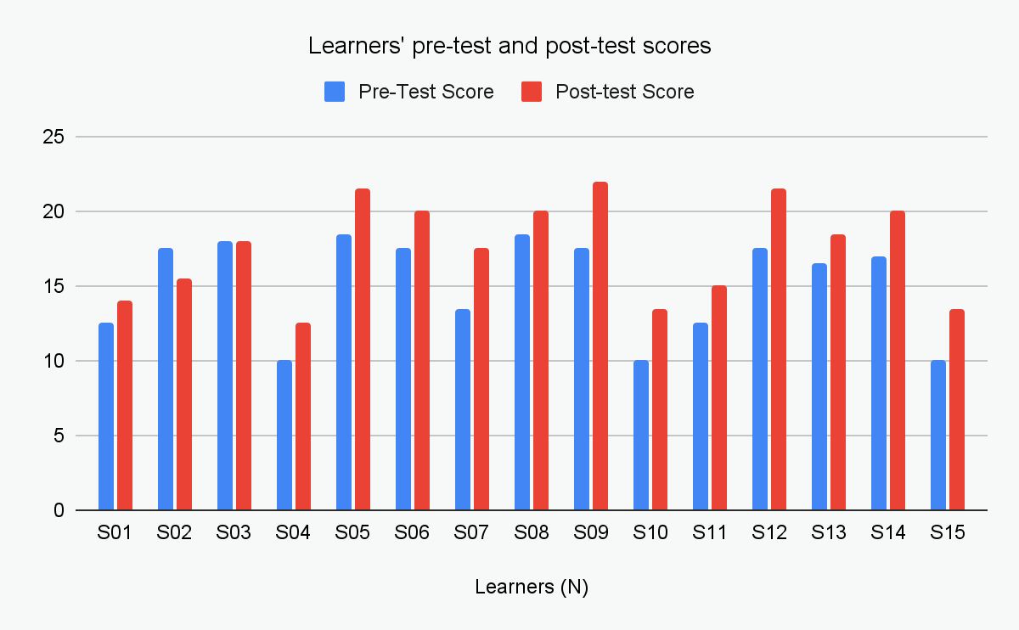
Graph 01. Learners' Scores in the Pre-test and the Post-test.
The data displayed in both the table and graph indicates a notable difference in scores achieved by the learners in the pre-test and post-test. This is further validated by the total scores obtained by the participants, which amounted to 227 on the pre-test and 263 on the post-test, representing a substantial difference of 36 points between the two totals. Based on this analysis, we can tentatively infer that the intervention and treatment have positively impacted the participants' performance and have been effective in enhancing their speaking skills.

2.2.2. Frequency of Scores
The frequency of learners' scores are presented in Table 04, which displays the distribution of scores in ascending order.
Pre-test |  | Post-test
Score | Frequency | Score | Frequency
10 | 3 | 12.5 | 1
12.5 | 2 | 13.5 | 2
13.5 | 1 | 14 | 1
16.5 | 1 | 15 | 1
17 | 1 | 15.5 | 1
17.5 | 4 | 17.5 | 1
18 | 1 | 18 | 1
18.5 | 2 | 18.5 | 1
- | - | 20 | 3
- | - | 21.5 | 2
- | - | 22 | 1
Sum | 15 | Sum | 15

Table 04. Frequency Distribution of Pre-test and Post-test Scores
To gain meaningful insights into the learners' progress, it is crucial to examine the score range in both the pre-test and post-test, including the scores above and below the average, as well as the highest and lowest scores.
Regarding the pre-test scores, the data indicated that:
- the scores ranged from 10 to 18.5, with a noticeable predominance of the score 17.5
- There were three scores lower than the average of 12.5
- 18.5 was the highest in the pre-test among all scores.
Concerning the post-test scores the following observations can be made:
- The scores ranged from 12.5 to 22, with the score of 20 being the most frequent.
- All the scores surpassed the average of 12.5
- 22 was the highest score.
- All learners performed better in the post-test in comparison to the pre-test except for two outliers one of whom scored less in the post-test.
Graph 02 below illustrates the difference between learner's performance in the pre-test and the post-test
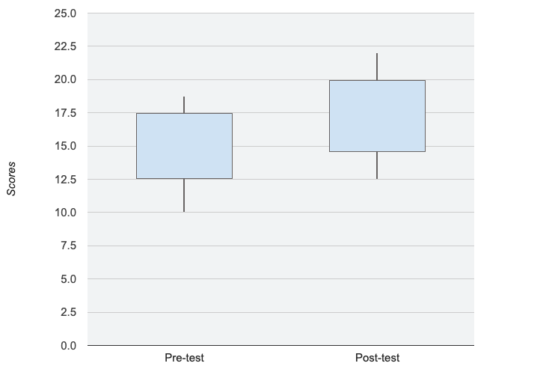
Graph 02. Comparison of Learner's Performance in the Pre-test and Post-test

2.2.3. Descriptive Statistical Analysis of the Pre-test and Post-test Scores
The pre-test and post-test scores of the experimental group were subjected to descriptive statistical analysis, as presented in Table 05. It is important to note that, rather than employing manual methods of calculation, the decision was made to utilise Excel technology as the designated measuring instrument for all requisite calculations.

Descriptive Statistics | Min | Max | Mean | Median | Mode | Std. Deviation
Pre-test | 10 | 18.5 | 15.13 | 17 | 17.5 | 3.319
Post-test | 12.5 | 22 | 17.53 | 18 | 20 | 3.292

Table 05. Descriptive Statistics of the Pre-test and Post-test Scores
The average of all the scores for the pre-test is 15.13, while in the post-test the average increased to 17.53. This indicates a notable difference in scores between the pre-test and post-test. Graph 03 below displays a graphical representation of the descriptive statistics shown in the table above.
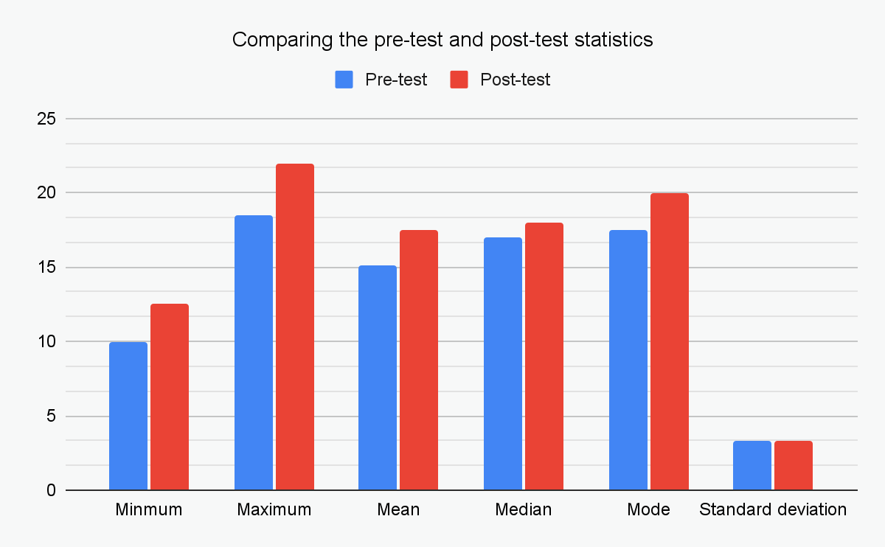
Graph 03. Visual Representation of Pre-test Post-test Descriptive Statistics
Graph 03 depicts a notable gap between the pre-test and post-test with relatively matching Standard Deviations, which strongly suggests that the communicative language teaching (CLT) approach improved learners' performance in the post-test which is expressed in the progress of the majority of learners.

2.2.4. The Paired-Sample T-test
In order to confirm the statistical significance of the improvement, additional inferential statistics need to be obtained, specifically the paired-sample t-test. The paired-sample t-test is a statistical test used to compare the means of one group in two different tests, such as pre-test and post-test, to determine if there is a notable difference between them (Mackey & Gass, 2021). For this study, a paired-sample t-test is applicable. The purpose of the paired-sample t-test, as stated by Chen (2012), is to determine if the intervention had any influential effect.
Prior to calculating the t-test, the researcher must establish the alpha decision level, which is set at either α < .05 or the more conservative α < .01, as recommended by Fisher (1992). For this study, the alpha level was set at α < .05, which allows for a 5% chance of error. The hypothesis is directional/one-tailed, meaning that the test is also directional because there is a theoretical assumption that one mean is expected to be higher than the other. Specifically, the prediction is that the post-test scores will be higher than those of the pre-test. A one-tailed hypothesis is preferred because it is stronger than a two-tailed test as it makes assumptions about the population and the outcome direction (Cohen et al., 2000).
Accordingly, based on the experimental group size of 15 learners, the degree of freedom is calculated to be df = 14 calculated as follows (df = N - 1) hence (df = 15 - 1) df = 14. This implies that in the case of this group size, if the T-value (t_{obs}) is lower than the critical value (t_{crit}) that is ( t_{obs} < t_{crit} ) then it is highly probable that the outcome occurred due to chance and probability. According to Fisher and Yates’ table of Critical values (see appendix D) the critical t-value is set at t_{crit} = 1.761 for df = 14 thus any calculated T-value (t_{obs}) lower than 1.761 that is ( t_{obs} < 1.761 ) would suggest that the progress of the learners in the post-test could be attributed to chance and probability alone.
Table 06 presents the findings obtained from the paired-sample t-test statistics used to test the null hypothesis.

Paired Sample T-test
 | Mean | Std. Deviation | Std. Error Mean | 95% Confidence Interval of the Difference |  | t | df | Significance  One-Sided p
 |  |  |  | Lower | Upper
Pre-test Post-test Scores | 2.400 | 1.681 | .4342 | 3.3314 | 1.4686 | 5.527 | 14 | <.001

Table 06. Paired Sample T-test Results

Based on the information provided in Table 06, we can conclude that the observed statistics is greater than the critical value (t_{obs} > t_{crit} ; 5.527 > 1.761), indicating that the progress observed in the learners' speaking skills is statistically significant and highly unlikely to be due to chance. In fact, there is a 95% likelihood that the improvement is attributed to other factors, such as the CLT intervention used in the classroom. Therefore, it can be concluded that there is a positive causal relationship between the use of CLT activities in the classroom, as an intervention, and the post-test results, with more than 95% certainty.
As a result, The null hypothesis (H0), which assumes that there is no significant impact of CLT on the development of adult EFL learners' speaking skills, can be dismissed since it is not supported at P < .05. Therefore, the alternative hypothesis (H1), which states that the implementation of CLT approach has a positive effect on the learners' speaking skill, is to be embraced.

2.2.5. The Effect Size
In order to determine the practical significance of the observed improvement, Cohen's d was used as a measure of effect size. The calculated effect size was found to be d = 1.4, as illustrated in Table 07 below which, according to Cohen's criteria (1988), represents a large effect. This indicates that the intervention had a significant impact on the speaking skills of the participants. Hence, we can confidently say that the results obtained have been statistically confirmed through the effect size.
Effect Size
 | Point Estimate | 95% Confidence Interval
 |  | Lower | Upper
Cohen's d | 1.427 | 2.143 | .687

Table 07. Cohen's d Effect size

These findings provide substantial evidence supporting the effectiveness of the intervention — i.e. incorporating the Communicative Language Teaching (CLT) approach — which sought to evaluate its influence on the target-language speaking ability of intermediate-level EFL adult learners. The results demonstrated a noteworthy enhancement in the participants' overall speaking proficiency in the post-test when compared to the pre-test. Therefore, these significant and statistically validated outcomes once again confirmed the validity of H1. In fact, It is noncontroversial to conclude that the incorporation of CLT in speaking practices is a productive way of developing EFL learners' speaking performance.

2.3. Discussion of Findings

2.3.1. Interpretation of Results
In this study, the aim was to investigate how the implementation of the Communicative Language Teaching (CLT) approach can enhance language speaking skills among adult intermediate-level English as a Foreign Language (EFL) learners at the Intensive Language Training Centre (CEIL) of Ghardaia University. Through the analysis of the data, interesting findings emerged that shed light on the development of the speaking skill of EFL learners using this approach.
A critical analysis of the quasi-experimental study showed that there was a significant difference between learners’ speaking scores in the pre-test and post-test. These positive results provide evidence of the effectiveness of CLT approach in enhancing language speaking proficiency of EFL learners.
The rejection of the null hypothesis (H0) at p < .05 suggests that the outcomes of the CLT intervention period were solely attributable to the intervention itself, and not to other external factors. This was confirmed by the effect size calculation, which attested to the generalizability of the findings. The acceptance of the alternative hypothesis supports the workability and positive effectiveness of the CLT approach in enhancing language speaking skills among adult intermediate-level EFL learners.
The findings of this study are consistent with previous research, such as Oradee's (2013), which has highlighted the benefits of using CLT in language learning. CLT emphasizes the importance of communication and interaction in language learning and encourages learners to use the language in authentic situations, promoting language acquisition, particularly in terms of speaking skills.
All in all, implementing the CLT approach in the Algerian EFL context has many positive effects, such as promoting learner-centeredness and creating a more communicative environment that offers students increased opportunities to practice speaking. Indeed, we have seen an improvement in learners’ pronunciation, accent, vocabulary use, fluency and accuracy through implementing communicative activities in the classroom.

2.3.2. Pedagogical Implications
The findings of this study hold some implications for language teaching practices and curriculum development, particularly in the context of adult EFL learners. From these results, the following implications and suggestions can be derived:
- The study validates the effectiveness and feasibility of implementing the CLT approach to foster speaking skills among adult EFL learners. This indicates that language training programs should incorporate CLT principles into their curriculum to encourage spontaneous communication.
- Traditional language teaching methods often prioritize vocabulary and grammar instruction, often neglecting the development of speaking skills. The study emphasizes the importance of striking a balance between vocabulary, grammar, and communicative language instruction. Language training programs should dedicate sufficient time and resources to cultivating learners' speaking abilities through CLT-based activities.
- CLT approach stresses the significance of authentic communication within meaningful contexts. Language instructors should provide learners with opportunities to engage in real-life communicative tasks and authentic language usage. This can be achieved through activities such as role-plays, discussions, interviews, and problem-solving tasks, which encourage learners to employ the language for practical purposes.
- Teachers are encouraged to experiment with the implementation of CLT activities in the classroom to ascertain students' preferences. Conducting a needs analysis can reveal the types of communicative activities learners find it relatable and comfortable to participate.
- The successful implementation of CLT approach necessitates skilled and knowledgeable language instructors. Therefore, teacher training programs should incorporate CLT principles and methodologies to equip teachers with the necessary tools to effectively integrate communicative activities and foster the development of speaking skills for the learners.
- Moreover, such training programs should assist teachers in broadening their perspectives sufficiently to recognize the negative effects of relying solely on a teacher-centred approach and consider alternative approaches to enhance student learning.
- The study emphasizes the need to review and revise existing language training curricula to align them with CLT principles. Language training programs should prioritize the integration of communicative activities, authentic materials, and real-world contexts in their curriculum design to enhance learners' communication in the target language.
- CLT should be implemented whenever the teacher is willing to establish an interactive learning atmosphere that provides learners with opportunities to practice and utilize the language within the classroom.
- To address the limitations of CLT, a blended learning approach that incorporates aspects from different language teaching methodologies should be considered to complement and enhance its effectiveness.

2.3.3. Suggestions and Recommendations for Further Research
Based on the limitations identified in the study, the following recommendations are suggested for further research:
- It is recommended that future research should consider including a larger sample of EFL learners by recruiting participants from multiple language training centres and institutions, which would increase the representativeness of the sample and provide a broader perspective on the effectiveness of CLT in enhancing English language speaking skills. And thus maximizing the generalizability of the findings.
- To establish a stronger causal relationship, future studies should strive to incorporate a true experimental design. By comparing the performance of learners who receive CLT instruction with those who receive instruction using traditional language teaching methods, researchers can increase the validity of the results and gain a clearer understanding of the specific benefits of CLT in comparison to other teaching approaches.
- While the current study focused on four types of communicative activities (i.e., role-playing, information gap, interviewing, and problem-solving), future investigations should consider analyzing and comparing these activities in order to gain a more comprehensive understanding of these communicative activities, their implications, and level of effectiveness in enhancing learners' speaking skill.
- To assess the long-term impact of CLT on learners' speaking skills, future studies should extend the duration of the intervention. Implementing the CLT approach over an entire semester or a longer period would allow for a thorough evaluation of its long-term effects.
- A mixed-methods research design could also be employed in future studies. In addition to the quasi-experimental design used in this study, the inclusion of qualitative data collection methods such as classroom observations and interviews with teachers and participants would provide valuable insights into the implementation process, learner experiences, and perceptions of the CLT approach.
- While the present study focused on speaking skills, further research could extend the investigation to assess the impact of CLT on other language skills, including listening, reading, and writing. With the aim of enhancing the combined four skills rather than separate linguistic skills examining the holistic development of language proficiency within the CLT approach.
- Furthermore, it would be worthwhile to investigate the effectiveness of CLT at different language proficiency levels, such as beginner or advanced levels. This would confirm whether the benefits of CLT in developing learners speaking skills are consistent across various levels of language proficiency.
- Lastly, conducting observations of teachers implementing CLT activities in different Algerian EFL contexts would offer a more detailed understanding of CLT practices and their variations in real classroom settings.

By addressing these research recommendations, future studies can fill the gaps left in this study and contribute to a more rigorous and comprehensive understanding of the effectiveness and implications of CLT for developing speaking skills among adult EFL learners.

Conclusion
Throughout this chapter, a comprehensive overview of the methodological decisions and procedures employed to address the research questions and test the hypotheses has been outlined and described in detail. The data collection process utilized a one-group pre-test post-test quasi-experimental design, and the specific procedures involved in its implementation were clarified. The results obtained from this quasi-experiment were subjected to critical analysis and interpretation both descriptively and statistically. By the end of the chapter, a rigorous and comprehensive discussion of the study findings was presented, aiming to offer definitive and relevant answers to the research questions at hand. In light of these findings, several pedagogical implications and recommendations for further research were put forth, targeting language instructors, language training institutions, and researchers involved in this field of inquiry. Overall, this chapter contributes to a deeper understanding of the feasibility of developing foreign language speaking skills through the CLT approach among intermediate-level EFL learners at CEIL of Ghardaia University.

GENERAL CONCLUSION

General Conclusion
In conclusion, this dissertation aimed to examine the effectiveness of the Communicative Language Teaching (CLT) approach in developing the speaking skills of adult intermediate-level English as a Foreign Language (EFL) learners at the Intensive Language Training Center (CEIL) of Ghardaia University. The study addressed the limitations observed in traditional language teaching methods, which tend to prioritize vocabulary and grammar instruction, often overlooking the development of speaking skills. Taking everything into account, the dissertation set out to answer the research questions and validate the proposed hypotheses.
The first chapter of this dissertation was dedicated to the review of related literature, offering a prevailing theoretical understanding of the CLT approach and Language Speaking, covering all the fundamental principles associated with these concepts. The first section of the chapter discussed the conceptualization of foreign language speaking skills, encompassing its key components, significance, and challenges encountered with its acquisition. Subsequently. the second section of the chapter presented a theoretical exploration of the CLT approach, shedding light on its underlying principles, techniques, and various communicative activities employed to enhance language proficiency.
To collect relevant data and draw meaningful inferences from the findings, a one-group quasi-experimental pre-test/post-test design was implemented. The study involved a four-week communicative language teaching intervention, during which learners were exposed to various communicative activities. The analysis of learners' scores revealed significant progress between the pre-test and post-test performances. These findings were validated through statistical analysis using the paired sample T-test and Cohen's d effect size, leading to the alternative hypothesis being confirmed and the null hypothesis being rejected.
All in all, this dissertation sheds light on the potential of CLT as an effective approach for developing language speaking skills among adult EFL learners. By embracing the communicative aspect of language learning and providing opportunities for authentic communication, educators can foster language proficiency that extends beyond mere vocabulary and grammar knowledge. Continued research and implementation of CLT hold promise for enhancing language teaching practices and contributing to the development of competent and confident language learners.

References
Alqahtani, M. (2015). The importance of vocabulary in language learning and how to be taught. International Journal of Teaching and Education, III(3), 21–34. https://doi.org/10.20472/te.2015.3.3.002
Aromdee, R. (2012). Using Authentic Materials Based on Communicative Language Teaching to Develop Factory Workers’ Basic EFL Literacy at A. I. P. CO., LTD.: A Case Study. Srinakharinwirot University. http://thesis.swu.ac.th/swuthesis/Tea_Eng_For_Lan(M.A.)/Rattanawan_A.pdf
Badroeni, B. (2018). IMPROVING STUDENTS’ MOTIVATION IN SPEAKING ENGLISH THROUGH ACTIVE LEARNING STRATEGY. Research and Innovation in Language Learning, 1(2), 76. https://doi.org/10.33603/rill.v1i2.1075
Blaz, D. (1999). Foreign Language Teacher’s Guide to Active Learning. New York: Eye On Education.
Brudden, P. M. (1995). Effective English Teaching (2nd ed.). New York: The Bob’s Merril Company.
Brydges, C. R. (2019). Effect Size Guidelines, Sample Size Calculations, and Statistical Power in Gerontology. Innovation in Aging, 3(4). https://doi.org/10.1093/geroni/igz036
Cambridge Assessment English. (2018). B1 Preliminary exam format | Cambridge English. https://www.cambridgeenglish.org/exams-and-tests/preliminary/exam-format/
Canale, M. (1980). THEORETICAL BASES OF COMMUNICATIVE APPROACHES TO SECOND LANGUAGE TEACHING AND TESTING. Applied Linguistics, 1(1), 1–47. https://doi.org/10.1093/applin/1.1.1
Celce-Murcia, M. (2001). Teaching English as a Second Or Foreign Language (3rd ed.). Boston: Heinle ELT & Heinle Pub.
Chen, H. (2012). Approaches to Quantitative Research: A Guide for Dissertation Students. Oxford: Oak Tree Press.
Cohen, L. A., Manion, L., & Morrison, K. (2000). Research Methods in Education. In Routledge eBooks (5th ed.). Routledge. https://doi.org/10.4324/9780203224342
Ellis, M., & Johnson, C. (1994). Teaching Business English (illustrated ed.). Oxford, England: Oxford University Press.
Fillmore, C. J. (1979). On Fluency. In Elsevier eBooks (pp. 85–101). https://doi.org/10.1016/b978-0-12-255950-1.50012-3
Fisher, R. A. (1992). Statistical methods for research workers. Springer New York, 66–70.
Fisher, R. A., & Yates, F. (1963). Statistical Tables. Journal of the American Statistical Association.
Glen, S. (2017, October 12). Practice Effect & Carry Over Effect Definition & Examples - Statistics How To. Statistics How To. Retrieved April 7, 2023, from https://www.statisticshowto.com/practice-effect/
Gribbons, B. C., & Herman, J. L. (1996). True and Quasi-Experimental Designs. Practical Assessment, Research and Evaluation, 5(14), 14. https://doi.org/10.7275/fs4z-nb61
Han, J., & Yin, H. (2016). Teacher motivation: Definition, research development and implications for teachers. Cogent Education, 3(1), 1217819. https://doi.org/10.1080/2331186x.2016.1217819
Hanifa, R. (2018). Factors generating anxiety when learning EFL speaking skills. Studies in English Language and Education, 5(2), 230–239. https://doi.org/10.24815/siele.v5i2.10932
Harmer, J. (2002). The Practice of English Language Teaching, 4th Edition (4th ed.). England: Longman.
Harmer, J. (2022). Jeremy Harmer’s 50 Communicative Activities. Cambridge: Cambridge University Press.
Harris, P. (1974). Testing English as a second language. New York: Mc. Graw. Hill Book Company.
Hedge, T. (2000). Teaching and Learning in the Language Classroom (1st ed.). Oxford University Press. http://ci.nii.ac.jp/ncid/BA49024164
Howatt, A. P. R. (1984). A history of English language teaching. Oxford: Oxford University Press. http://archives.umc.edu.dz/handle/123456789/111058
Kayi, H. (2008). Teaching Speaking: Activities to Promote Speaking in a Second Language. The Internet TESL Journal, 12(11). http://iteslj.org/Techniques/Kayi-TeachingSpeaking.html
Kirk, R. E. (1994). Experimental design: Procedures for the behavioral sciences (3rd ed.). California: Wadsworth Publishing.
Klippel, F. (1984). Keep Talking: Communicative Fluency Activities for Language Teaching. Cambridge: Cambridge University Press.
Krashen, S. (1982). Principles and Practice in Second Language Acquisition. The Modern Language Journal, 67(2), 168. https://doi.org/10.2307/328293
Larsen-Freeman, D. (2000). Techniques and Principles in Language Teaching, Second Edition. In Oxford University Press eBooks. http://elibrary.clce.ac.zm:8080/jspui/handle/123456789/84
Leong, L. M., & Ahmadi, S. M. (2017). An Analysis of Factors Influencing Learners’ English Speaking Skill. International Journal of Research in English Education, 2(1), 34–41. https://doi.org/10.18869/acadpub.ijree.2.1.34
Littlewood, W. (2007). Communicative and task-based language teaching in East Asian classrooms. Language Teaching, 40(3), 243–249. https://doi.org/10.1017/s0261444807004363
Mackey, A., & Gass, S. (2021). Second Language Research: Methodology and Design (3rd ed.). New York: Routledge. http://dx.doi.org/10.4324/9781003188414
Mena, K. S. (2019). English Pronunciation Proficiency. University of Costa Rica. https://doi.org/10.13140/RG.2.2.17486.92487
Moore, K. A. (2008). Quasi-Experimental Evaluations: Part 6 in a Series on Practical Evaluation Methods. Research-to-Results Brief. Child Trends., 2008–04. https://cms.childtrends.org/wp-content/uploads/2008/01/Child_Trends-2008_01_16_Evaluation6.pdf
Muysken, P. (1995). Code-switching and grammatical theory. In Cambridge University Press eBooks (pp. 177–198). https://doi.org/10.1017/cbo9780511620867.009
Nunan, D. (1989). Designing Tasks for the Communicative Classroom. Cambridge: Cambridge University Press.
Nunan, D. (1990). Designing Tasks for the Communicative Classroom. The Modern Language Journal, 74(1), 89. https://doi.org/10.2307/327949
Nunan, D. (1991). Language Teaching Methodology: A Textbook for Teachers. New York: Prentice Hall.
O’Malley, J. M., & Pierce, L. V. (1996). Authentic Assessment for English Language Learners: Practical Approaches for Teachers. London: Longman.
Omari, F. (2016). An Evaluation Of The Teaching Of The Speaking Skill In Efl Classrooms Within The Framework Of The Cba. The Case of 3rd Year Pupils in 3 Secondary Schools in Tlemcen, [Thèse de Doctorat, Université Abou Bekr Belkaid-Tlemcen]. http://dspace.univ-tlemcen.dz/handle/112/8774
Oradee, T. (2013). Developing Speaking Skills Using Three Communicative Activities (Discussion, Problem-Solving, andRole-Playing). International Journal of Social Science and Humanity, 533–535. https://doi.org/10.7763/ijssh.2012.v2.164
Oura, G. K. (2001). Authentic Task-Based Materials:Bringing the Real World Into the Classroom. Portland State University.
Procter, P. (2004). Speak. In M. Mayor (Ed.), Longman Dictionary of Contemporary English (4th ed., p. 15). England: Longman.
Richards, J. C. (2008). Teaching Listening & Speaking: From Theory to Practice. Cambridge: Cambridge University Press.
Richards, J. C., & Rodgers, T. S. (1986). Approaches and Methods in Language Teaching: A Description and Analysis. Oxford: Oxford University Press. http://ci.nii.ac.jp/ncid/BA00508734
Richards, J. C., & Rodgers, T. S. (2001). Approaches and Methods in Language Teaching (2nd ed.). Cambridge: Cambridge University Press.
Saputra, J. B. (2015). Communicative Language Teaching: Changing Students’ Speaking Skill. Journal of English Education and Applied Linguistics, 4(1). https://doi.org/10.24127/pj.v4i1.277
Savage, K. L., Bitterlin, G., & Price, D. (2010). Grammar Matters: Teaching Grammar in Adult ESL Programs. Cambridge: Cambridge University Press.
Shaw, C., & McDonough, J. (1993). Materials and Methods in ELT: A Teacher’s Guide. Cambridge: Blackwell Publisher. https://openlibrary.org/books/OL22577880M/Materials_and_methods_in_ELT
Spada, N. (2007). Communicative Language Teaching. In International Handbook of English Language Teaching (Vol. 15, pp. 271–288). Springer, Boston, MA. https://doi.org/10.1007/978-0-387-46301-8_20
Swan, M. P. (1985). A critical look at the Communicative Approach (2). ELT Journal, 39(2), 76–87. https://doi.org/10.1093/elt/39.2.76
Thornbury, S. (2005). How to Teach Speaking (1st ed.). London: Pearson Education.
Thornbury, S., & Slade, D. (2006). Conversation: From Description to Pedagogy. Cambridge: Cambridge University Press.
Ur, P. (2012). A course in English language teaching. Cambridge: Cambridge University Press.
Vorholt, J. (2018). New Ways in Teaching Speaking (TESOL association, Ed.; 2nd ed.). Virginia: TESOL Press.
Zhang, Y. (2009). Reading to Speak: Integrating Oral Communication Skills. English Teaching Forum, 47(1), 32–34. http://files.eric.ed.gov/fulltext/EJ923446.pdf

Appendices

Appendix A. The speaking section of the Prelimnary English Test (PET)

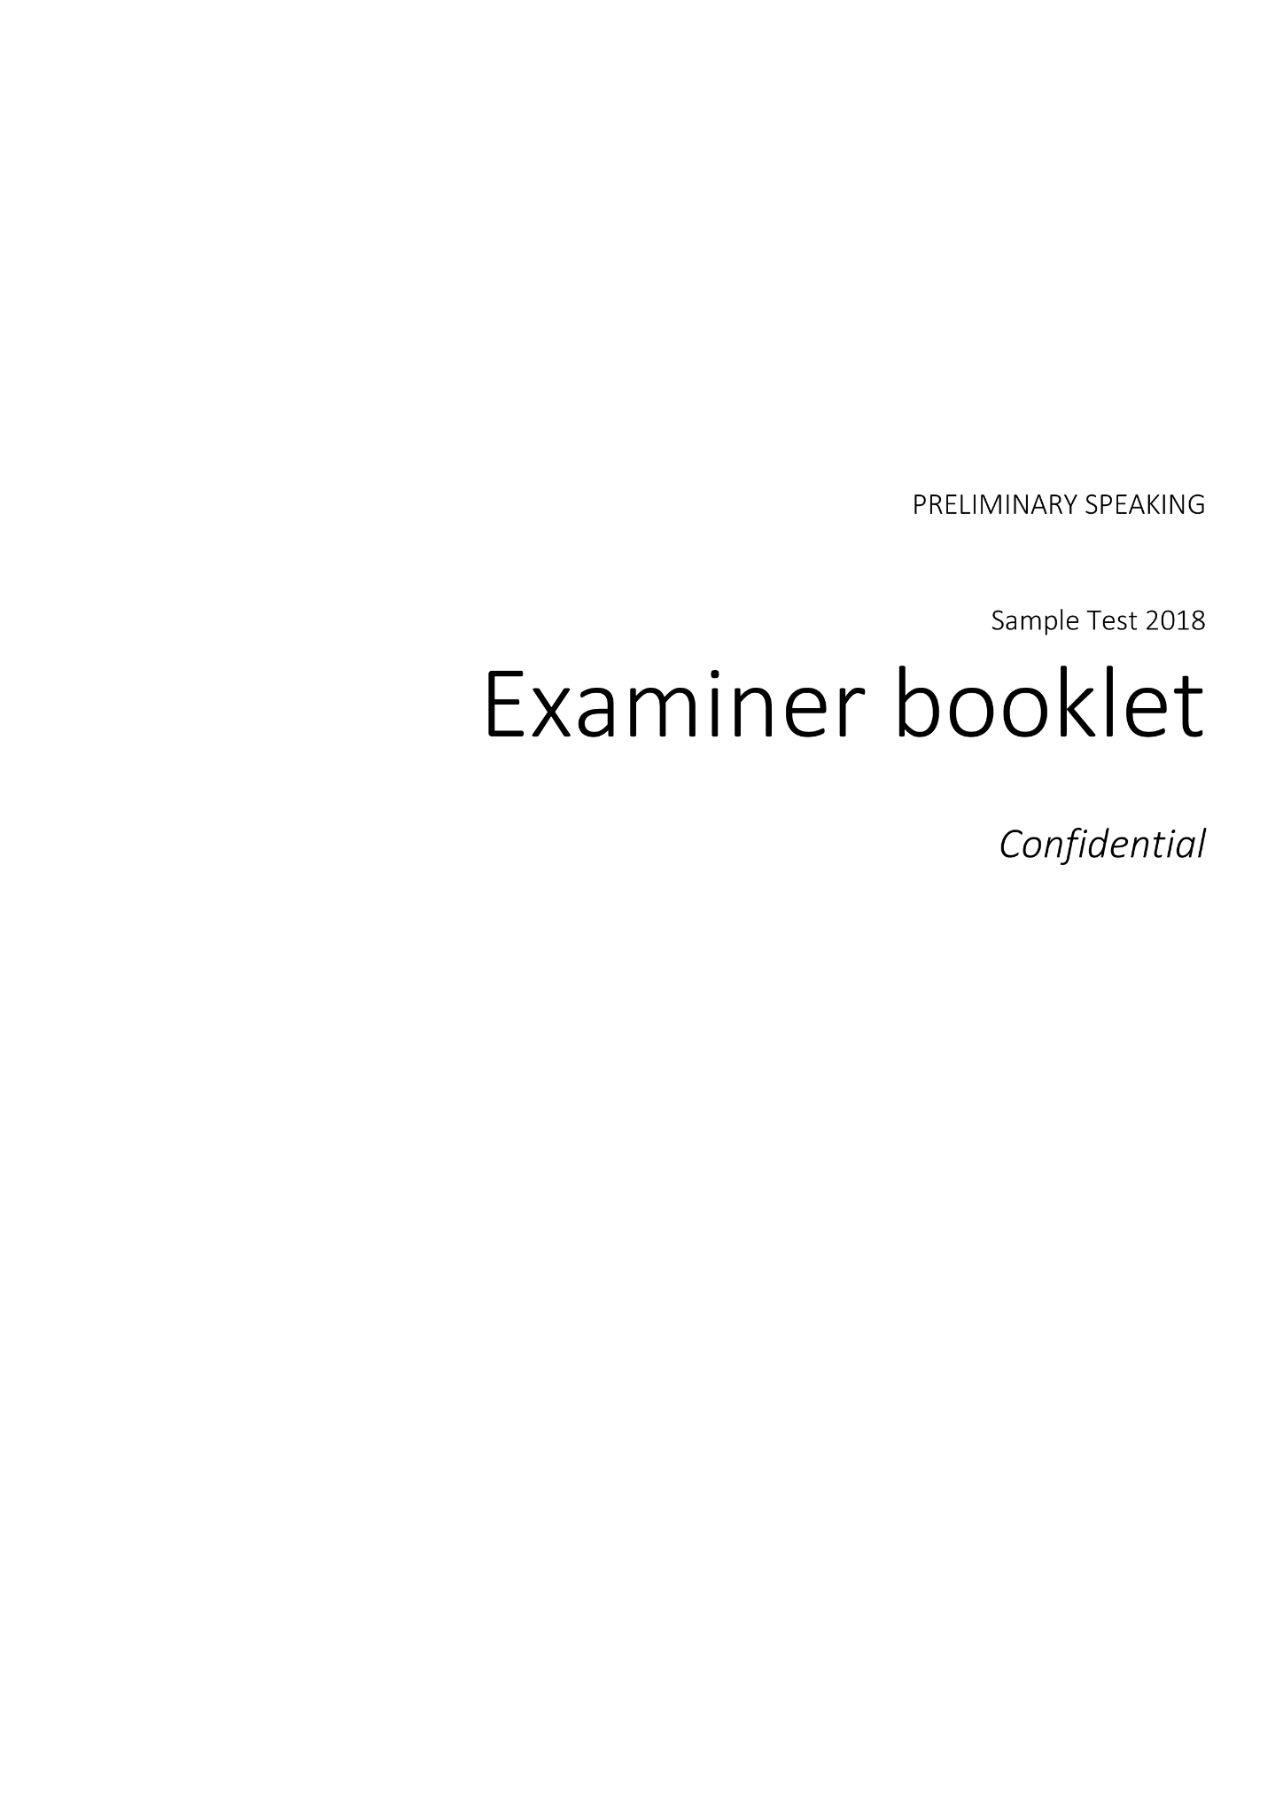

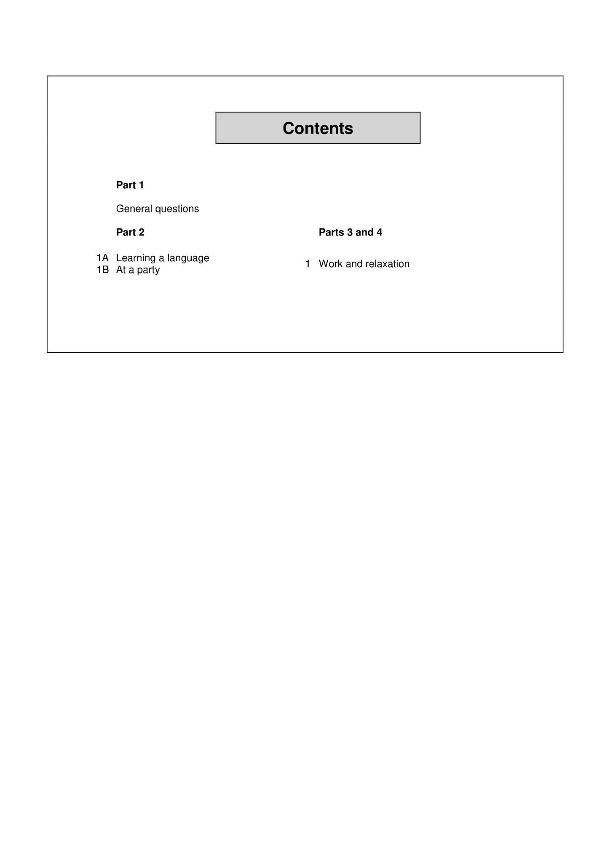

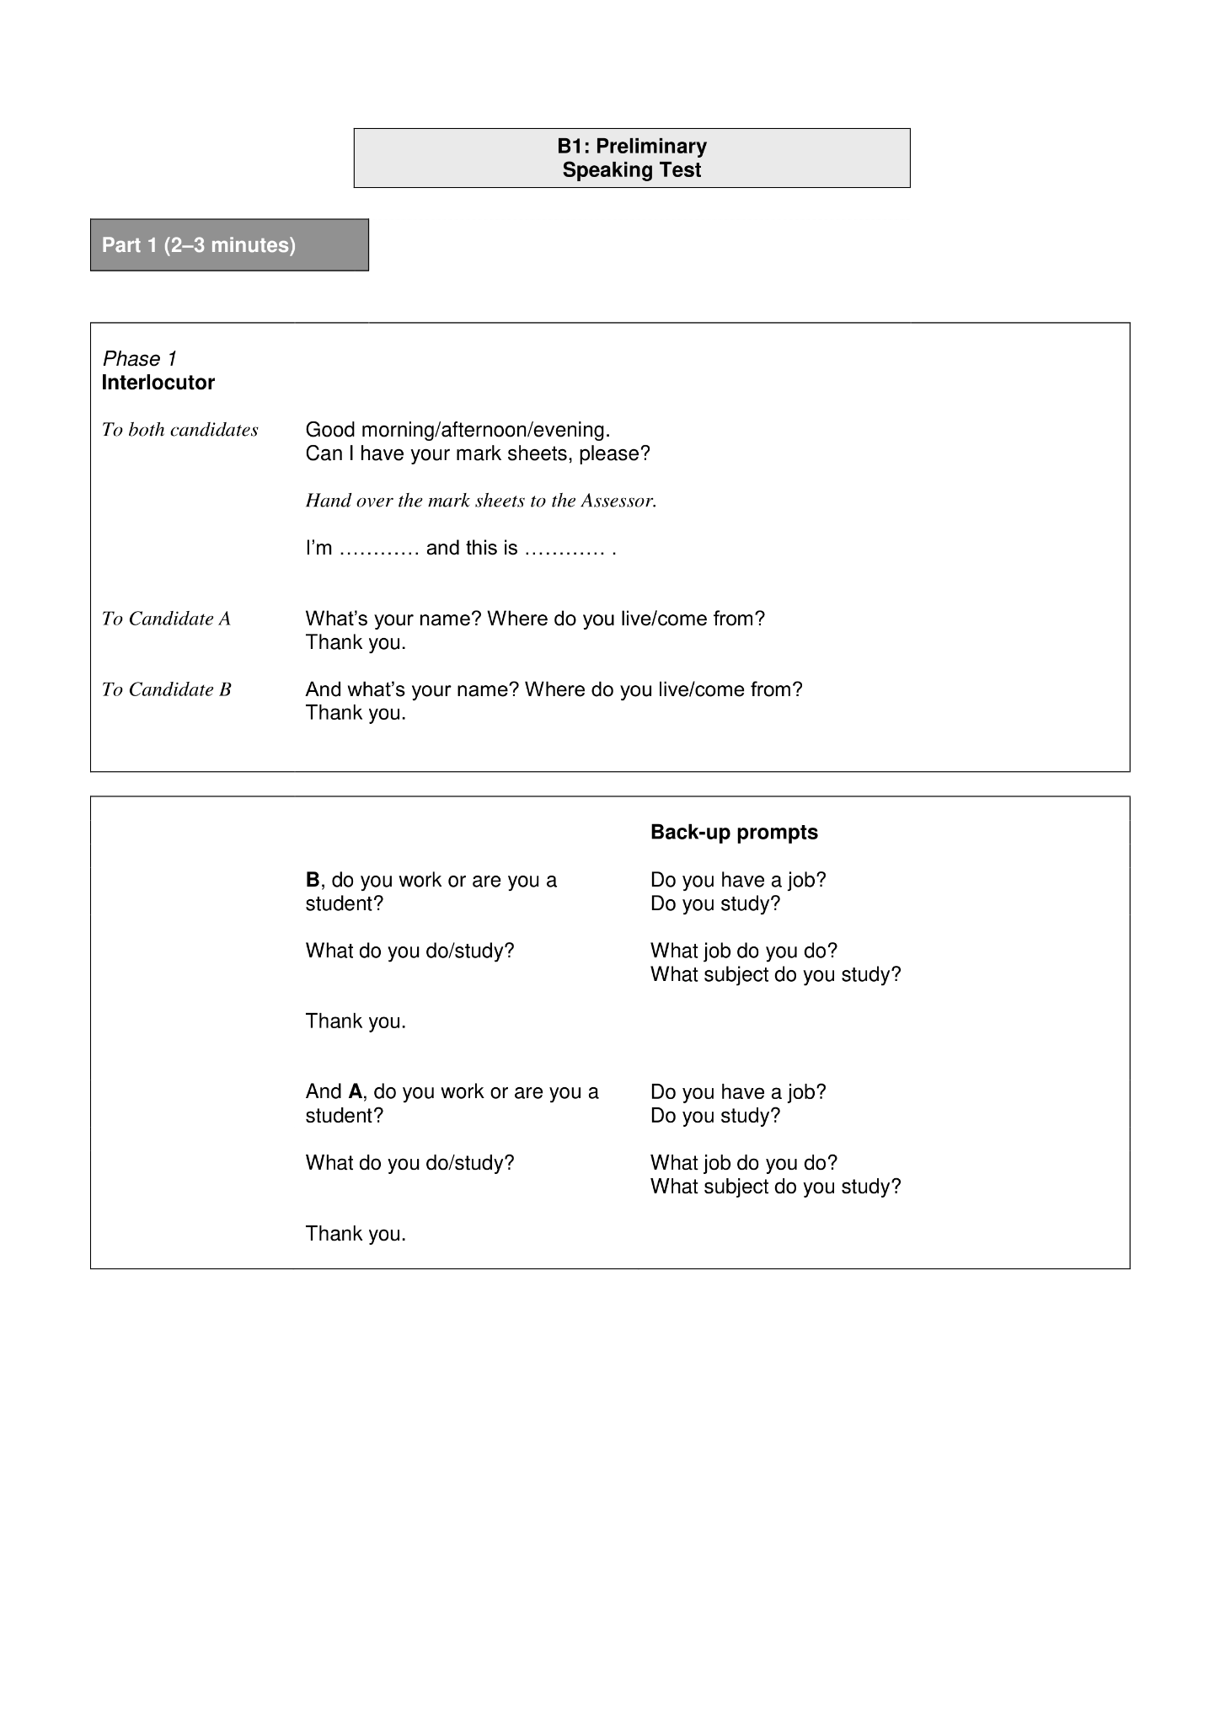

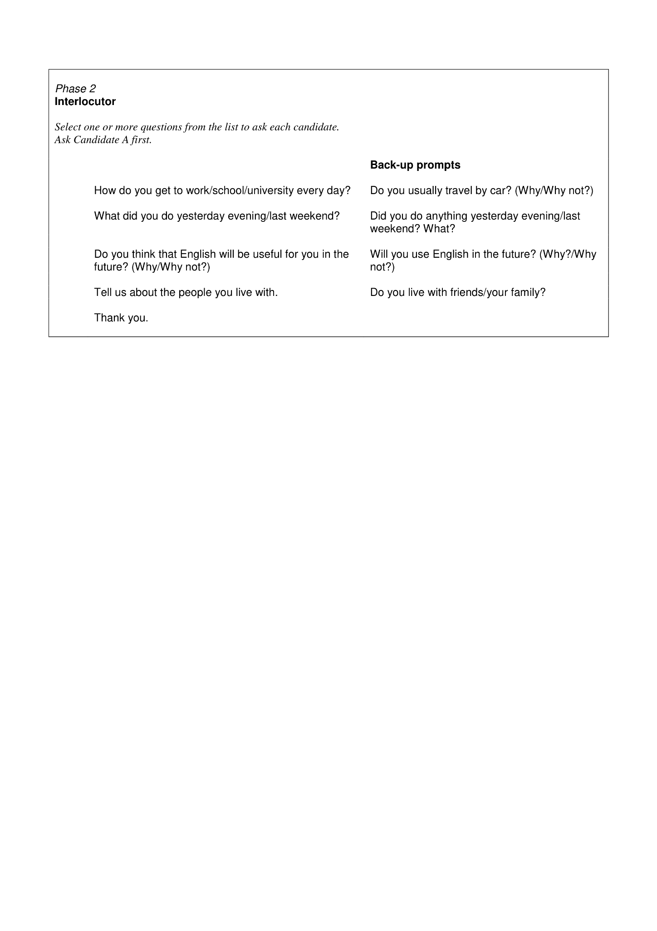

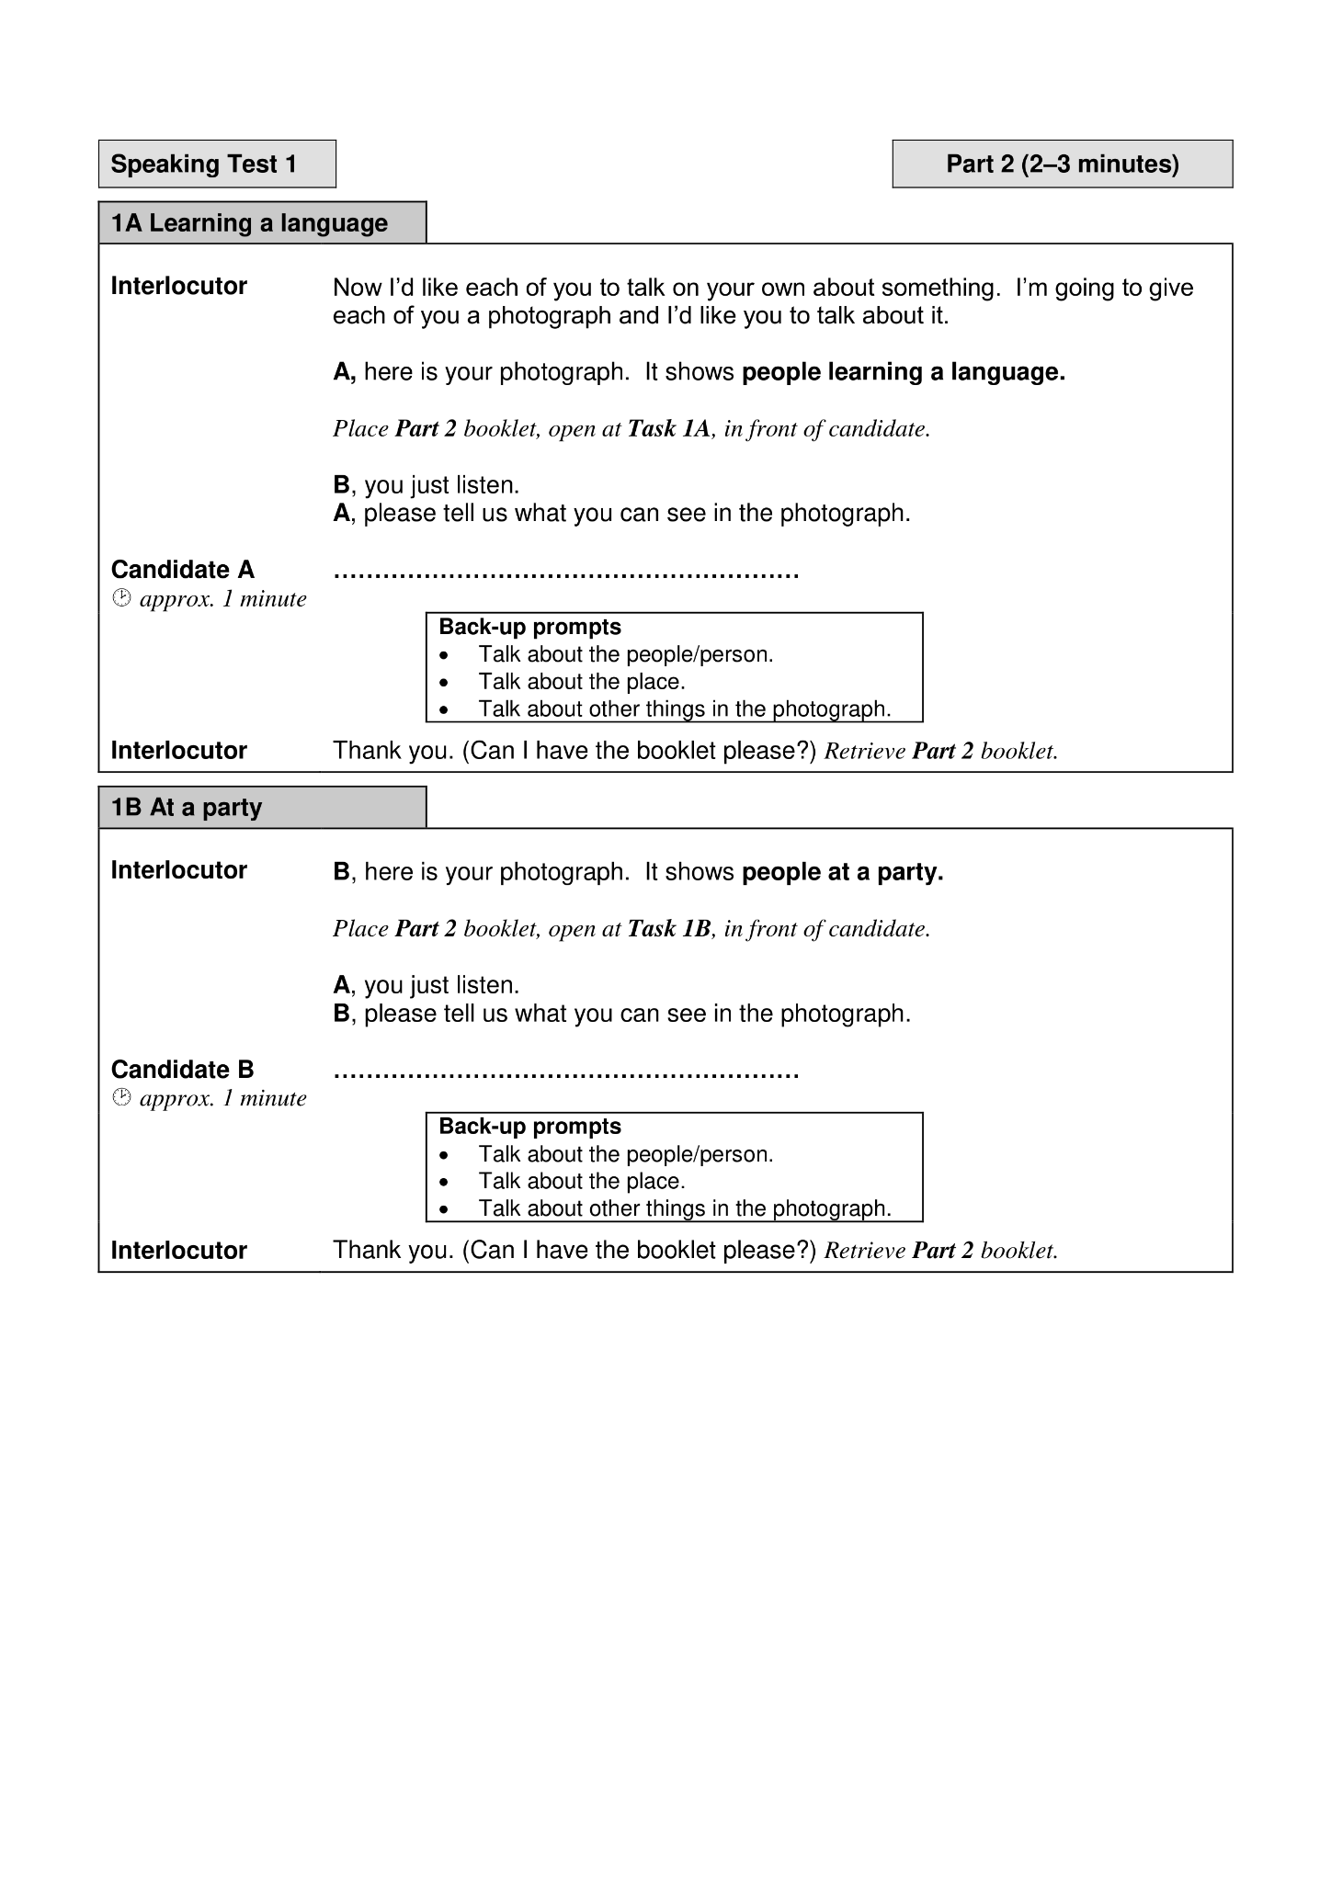

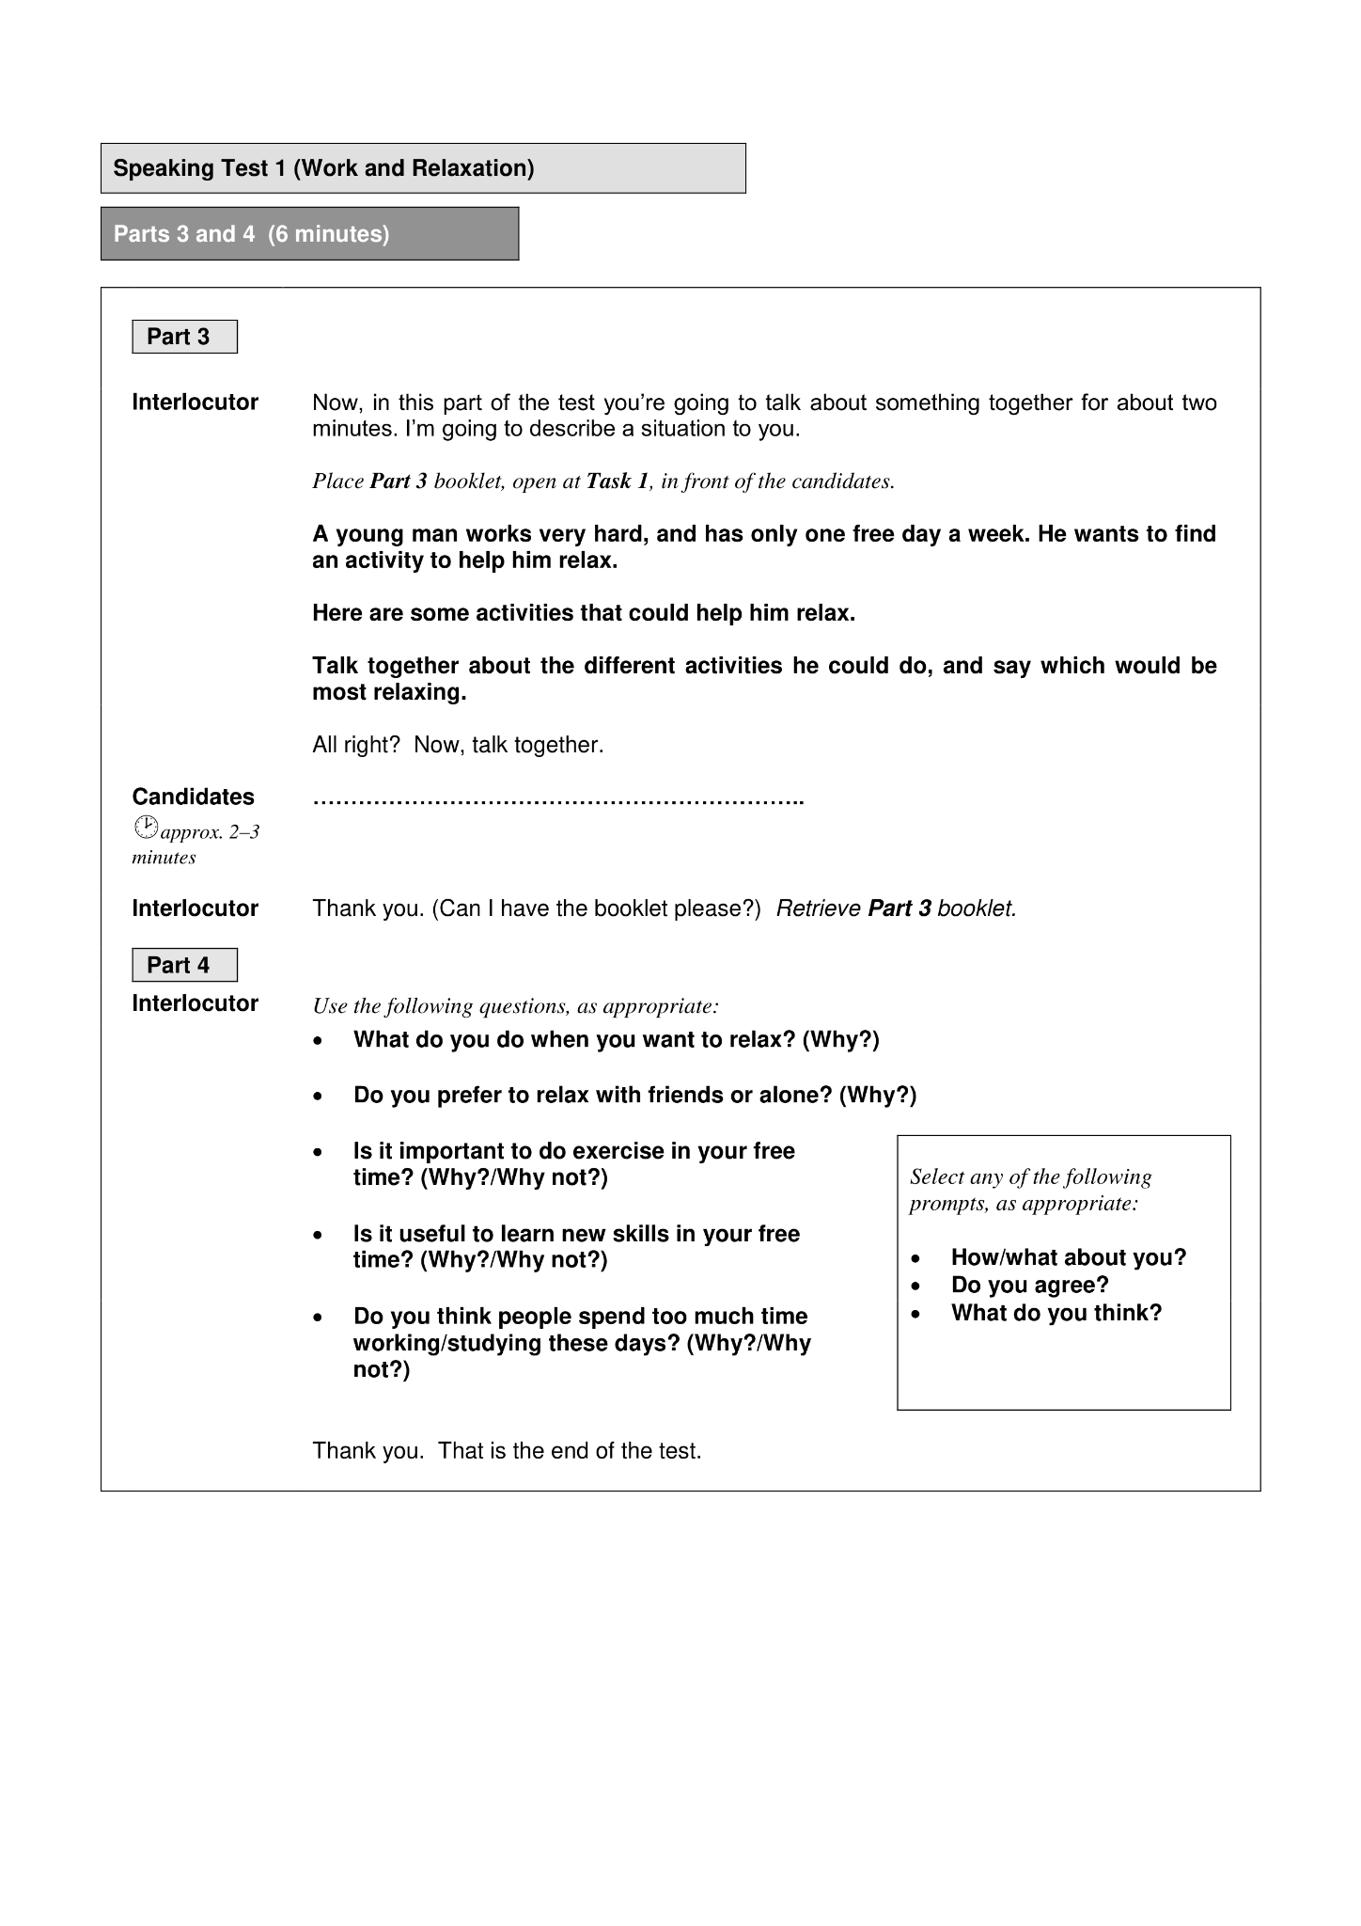

Source: Cambridge Assessment English. (2018). B1 Preliminary exam format | https://www.cambridgeenglish.org/Images/504344-b1-preliminary-2020-sample-papers.zip

Appendix B. PET speaking scale assessment rubric

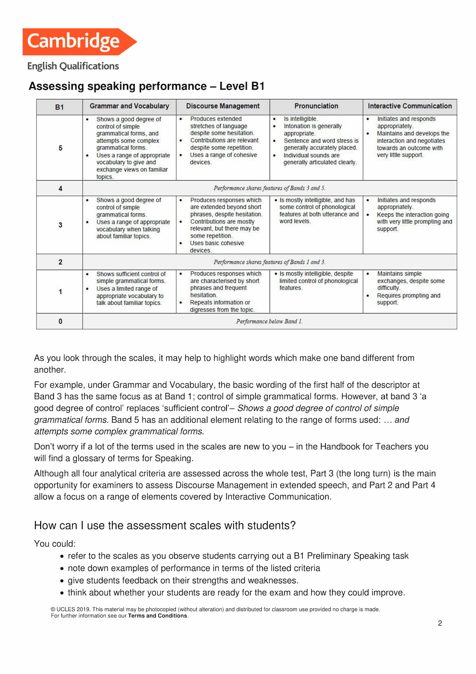

Source: Cambridge Assessment English. (2018). Assessing speaking performance – B1 https://www.cambridgeenglish.org/Images/563276-b1-preliminary-assessing-speaking.pdf

Appendix C. The scheduling of the intervention and the selected activities

(Week 1)

Session 1
Communicative activity planned | 2. Personal Interview (Harmer, 2022, p. 4)
Activity description | “Lea​rners interview each other based on questions that are suggested by an initial learner contribution.” (Harmer, 2022, p. 4)
Activity type | Interviewing
Nature of particpation | Individual / In pairs
Time allotted for the activity | 30 Minutes
Session 2
Communicative activity planned | 4. Experts (Harmer, 2022, p. 8)
Activity description | “Learners pretend to be experts in a subject. They have to answer questions put to them, but only one word at a time.” (Harmer, 2022, p. 8)
Activity type | Role-playing
Nature of particpation | Individual
Time allotted for the activity | 30 Minutes

(Week 2)

Session 3
Communicative activity planned | 11. Mystery Objects (Harmer, 2022, p. 22)
Activity description | “Learners introduce mystery objects and their classmates have to try and work out what they are by initiating Information seeking conversations.” (Harmer, 2022, p. 22)
Activity type | Problem-solving
Nature of particpation | In pairs
Time allotted for the activity | 45 Minutes
Session 4
Communicative activity planned | 12. Discussion Cards (Harmer, 2022, p. 24)
Activity description | “Learners are given a series of random discussion questions. Together they explore their opinions and their answers to those questions.” (Harmer, 2022, p. 24)
Activity type | Role-playing
Nature of particpation | In Groups
Time allotted for the activity | 1 Hour

(Week 3)

Session 5
Communicative activity planned | 14. Ask the Right Question (Harmer, 2022, p. 29)
Activity description | “Learners have to ask questions which get exactly the answer –from another learner – that is written on their card.” (Harmer, 2022, p. 29)
Activity type | Information-gap
Nature of particpation | In pairs
Time allotted for the activity | 30 Minutes
Session 6
Communicative activity planned | 27. Press Conference (Harmer, 2022, p. 56)
Activity description | “Learners role-play a press conference with characters from a passage or story which they have read.” (Harmer, 2022, p. 56)
Activity type | Role-playing
Nature of particpation | Entire class
Time allotted for the activity | 1 Hour

(Week 4)

Session 7
Communicative activity planned | 29. Suitcase Language (Harmer, 2022, p. 60)
Activity description | “Learners choose the words they would most like to ‘put in their suitcase’ and then explain why and how they will use them. In groups, they use these words to create their own text.” (Harmer, 2022, p. 60)
Activity type | Problem-solving
Nature of particpation | In groups
Time allotted for the activity | 45 Minutes
Session 8
Communicative activity planned | 46. Formal Debate (Harmer, 2022, p. 97)
Activity description | “Learners prepare for and take part in a formal debate.” (Harmer, 2022, p. 97)
Activity type | Role-playing / Problem-solving
Nature of particpation | Entire class
Time allotted for the activity | 1 Hour and 30 Minutes

Appendix D. Fisher and Yates’ table of Critical values

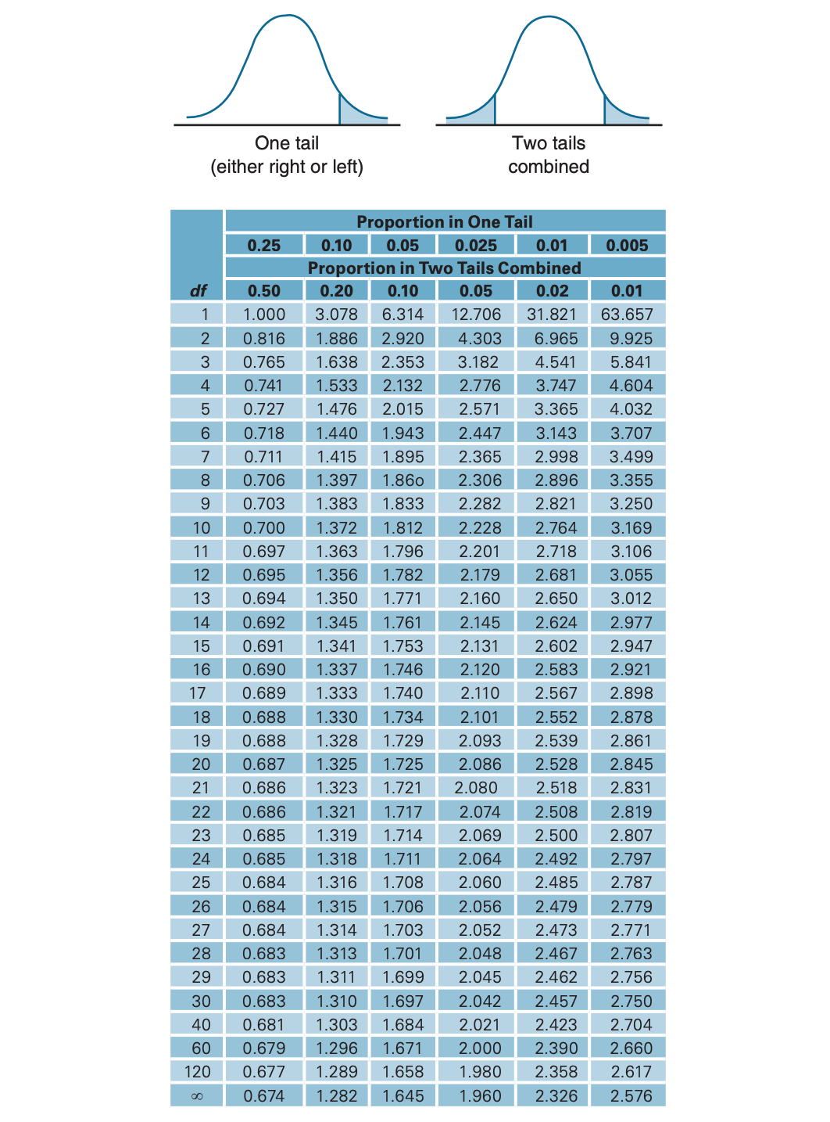

Source: Fisher, R. A., & Yates, F. (1963). Statistical Tables. Journal of the American Statistical Association.

الملخص

من بين الأهداف الرئيسية التي يسعى إلى تحقيقها متعلمو اللغة البالغين عند إنخراطهم في البرامج التدريبية للغات الأجنبية، هي القدرة على التحدث بطلاقة بواسطة اللغة الأجنبية المراد تعلمها. ولكن، تعتبر مهارة التحدث و بلا شك من أشد المهارات صعوبةََ في الإكتساب من بين المهارات اللغوية الأربع. خاصة عند إتباع طرق التدريس التقليدية التي تعتمدها العديد من مراكز ومناهج تعليم اللغات الأجنبية، والتي تولي أهمية بالغة لتعليم المفردات والقواعد النحوية على حساب المهارات اللغوية الأخرى. وفي ضوء هذا السياق، تهدف هذه الدراسة إلى فحص فعالية استخدام نهج تعليم اللغة التواصلي في تطوير مهارات التحدث لدى متعلمي اللغة الإنجليزية كلغة أجنبية البالغين ذوي المستوى المتوسط ​​بالمركز المكثف لتعليم اللغات الأجنبية بجامعة غرداية. لاختبار هذه الفرضية، تم إجراء دراسية كمية بإستخدام نهج البحث الشبه تجريبي لمجموعة واحدة بواسطة الاختبار القبلي والبعدي. تكونت المجموعة من 15 متعلمًا بالغًا ينتمون إلى خلفيات أكاديمية ومهنية متنوعة مسجلون ضمن المستوى المتوسط في اللغة (B1). تم تقييم المشاركين على مستوى إتقانهم للتحدث باللغة الإنجليزية بواسطة جزء التحدث من إمتحان اللغة الإنجليزية الأولي (PET) قبل وبعد فترة المعالجة التي دامت أربع أسابيع وإتبعت مبادئ نهج تعليم اللغة التواصلي. من خلال تحليل وتفسير مفصل لنتائج الاختبار القبلي والبعدي، أشارت النتائج إلى أن تطبيق نهج تعليم اللغة التواصلي يعتبر طريقة فعالة ومجدية لتطوير مهارة التحدث باللغة الأجنبية لدى متعلمي اللغة الإنجليزية البالغين ذوي المستوى المتوسط في اللغة. لذلك، قد تحمل هذه الدراسة بعض الآثار الإيجابية المحتملة لتبني نهج تعليم اللغة التواصلي ضمن الأقسام الدراسية للغة الإنجليزية كلغة أجنبية.
كلمات مفتاحية: تعليم اللغة التواصلي، اللغة الإنجليزية كلغة أجنبية، مهارة التحدث، دراسة شبه تجريبية، مناهج تعليم اللغات الأجنبية، متعلمو اللغات الأجنبية البالغين.

